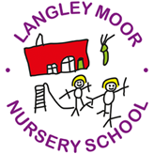

Langley Moor Nursery School
Brandon Lane
Durham
DH7 8LL
Phone:0191 378 0830

Dear Applicant,

Thank you for your enquiry regarding the position of part time Early Years Practitioner within our nursery school.
We are a small nursery school which delivers high quality learning and teaching experiences for children under five.
Please find attached information regarding the position, as well as an application form.
Please send your completed written application to the above address, to reach the above address by close of business on Friday 19th December. Emailed applications will not be considered.
It is anticipated that interviews will take place on Monday 19th January.

Regards

The Governors of Langley Moor Nursery School

