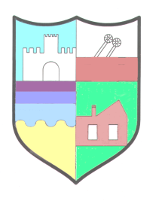

Education without Compromise

Headteacher: Mr K. Vardy B.Ed ADE Warkworth Drive, Ellington, Morpeth, Northumberland, NE61 5HL
Telephone: 01670 860769 Fax: 01670 862940 Email:Admin@ellington.northumberland.sch.uk
www.ellingtonprimaryschool.co.uk

FURTHER INFORMATION

Our school serves the area of Ellington and Cresswell on the beautiful Northumberland coastline, although an increasing number of children are transported to the school from outlying areas. We are a very popular and inclusive school, which is highly regarded within the local community and surrounding areas. We were judged to be a good school in our last Ofsted inspection in January 2019.

We have been a primary school from September 2015, having been a first school until the re-organisation of the Ashington Partnership from 3 to 2 tier education in 2015. Children enter our school at the age of 3+ and remain with us until the age of 11 when they transfer to Ashington Academy. We have close links with the other schools in our partnership and work collaboratively with them.

Our school building consists of a nursery, three reception and key stage one classrooms and four key stage two classrooms. The school facilities also include a hall, studio, community lounge, floodlit all-weather multi-use games area and a field.

We work together as a team towards whole school aims, objectives and policies.

We are fortunate to have a very supportive governing body and PTA.

We are committed to safeguarding and promoting the welfare of children and we expect all staff and volunteers to share this commitment. An enhanced criminal records check is required for this post.

Further details about our school can be found on our website:
www.ellingtonprimaryschool.co.uk

