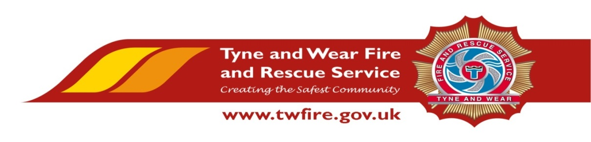
Health and Safety Advisor – Fixed Term until 31 July 2020
£29,636 + Benefits

We have an exciting opportunity for a talented and experienced Health and Safety (H&S) practitioner with the confidence and ambition to support the implementation of the Service’s H&S policy and the ability to influence others. If you are comfortable working in a fast paced, dynamic organisation and have the proven ability to provide competent and professional H&S related advice and guidance, we would be very interested to hear from you.

The diverse nature of activities undertaken by a metropolitan fire and rescue service offer a unique opportunity for a H&S practitioner to expand existing skills and develop expertise in new areas through a process of continued personal development.
The Role
Working within the H&S Team, the role involves coordinating with the internal managers and external stakeholders to enable the efficient and effective development, implementation and review of the Service’s safety management system.

The successful candidate will be capable of undertaking a range of functions including providing H&S related advice, undertaking risk assessments, inspections, audits, and accident and incident investigations. In addition they will analyse, interpret and report upon a range of information.
Required Skills/Experience:
- NEBOSH National General Certificate in Occupational Health and Safety.
- Significant experience within a H&S role.
- A minimum of IOSH technical membership, including substantial relevant experience providing a professional advisory service within an H&S function.
- Able to demonstrate an up to date IOSH continued personal development log (CPD).
- A recognised teaching or training qualification (i.e. Cert Ed/7304/6 PTLLS) or actively working towards and with significant experience of H&S related training delivery.
- Comprehensive knowledge of H&S legislation, associated approved codes of practice and other guidance, both in general terms and awareness of those relevant to the undertakings of a Fire and Rescue Service.
- A proven ability to interpret legal requirements and associated guidance in order to develop and implement effective H&S policy and procedure.
- Significant experience of undertaking risk assessments relating to a range of work activities and associated hazards.
- Significant experience of undertaking accident and incident investigation.
- Experience in conducting workplace inspections and audits and the creation of comprehensive reports with accompanying action plans.
- The development and delivery of effective user-friendly presentations to analyse and illustrate performance, and identify trends.
- Significant experience in the use of effective interpersonal skills and engagement at all levels, which facilitate delivery of organisational objectives.
- Good standard of IT skills and competent in the use of the entire Microsoft Office Suite.

What we can offer you

Tyne and Wear Fire and Rescue Service Headquarters (TWFRS) are based in a purpose built office accommodation in Washington, with ample free parking and easy access from the A1 and A19. On site facilities, include catering services and an on-site gym. The role also benefits from an attractive benefits package, including up to 41 days holiday, Local Government Pension Scheme, and access to a range of social and volunteering opportunities.

Closing date: Tuesday 24 September 2019 at 12 noon.
Interview: Friday 04 October 2019

Please visit https://www.twfire.gov.uk/work-for-us/ apply for this role

We positively welcome applications from all individuals within the community particularly those who are from under-represented groups.
Working towards equality and diversity for the community we serve.
