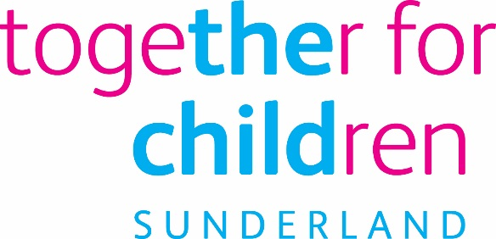
Job Description
Job Title: Early Help Worker- Targeted Youth Services-
PVH contract / Sessional
Salary Grade: Grade 3
SCP: 07 to 11
Job Family: People Care
Job Profile: PC2
Directorate: Early Help
Work Environment: Agile, office, Police stations and outreach
Reports to: Targeted Youth Services Team manager
Number of Reports: Several posts
This position requires an Enhanced Disclosure and Barring Service (DBS) Check.

Purpose:
To work directly with children and young people in community.
To undertake specific tasks at the direction of the designated manager to prevent the offending/re offending of children and young people.
To support Targeted Youth Services staff in delivering services for children & young people.
To improve outcomes for vulnerable children, young people and their families
Key Responsibilities:
To work directly with children, young people and families in community settings to provide support and interventions.
Outreach Support

- Supervise individuals or groups of young people
- To support young people in Police custody
- Support young people to attend appointments
- Complete any necessary paperwork and recording of engagement activities with children and young people
- Work with colleagues in Early Help, Children’s Social Care and Education Services to offer appropriate support to improve outcomes
- To act as an advocate for the Child’s Voice
- To champion and support the embedding of Mind of My Own across the City
- Support prevention and innovations service to deliver it’s aims and objectives.
- To champion diversity and equality

Safeguarding and Child Protection
- Follow Child Protection Procedures and liaise with the team around the child
- Develop professional, honest relationships with children, young people and families
Training
To attend all necessary training

Statutory requirements:
In line with the Together for Children’s Statutory Requirements, all employees should:
Comply with the principles and requirements of the General Data Protection Regulation (GDPR) in relation to the management of Together for Children Sunderland’s records and information and respect the privacy of personal information held by Together for Children Sunderland.
Comply with the principles and requirements of the Freedom in Information Act 2000;
Comply with the Together for Children Sunderland’s information security standards, and requirements for the management and handling of information;
Undertake the duties of the post in accordance with the Company’s Equal Opportunities Policy, Health and Safety Policy and legislative requirements and all other Company policies.

Author: Susan Flett
Date: 28/03/2022
Person Specification

Job Title: Early Help Worker- Targeted Youth Services

Essential Requirements

Qualifications:  - Level 3 or higher qualification in an appropriate discipline.  - Level 2 English (Grade C GCSE or equivalent)  - Level 2 mathematics (Grade C GCSE or equivalent) | Application Form/Interview
Experience of:  - Working with children, young people and their families  - Working in a challenging and pressured environment  - Working with a diverse range of people in an empowering and person-centred manner  - Working with a high degree of autonomy;  - The ability to manage expectations of different groups, including potentially conflicting demands and challenge to TfC and partner decisions around strategic objectives | Application Form / Interview
Knowledge and understanding of::  - The problems faced by children, young people and their families nationally, regionally and locally  - The legal framework pertaining to safeguarding and child protection  - Engagement methodologies, and equality and human rights legislation and policy, particularly around rights and inclusion | Application Form / Interview
Ability to:  - Work within regulations and agreements pertaining to confidentiality, information-sharing, GDPR, safeguarding  - Engage in meaningful professional relationships with children, young people and their families  - Communicate effectively with a range of audiences and in a variety of formats (verbal and written)  - Work flexibly and on own initiative  - Make decisions and problem-solve  - Recognise and respond appropriately to risk  - Respond professionally to high levels of challenge  - Offer support and guidance to team members when required | Application Form / Interview

Author: Susan Flett
Date: 28-03-2022

