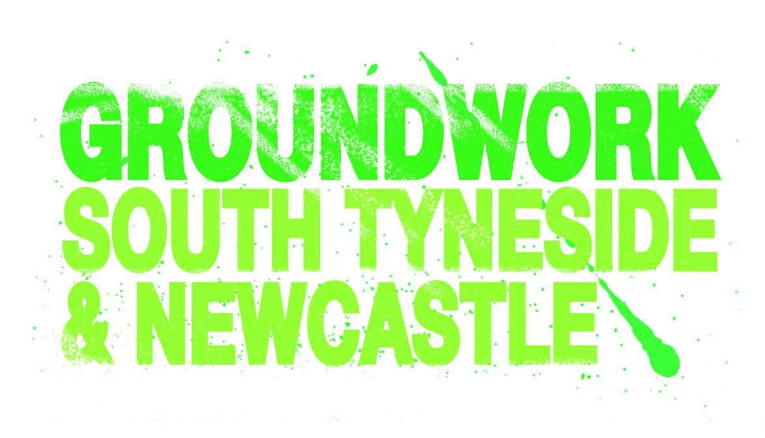

PERSON SPECIFICATION
Learning Support Assistant (LLDD)
 | ESSENTIAL | DESIRABLE
Education/ Training/Qualifications | - NVQ Level 2 Teaching Assistant / Care (or equivalent)  - Maths and English Level 2 (achieved or willing to work towards) | - NVQ Level 3 Teaching Assistant / Care (or equivalent)  - Food Hygiene and Safety Level 2  - MIDAS Minibus Driver Certificate
Experience | - Experience of working in a care or education environment.  - Experience of working with vulnerable adults or young people  - Experience of working with learners with learning difficulties and/or disabilities. | - Experience of providing in class support to students  - Experience of sharing good practice with others.  - Experience of OFSTED requirements.
Competencies | - Well developed communication skills (oral and written)  - Basic ICT Skills.  - Excellent interpersonal skills.  - Ability to motivate others.  - Able to look at a problem and produce  creative solutions.  - Ability to work effectively and sensitively with service users (families/carers, staff and professionals) | - Basic understanding of Autism / special needs.  - Knowledge of relevant legislative framework, including safeguarding procedures.  - Report writing skills.
Values and Attitudes | - Confidence and professionalism  - Focused and flexible.  - Calm manner with an appreciation of  a good sense of humour.  - Amicable and approachable.  - Team player with sound initiative.  - Enthusiasm.  - Empathy.
Additional Requirements | - This post is subject to a satisfactory Enhanced DBS check  - Committed to the ethos of Groundwork and its practices.  - Commitment to Health and Safety, Safeguarding and Prevent processes. | - A full driving license

 | ESSENTIAL | DESIRABLE
Education/ Training/Qualifications | - NVQ Level 2 Teaching Assistant / Care (or equivalent)  - Maths and English Level 2 (achieved or willing to work towards) | - NVQ Level 3 Teaching Assistant / Care (or equivalent)  - Food Hygiene and Safety Level 2  - MIDAS Minibus Driver Certificate
Experience | - Experience of working in a care or education environment.  - Experience of working with vulnerable adults or young people  - Experience of working with learners with learning difficulties and/or disabilities. | - Experience of providing in class support to students  - Experience of sharing good practice with others.  - Experience of OFSTED requirements.
Competencies | - Well developed communication skills (oral and written)  - Basic ICT Skills.  - Excellent interpersonal skills.  - Ability to motivate others.  - Able to look at a problem and produce  creative solutions.  - Ability to work effectively and sensitively with service users (families/carers, staff and professionals) | - Basic understanding of Autism / special needs.  - Knowledge of relevant legislative framework, including safeguarding procedures.  - Report writing skills.
Values and Attitudes | - Confidence and professionalism  - Focused and flexible.  - Calm manner with an appreciation of  a good sense of humour.  - Amicable and approachable.  - Team player with sound initiative.  - Enthusiasm.  - Empathy.
Additional Requirements | - This post is subject to a satisfactory Enhanced DBS check  - Committed to the ethos of Groundwork and its practices.  - Commitment to Health and Safety, Safeguarding and Prevent processes. | - A full driving license

