Discovery Special Academy
Background Information

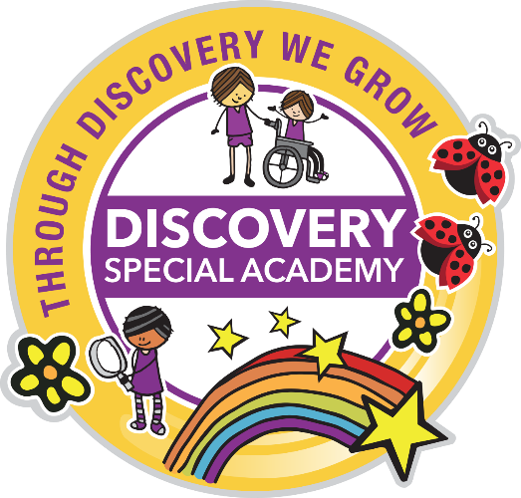

Discovery Special Academy caters for pupils age 4 – 11 with severe learning difficulties (SLD) and is an academy within the Tees Valley Education Trust.
The Academy is dedicated to delivering outstanding inclusive practice through a culture of co-production, experiential learning and growth where carers and professionals work together to support the holistic development of the child in which all therapies are an integral part of pupils’ education. This is reflected in our academy motto:
Through Discovery We Grow
Discovery Academy is committed to enhancing the lives of all the pupils in its care to enable them to secure the best possible life chances as they move through their educational career and beyond. We ensure pupils are confident, tolerant and resilient by offering a challenging and exciting curriculum through which they can take risks and grow with each and every learning opportunity.
Pupils at Discovery will work collaboratively and independently. This will allow them to develop high levels of self-esteem, communication and interaction across the day through both learning and therapies. In this way, all pupils will be supported to reach their full potential and develop the life skills they need.
Therefore, the principles of the Discovery Special Academy are to achieve excellence and enjoyment for all by building a learning community that ensures all pupils are well supported, can reach their personal potential and are equipped with the necessary life skills they need to become effective citizens of the 21st century.
We look forward to welcoming you to Discovery Special Academy to be part of this exciting opportunity to build the future of the Discovery community.
Please visit https://www.discoveryspecialacademy.org.uk/ for further information about the academy.
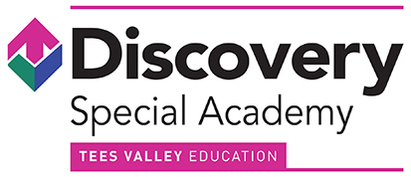
Miss J Duncan
Head Teacher

