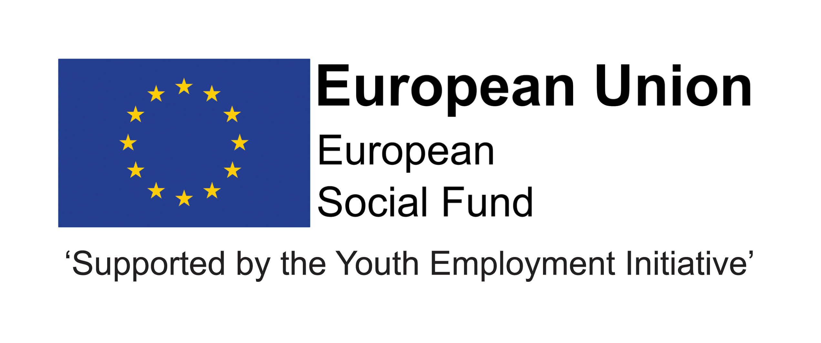

JOB DESCRIPTION

Children and Young People’s Services

 | POST TITLE: Programme Support Officer
- 2. | POST NUMBER:
- 3. | GRADE: 9  Job Evaluation Ref No: N9074
 | LOCATION: Your normal base will be at the Civic Centre, Crook. However you will be required to work at any council workplace within County Durham; in a range of schools, colleges and independent private providers; and across the North East region and beyond.

- RELEVANT TO THIS POST:
This post is funded until July 2021 through the ESF/YEI DurhamWorks project.

This post is funded through ESF and the Youth Employment Initiative (YEI) as part of the 2014-2020 European Structural and Investment Funds Growth Programme in England. The YEI/ESF funding will end in July 2021.

Flexible Working: Subject to service needs, the Council’s flexible working policy is applicable to this post. The post holder may be required to work outside of normal hours.

- ORGANISATIONAL RELATIONSHIPS:
The post holder will be accountable to the External Programme Manager within the Adult Learning and Skills Service and will provide line management for the Administration Co-ordinator and lead a team of administration staff and apprentices responsible for the efficient and effective running of the programme. The Programme Support Officer will establish positive working relationships with other DCC services and a wide range of partners and stakeholders and lead other support functions for the programme.

- DESCRIPTION OF ROLE:
The post holder will be an experienced manager who will play a key role in the efficient and effective delivery of the ESF programme, which seeks to support young people/adults to improve their education and skills and move into employment, training or further education.

- DUTIES AND RESPONSIBILITIES SPECIFIC TO THIS POST:
Listed below are the responsibilities this role will be primarily responsible for:

- Programme administration –
  - Line managing the Administration Co-ordinator and leading a team of administration staff and apprentices responsible for the efficient and effective administration of the programme.
  - Working closely with the Data Officer, lead the development, implementation and review of effective administration processes and systems to support the delivery of the programme and compliance with external and internal audit.
  - Maintaining effective and up to date expertise around the programme’s Management Information Systems.
  - Implementing and reviewing the processes for the efficient handling, storage and retrieval of paperwork to ensure compliance with ESF regulations.
  - Leading the implementation of special events/projects including the DurhamWorks Achievement Awards, working closely with the Marketing and Communications Officer.

- Audit and procurement -
  - Developing excellent working relationships with internal colleagues including Procurement, Internal Audit and Funding and Programmes.
  - Leading on the preparation for, and co-ordination of, external and internal audits, working closely with the External Delivery Co-ordinator and Senior Finance Monitoring Officer.
  - Maintaining a detailed understanding of DWP/ESF/DCC audit requirements to ensure full compliance.
  - Working with other DurhamWorks managers and Contract Officers, Corporate Procurement, stakeholders and partners to develop specifications and successfully procure services that support the effective delivery of the programme.

- Cross cutting themes –
  - Leading the development of cross-cutting themes (Sustainability and Gender Equality and Equal Opportunities) within the programme.
  - Engaging with appropriate groupings of Delivery Partners/sub-contractors/participants to develop strategies and embed action plans for the cross cutting themes.

- General –
  - Contributing to programme-wide performance and sharing of good practice.
  - Preparing and presenting reports on progress.
  - Commitment to continuous professional development.

The above is not exhaustive and the post holder will be expected to undertake any duties which may reasonably fall within the level of responsibility and the competence of the post as required by the Service.

9. COMMON DUTIES AND RESPONSIBILITIES:

9.1 Quality Assurance
To set, monitor and evaluate standards at individual, team performance and service quality so that the user and the Service’s requirements are met and that the highest standards are maintained.
To establish and monitor appropriate procedures to ensure that quality data are reported and used in decision making processes and to demonstrate through behaviour and actions a firm commitment to data security and confidentiality as appropriate.

9.2 Communication
To establish and manage the team communications systems ensuring that the Service’s procedures, policies, strategies and objectives are effectively communicated to all team members.
9.3 Professional Practice
To ensure that professional practice in the team is carried out to the highest standards and developed in line with the Service’s stated objectives of continual improvement in quality of its service to internal and external customers.
9.4 Health and Safety
Manage health and safety in their area of responsibility in accordance with the relevant section(s) of the Corporate/Service Health and Safety Policy and to ensure that the Health and Safety policy, organisation arrangements and procedures as they relate to areas, activities and personnel under your control are understood, implemented and monitored.
9.5 General Management (where applicable)
To provide vision and leadership to staff within a specialist team, ensuring that effective systems are in place for workload allocation and management, the application of the Authority’s and the Service’s policies and procedures, including those relating to equality, supervision and appraisal and all aspects of their performance, personal development, health and welfare.
9.6 Financial Management (where applicable)
To manage a designated budget (as required) ensuring that the Service achieves value for money in all circumstances through the monitoring and control of expenditure and the early identification of any financial irregularity.
9.7 Appraisal
All members of staff will receive appraisals and it is the responsibility of each member of staff to follow guidance on the appraisal process.
9.8 Equality and Diversity
As an organisation we are committed to promoting a just society that gives everyone an equal chance to learn, work and live free from discrimination and prejudice. To ensure our commitment is put into practice we have an equality policy which includes responsibility for all staff to eliminate unfair and unlawful discrimination, advance equality of opportunity for all and foster good relations.

These policies apply to all employees of Durham County Council.
9.9 Confidentiality
All members of staff are required to undertake that they will not divulge to anyone personal and/or confidential information to which they may have access during the course of their work.
All members of staff must be aware that they have explicit responsibility for the confidentiality and security of information received and imported in the course of work and using Council information assets. The Council has a Personal Information Security Policy in place.

9.10 Induction
The Council has in place an induction programme designed to help new employees to become effective in their roles and to find their way in the organisation.

PERSON SPECIFICATION: - Grade 9 – Programme Support Officer
 | Essential | Desirable | Method of Assessment
Qualification | - Minimum Level 4 qualification. | - Degree in relevant subject | - Application form  - Selection Process  - Pre-employment checks.
Experience | - Experience of managing teams  - Experience of implementing administrative systems  - Experience of managing internal and external audits and implementing findings  - Experience of managing procurement processes  - Range of experience in implementing successful projects to timescales and achieving targets  - Proven track record of working with partners to effect change  - Experience of managing externally funded programmes  - Experience of contract management  - Experience of using action planning to drive performance and quality. |  | - Application form  - Selection Process  - Pre-employment checks.
Skills/Knowledge | - Ability to manage staff and develop a strong team  - Knowledge of audit, procurement and administrative processes and regulations  - Excellent communication skills  - Contract management skills  - Operation of externally funded programmes  - Concise and accurate verbal and written reporting skills  - Able to work effectively in a team, but also capable of individual initiative  - Excellent ICT skills including the use of Microsoft Office and Management Information systems. | - Understanding of European grant programmes  - Knowledge of programme management software. | - Application form  - Selection Process  - Pre-employment checks.
Personal Qualities | - Has drive, enthusiasm and a flexible approach to work  - Able to plan work and manage time effectively  - Able to motivate self and others  - Able to work effectively in a team  - Able to carry out work with the minimum of supervision  - Able to relate well and quickly to other team members and senior people from other organisations  - Must be performance oriented i.e. motivated by a desire to achieve performance targets and deliver a quality service  - Flexible approach to working across the LA geography. Current valid driving licence required or access to a means of mobility transport  - Able to work under pressure, to prioritise and to meet deadlines  - Pays attention to detail  - Open to change and committed to innovative development  - Holds high aspirations for young people/young adults. |  | - Application form  - Selection Process  - Pre-employment checks.

