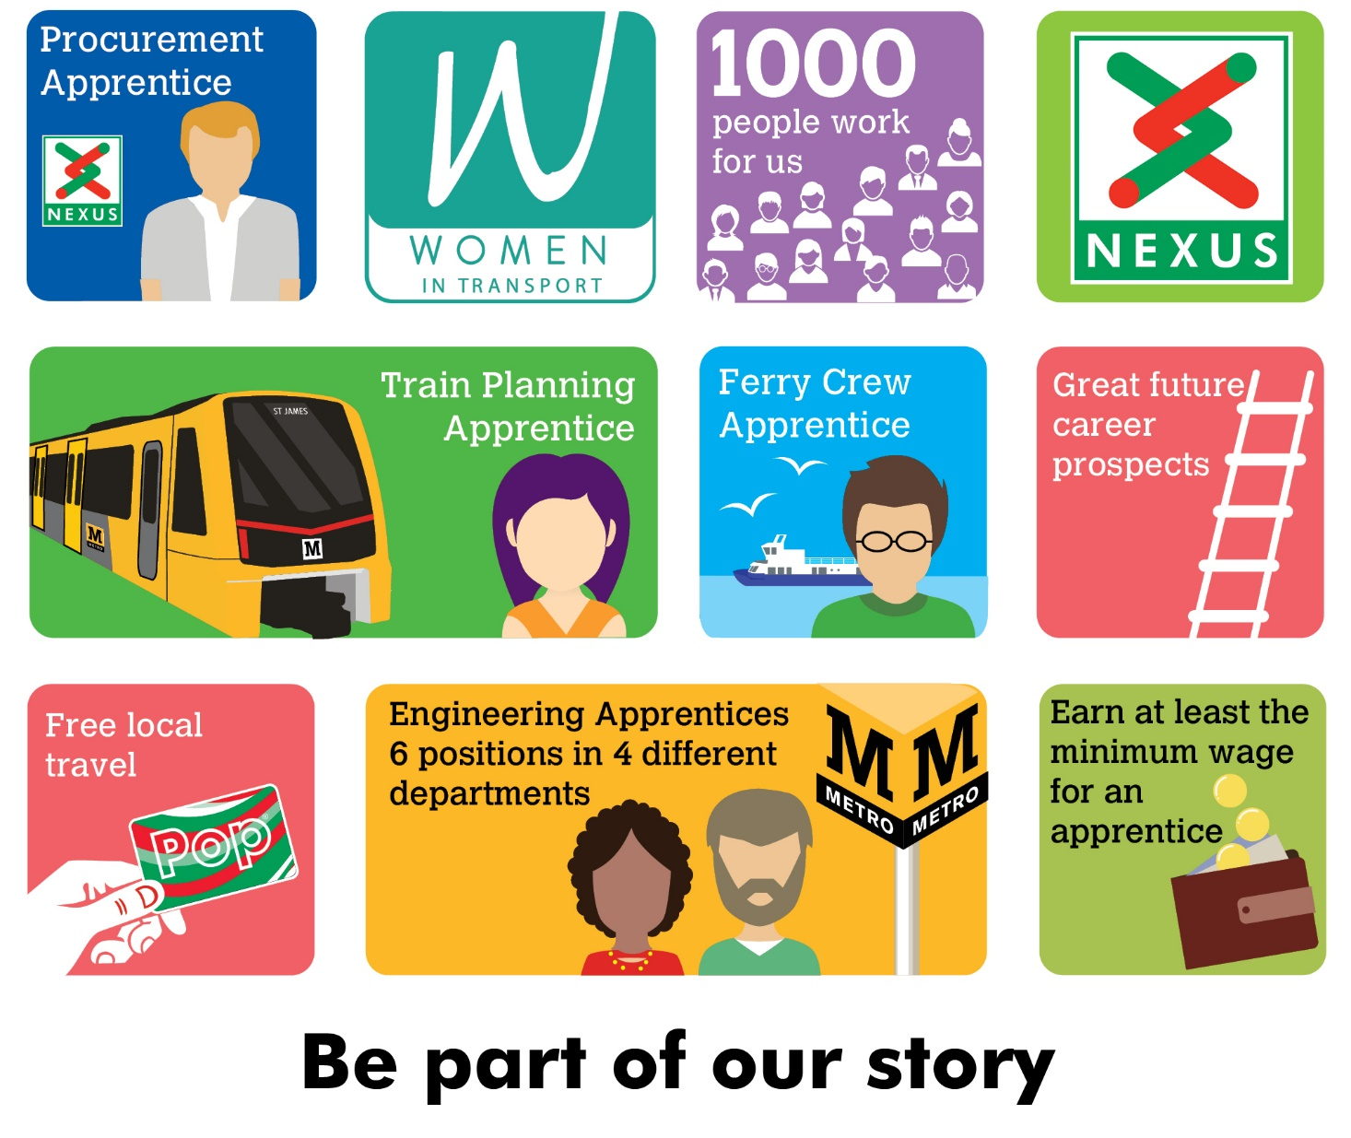
Train Planning, Performance and Resources Apprentice
Nexus is looking to recruit a Train Planning, Performance and Resources Apprentice to join the team in the Metro Operations directorate at Nexus.
You will spend time engaging and developing skills within these three departments. During your apprenticeship you will learn how to develop timetables for the Metro system that are focused on improving the customer journey experience by operating efficiently and offering better journey times. You will also learn how to plan the use of trains across the network and resource the service provision accordingly in line with relevant agreements, policies and processes. This ensures the safe operation of the Metro system.
The knowledge and experience you will gain within Planning and Resource will allow you to understand how this links in with Metro performance. This aspect of the role involves reviewing the performance of the Metro system through the analysis of large amounts of data, gain insight into any trends forming and identify opportunities for improvement.
The successful candidate will have great attention to detail and enjoy working with numbers with an eagerness to learn to learn new skills.
Salary - Age dependant (not less than Apprentice minimum wage)
Plus, defined benefit pension scheme, free local travel and access to other benefits.
Closing date 5th June 2022
Find out more at nexus.org.uk

