Villiers Street South
Sunderland
Tyne and Wear
SR1 2AH
Tel: (0191) 5143434
Email: hudson.road.primary@schools.sunderland.gov.uk

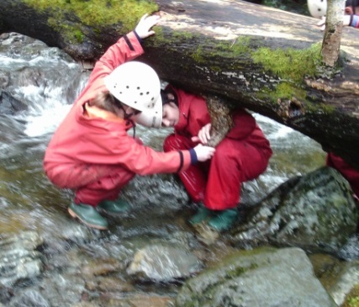
__________________________________________________________________________________________________________________

Headteacher: Mrs C. Westgate BA Hons M.Ed
Chair of Governors: Mr S. Henry

Dear Applicant

Thank you for expressing an interest in the Deputy Headteacher post at Hudson Road Primary School. I hope that you will find the following information useful when considering your application.

At Hudson Road Primary School we strive to achieve the following:
- everyone working together to ensure that we promote learning and achieve the highest standards for every child through high expectations and high quality teaching;
- the provision of a rich pupil led curriculum that is enjoyable, inclusive, stimulating and challenging and which allows everyone to meet their full potential and develop skills for life;
- for our school to be at the heart of the community, providing a safe, secure and respectful environment which enables pupils to develop emotionally, physically, socially and academically.

Hudson Road Primary serves a vibrant, inner city area. Currently there are 311 pupils on roll from nursery through to Y6 as well as Bright Stars childcare which includes provision for 0-4 year olds. We are the hub of the Sunderland East Children’s Centre hosting a range of community activities.
We have a creative, child centred, inquiry led curriculum that includes
regular visits to the many city attractions ‘on our doorstep’ as well as
travelling further afield. Our core values underpin our school ethos
and curriculum: principles of respect, high expectations, understanding
of rights and responsibilities, curiosity and a sense of belonging and
purpose.

We are looking for an innovative and dedicated Deputy Headteacher to join our hard-working staff and children and make a significant contribution to the further development of our friendly and caring school. You will be warmly welcomed into our highly committed and motivated team.

Please find attached a person specification and job description highlighting the areas of expertise and skills which we hope that the appointed person will be able to offer.

Visits to the school, led by the Headteacher and a representative from the governing body, are warmly welcomed. Visits are available at 1.30pm on Wednesday 20th February 2019, 4.30pm on Wednesday 27th February 2019 or 1.30pm on Friday 1st March 2019. If you would like to come along to find out about our school, please contact Angela Carling by telephone: 0191 5143434.

We will be shortlisting on Monday 18/3/2019 and plan to interview for this post on Tuesday 2/4/2019.
Shortlisted applicants will be invited to interview by telephone and details of the interview process will be sent by email and follow up letter. Please ensure you include a telephone contact number and email address in your application.

The Governing Board of Hudson Road Primary School and Sunderland City Council are committed to safeguarding and promoting the welfare of children, young people and vulnerable adults. The Headteacher is expected to share this commitment and must ensure that the highest priority is given to following the guidance and regulations to safeguard them. This post is exempt from the Rehabilitation of Offenders Act 1974 and therefore applicants will be subject to appropriate background checks and vetting including an enhanced DBS check and checks against the children’s barred list. At minimum of two references are required prior to the commencement of employment. Additional references may be requested.

Application packs are available to download from NE Jobs or by contacting the HR team at Together for Children (0191 561 7233). Please return completed applications to: hradmin@togetherforchildren.org.uk

The closing date for applications is 12.00pm noon on Tuesday 12/3/2019.

This will be a satisfying and rewarding role for the right applicant. We look forward to receiving your application.

Yours sincerely Yours sincerely

Mrs Cathy Westgate Mr Simon Henry
Headteacher Chair of Governors
Hudson Road Primary School Hudson Road Primary School

