Secondment opportunity - Frontline Consultant Social Worker (CSW)

What is Frontline?
Frontline is an intensive social work qualifying programme which offers people the opportunity to train on the job as child protection social workers. Participants on the programme work in units of four, which are managed by a Consultant Social Worker.

What is a Consultant Social Worker?
Consultant Social Workers (CSWs) are vital to the Frontline model. Each CSW is responsible for four participants who are undertaking their Postgraduate Diploma in Social Work. CSWs work with participants using a unit model approach – a systemic practice model for working with families, with cases managed through weekly unit meetings. These meetings provide a dynamic learning environment and a reflective space to think systemically about the cases in your unit. The role offers those who wish to remain in practice the opportunity to do so alongside the chance to take on supervisory and management responsibility for a small team. For more information about what a day in the life of a CSW looks like, take a look at our website here.

What will I get from being a CSW?
- An exciting opportunity for experienced practitioners to remain in practice whilst also taking on a management and teaching role
- Access to a high quality training programme and the opportunity to work towards a Foundation level in Systemic Practice
- Access to 1:1 coaching and mentoring from a Practice Tutor
- Be part of a national network of CSWs contributing to innovations in practice and broader social work reforms
- CSW continuing in the role for two or more years will also become part of the Frontline Fellowship

How to apply
You may find the application and recruitment process for the CSW role is different to previous social work roles you have applied for. Please do not let that deter you from applying for the role.

Stage one - Application form and video interview.
If you would like to apply for the role, you will need to-
- Complete a standard local authority application form (you do not need to complete the additional information section)
- Take part in a video interview. Please email joanne.ormston@thefrontline.org.uk who will send you a link to the access the video interview. The link will take you through a step by step process of how to set up the software well as giving you tips on how to prepare. You will be asked 5 questions and given between 1 and 2 minute to record each answer. There is also some time to think through and plan your answer. The video interview recording will then be sent to us for shortlisting.

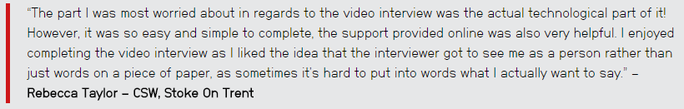
Stage two - Assessment day.
Shortlisted candidates are invited to an assessment day where you will have the opportunity to demonstrate your skills in different contexts. We have found traditional interviews alone do not always show candidates in their best light; but our assessment day activities really give you the chance to show us all your strengths. You will complete various activities including:
- a panel interview
-a written activity
-a listening activity
-a role-play activity
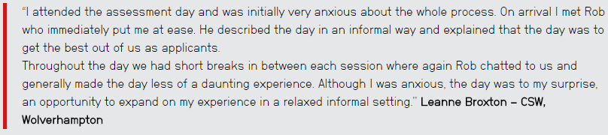

If you would like any further information about the role and application process there is a lot more information at our website here, or please contact Hazel Ostle, e-mail: hazel.ostle@durham.gov.uk Tel: 03000 262 306 or Joanne Ormston, joanne.ormston@thefrontline.org.uk, Tel: 07800 954 892.

There will also be an information session where you will have the opportunity to meet with the Frontline team and hear from a current CSW about the role.

Date: Friday 26 January 2018
Time: 2:00pm – 4:00pm
Venue: Durham Leadership Centre, Enterprise Way, Spennymoor, DL16 6YP

To book your place please e-mail socialworkcareers@durham.gov.uk

