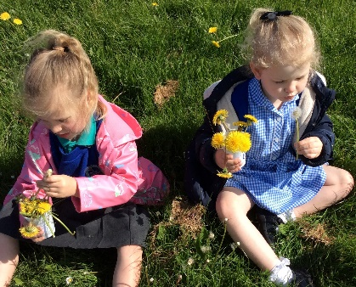
Dormanstown Primary Academy is a thriving learning community of 270 pupils aged 3-11. Our context is challenging, serving an area of socio-economic deprivation. A high proportion of our children are eligible for the pupil premium. We are unusual in that we have three high needs SEND classes. These are tailored to the needs and age range of pupils, who come to Dormanstown both from our catchment area and Redcar and Cleveland as a whole. Our inclusive ethos allows us to integrate our pupils as much as possible, and has created a nurturing environment that enables children to be successful learners. Central to this is our focus on excellent behaviour for learning, with children given clear and consistent expectations regarding their behaviour. Our school mascot, Honker the Goose, teaches us all the value of teamwork.
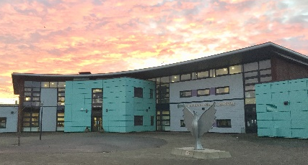
We aspire to equip children to become successful members of the community. We have a strong focus on improving standards in maths and English, so that our pupils transfer to secondary school with the necessary skills to succeed. Our commitment is to provide children with an excellent academic education, as well as a broad and balanced range of experiences. Our new building has been designed in such a way that every area can be used as a learning tool, from the corridors to the carefully planned outdoor spaces. A significant ICT investment has equipped our pupils with iPads, laptops and Kindles to engage learners and has further enhanced our creative curriculum.
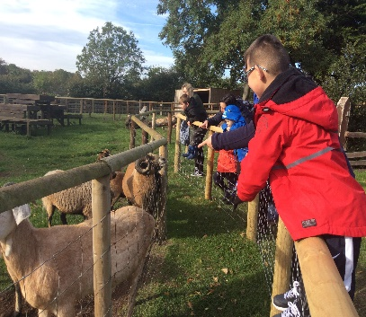
We work as part of Tees Valley Education, a Trust that has been operating since September 2015. We work very closely with our partner academies: Brambles, Pennyman, Wilton and Discovery. This gives us the opportunity to develop best practice and deliver improved outcomes for our children. It also allows us to ensure that all our staff receive high quality CPD to support them in achieving their professional goals.

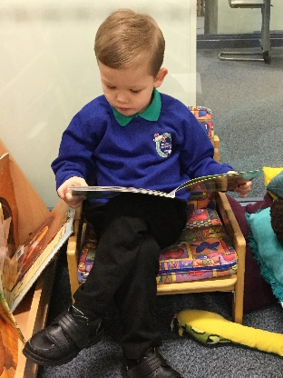
The vision for Dormanstown is ambitious, and presents a significant challenge, but we are already a long way into this journey. With inspirational pupils who share a love of learning, a passionate staff team and the resources of the TVEd Trust professionals, we are determined to ensure that our children are given every opportunity to fulfil their potential.

