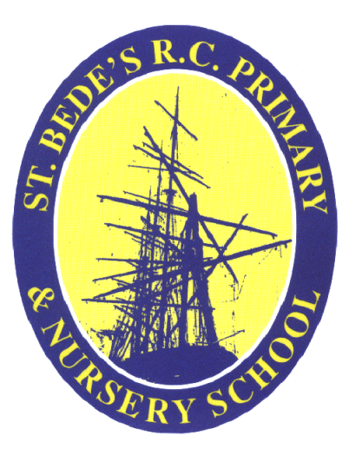
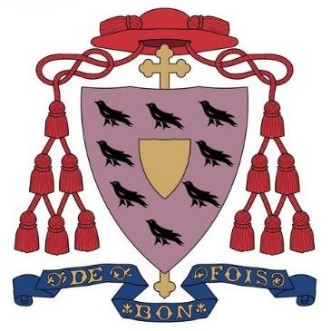

BISHOP CHADWICK CATHOLIC EDUCATION TRUST
JOB DESCRIPTION
POST TITLE: Lunch Time Supervisor
GRADE: 1 – SCP 3
RESPONSIBLE TO: Headteacher of St. Bede’s Catholic Primary School
This appointment is with the governors of the school under the terms of the Catholic Education Service contract signed with the governors as employers.
KEY AREAS OF RESPONSIBILITY
To ensure the well-being of all pupils.

To be responsible for the supervision and control of pupils during lunchtime.

To support school behaviour management by supervising areas of the school during lunchtimes and providing activities to divert pupils from engaging in behaviour that does not meet the standards required.

MAIN TASKS
- Supervise the washing of hands of pupils.
- Supervise entry/exit into/from the dining hall by the pupils.
- Assist pupils during the meal service.
- Clear up all spillages during mealtime promptly.
- Assist in wiping up trays, tables, chairs when necessary at end of the meal.
- Ensuring Health and Safety and other school procedures are observed, reporting of incidents/accidents and taking actions as required.
- Maintain accurate and relevant incident / accident records.
- Support the Leadership Team with evacuation procedures, if necessary.
- Raise safeguarding concerns appropriately.
- Be aware of individual pupil circumstances – i.e. – food allergies and medical conditions
- Adhere to all current Covid requirements
- Ability to be firm but fair at all times.
- Willingness to maintain confidentiality on all school matters
- Ensure pupils maintain high standards of behaviour, reporting any cases of misbehaviour, especially bullying, as appropriate.
- Supervision of children in designated areas ensuring good conduct in behaviour in accordance with the school’s behaviour policy.
- Initiate games and activities where appropriate, whilst maintaining broad supervision.
- Supervise children in classrooms during inclement weather.
- Engage pupils in safe, enjoyable, and creative activities.
- Perform basic first aid for minor incidents/accidents.

The successful candidate will also be required to attend any training courses relevant to the post, ensuring continuing, personal and professional development.

They must present themselves as a role model to pupils in speech, dress, behaviour and attitude, provide pastoral care and support to sick and injured children taking appropriate action as necessary ensuring parents and school staff are fully informed of incidents and accidents.

The Post holder may undertake any other duties that are commensurate with the post.

