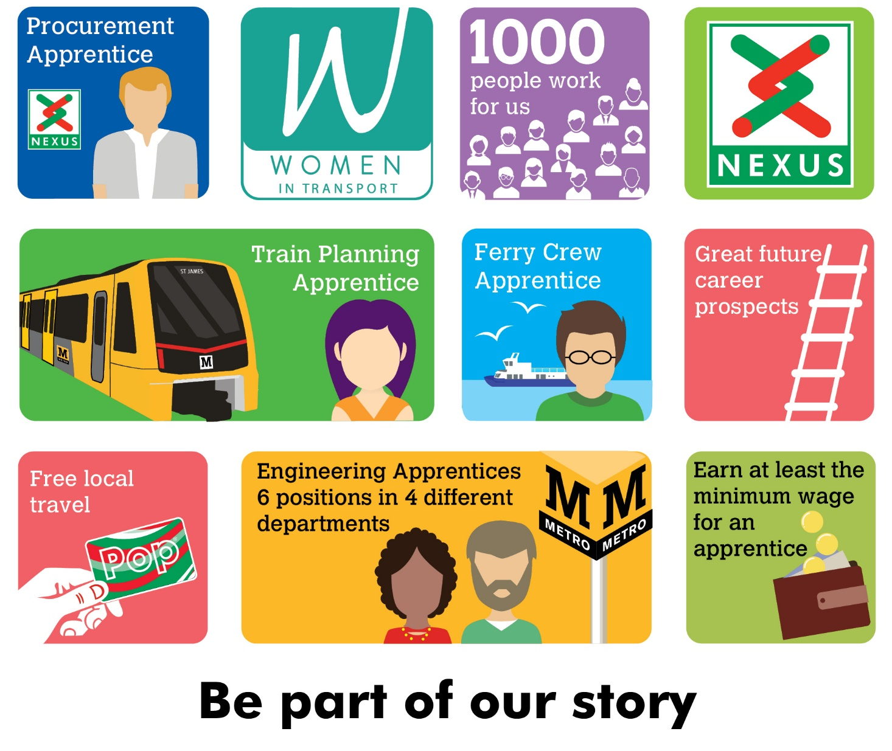

Nexus is looking for an Apprentice to join the South Shields Ferry team.

As a Ferry Crew Apprentice, you will become a fully trained crew member, working towards your Boat Master License, through classroom and work environment learning.

You will be trained to the Maritime Coastguard Agency Standard, preparing you for life on the river. You will learn all aspects of crewing the vessel, as well as working towards your Boat Masters License, which will enable you to take charge of a Class V passenger vessel. You will also gain excellent customer service skills by engaging with Nexus customers taking their daily journeys across the River Tyne. The successful applicant will have an outgoing personality and an eagerness to learn, with a passion for the marine environment.

You must be a minimum of 18 years of age, reaching the age of 20 within 20 months of the start of your apprenticeship. (Be 20 years of age by April 2024).

Salary - Age dependant (not less than Apprentice minimum wage)
Plus defined benefit pension scheme, free local travel and access to other benefits.
Closing date 5 June 2022
Interviews are scheduled to take place on 28 June 2022
Find out more at nexus.org.uk

