Job Title: Health and Safety Officer  Purpose: To provide health and safety support and guidance across all areas of the Nexus business | 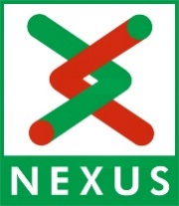

Person Specification

Date: November 2020

Essential Criteria
EDUCATION | Essential (E) or Desirable (D)
Educated to degree level or equivalent | D
NEBOSH National General Certificate or equivalent | E
Recognised safety qualification to Diploma level or equivalent | D
SPECIFIC KNOWLEDGE
Extensive knowledge of all aspects of health and safety legislation | E
Knowledge of health and safety risks specific to public transport (road, rail and inshore maritime) sector | D
Extensive knowledge and experience of working within Safety Management and Safety Assurance | E
SKILLS & COMPETENCIES
Good written and verbal communication skills | E
Good organisational skills, with ability to work on own initiative | E
Good analytical skills, with experience of investigation and reporting on significant incidents and accidents, and undertaking audits | D

EXPERIENCE
Experience of providing H&S advice in a complex, multi-disciplined, multi-site organisation | D

