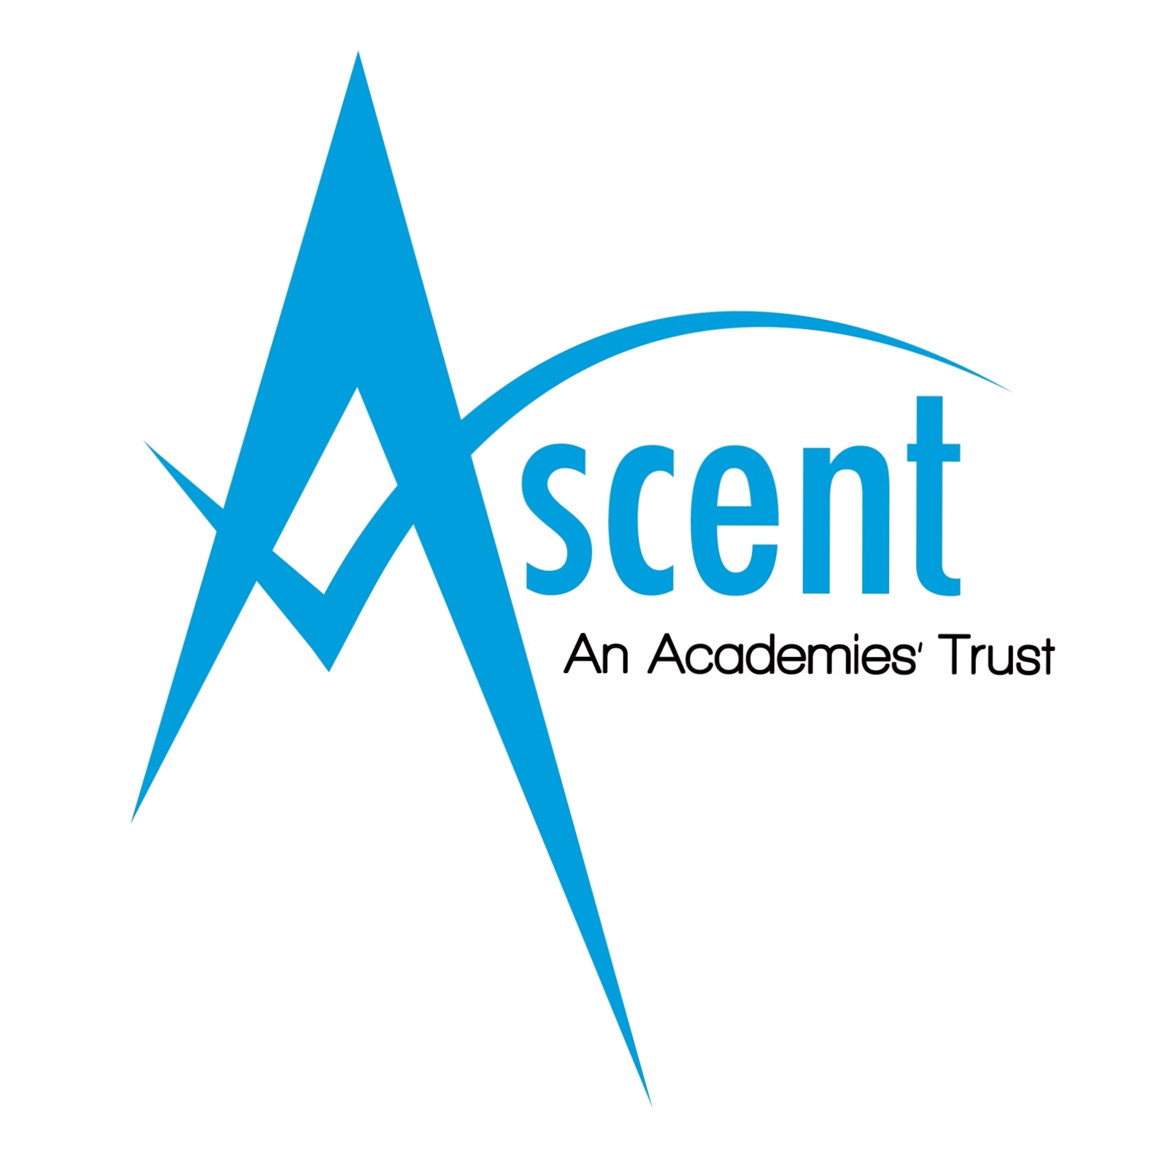

The Ascent Academies Trust
Weymouth Road
Sunderland
SR3 2NQ
Tel 0191 5536050

The Ascent Academies’ Trust is a partnership of five special academies in the North East, which provides and develops special needs provision across the region.

Post: Temporary Assistant Site Supervisor (casual) – 3 posts
Grade: Grade C, PT11 – PT13
Salary: £8.19 - £8.55 per hour plus holiday plusage and premium for weekend working
Hours: Minimum 20 hours per week + 1 Saturday per month - 2 posts
Minimum 10 hours per week - 1 post

The Trust are looking to add capacity to the Trust’s site maintenance team and recruit a number of Assistant Site Supervisors to work in the academies. Duties include opening the site and grounds of the relevant academies and ensuring they are maintained at all times, providing a safe, clean and healthy environment for pupils, staff, visitors and other users of the site facilities.

The posts will involve working on a rota / shift pattern consisting of early and late shifts including week days and weekends. These are casual posts which have a minimum number of hours per week, but the post holders must be flexible to undertake additional hours as and when required. There are 2 posts for academies in the northern region of the Trust and 1 post for the southern region.

Post holders will be required to work across a number of academies as part of the rota. The weekend work will include both Barbara Priestman and Portland Academies.

Candidates will possess a minimum of GCSE A*-C or equivalent in Maths and English, and must be able to travel to and between sites.

Further information can be sought from Andy Hall, Facilities Manager, Tel 0191 5536050 or email ahall@ascenttrust.org

The Trust is committed to safeguarding and promoting the welfare of children and young people with Special Needs and expects all staff and volunteers to share this commitment. This post is exempt from the Rehabilitation of Offenders Act 1974 and therefore will be subject to a DBS check from the Disclosure and Barring Service.

An Application Form, Job Description and Person Specification can be downloaded from the website www.ascenttrust.org listed under job vacancies. Completed applications are to be returned via email to HR@ascenttrust.org or direct to Human Resources, Portland Academy, Weymouth Road, Sunderland SR3 2NQ,

Closing date: Thursday 15th March at 12 noon
Interviews: Friday 23rd March

