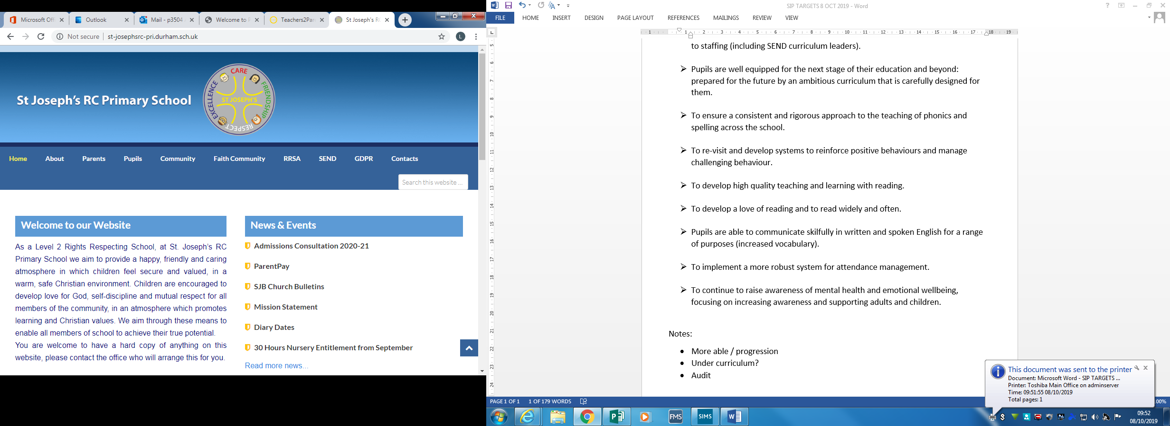

Supervisory Assistant

Person Specification

|  |  |  |  |
| --- | --- | --- | --- |
|  | **Essential** | **Desirable** | **Sources** |
| **References** | Fully supported in reference. |  | References |
| **Qualifications** | Willingness to learn and undertake further training. | First Aid certificate. | Application form  References |
| **Education** | Basic literacy and numeracy skills to be able to write accident reports, read medical information and instructions |  | Application form  References |
| **Knowledge/Experience** | Knowledge and ability to organise games and activities for pupils both inside and outside.  Evidence of working as part of an effective team.  Ability to promote and achieve high standards of behaviour from pupils in a friendly but firm manner. | Previous experience caring for/ working with children aged 4-11 years.  Experience of working in a school environment either in a paid or voluntary capacity. | Interview  Application Form  References |
| **Personal Qualities and Skills** | Support the school’s Catholic ethos.  Demonstration of positive attitudes towards pupils.  Patient and caring towards all children.  Recognition of the needs of SEN children and the ability to promote good playtime behaviour.  Good communication.  Good relationships with all staff.  To be able to work as part of a team.  Self-motivated, reliable and hard working.  Calm positive and flexible approach to work.  Awareness of confidentiality.  Enthusiastic, courteous and polite approach.  Ability to present oneself as a positive role model to pupils through dress, speech and attitude.  Good timekeeping.  To be able to work under pressure  Patience and emotional resilience in working with challenging behaviours  Use own initiative | Basic understanding of child development and learning.  An understanding of children with additional needs.  Good behaviour management strategies. | Interview  Application Form  References |
| **Disclosure of Criminal**  **Record** | Enhanced DBS check confirming suitability to work with children (school will arrange this). |  | Disclosure and Barring Service check |