 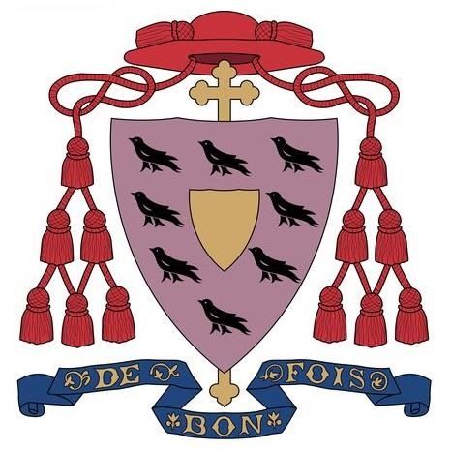

**ST JAMES’ CATHOLIC PRIMARY SCHOOL PART OF**

**THE BISHOP CHADWICK CATHOLIC EDUCATION TRUST**

**JOB DESCRIPTION**

**Job Title:** Administrative Assistant

**Band:** RLW – £21,029 (whole time salary) £7,214 (pro-rata salary)

**Hours:** 15 hours per week Term time only

**Job Location:** St James Catholic Primary School

**Responsible to:** Headteacher

**Purpose of Job:**

* Under the instruction/guidance of senior staff provide general administrative/financial support to the School, maintaining confidentiality at all times.

**Main Duties:**

**Organisational**

* Undertake reception duties and hospitality, answering general telephone and face to face enquiries and signing in visitors.
* Assist with pupil first aid/welfare duties, looking after sick pupils, liaising with parents/staff etc.
* Assist in arrangements for schools trips, events etc.

**Administration**

* Provide general clerical and administration support eg photocopying, filing, complete forms, respond to routine correspondence.
* Maintain manual and computerised records/management information systems
* Produce lists/information/data as required eg pupils data
* Support the Office Manager in all administrative duties.
* Undertake typing and word-processing and other IT based tasks
* Sort and distribute mail

**Resources**

* Operate relevant equipment/ICT packages (eg word, excel, databases, spreadsheets, Internet, SIMS)
* Maintain stock and supplies, cataloguing and distributing as required.
* Operate and record dinner money and all other school sales eg uniform, concert tickets, etc
* Provide general advice and guidance to staff, pupils and others

**Responsibilities**

* Be aware of and comply with policies and procedures relating to child protection, health, safety and security, confidentiality and data protection, reporting all concerns to an appropriate person.
* Be aware of and support difference and ensure equal opportunities for all
* Contribute to the overall ethos/work/aims of the school
* Appreciate and support the role of other professionals
* Attend and participate in relevant meetings as required
* Participate in training and other learning activities and performance development as required.
* Provide support and guidance and supervision to staff that may come under your responsibilities.

The post holder must promote and safeguard the welfare of the children and young people that they are responsible for, or come into contact with. The post holder must act in compliance with data protection principles in respecting the privacy of personal information held by the school/trust. The post holder must carry out their duties with full regard to the Trust’s Code of Conduct, Safeguarding Policy and all other Trust Policies.

The above list is not exhaustive and other duties may be attached to the post from time to time. Variation may also occur to the duties and responsibilities without changing the general character of the post.