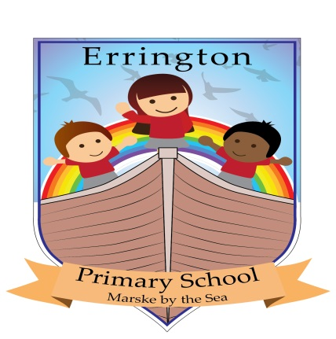
ERRINGTON SCHOOL VISION
VALUE STATEMENT
The ethos of our school is based on care, trust and honesty. The key values we hold are the consideration and feelings of others, respecting each other and a high appreciation and expectation of what we have around us.
MISSION STATEMENT
Errington Primary strives to meet the needs of all children in our care. Learning to us is about children feeling enjoyment and confidence so that they experience greater opportunities and take a natural ownership to discover, challenge and be creative in all aspects of their learning. We aim to engage and capture the interest of children through our inspiring curriculum, which enhances key skills and has a strong emphasis on international, social, emotional and physical attributes.
Our children love to learn and talk about learning.
ERRINGTON AIMS TO:
We aim to help all children reach their full potential and raise standards through meeting needs. Offering an inspiring and motivational curriculum, which children enjoy, are challenged and can experience enriched inclusive opportunities.
We aim to ensure children have self- confidence and independence in learning and can apply key skills in literacy, mathematics and other subjects.
We aim to have children who care and consider others, developing strong social and emotional values and a clear sense of people’s ways of life and beliefs.
We aim to create an ethos of positive behaviours where children can flourish in self- confidence and can deal with or provide solutions to challenges and changes they may come across in life.
We aim to create an environment of equal opportunity where children can enjoy and have personalised programs of support to offer success and involvement from parents and the community.

