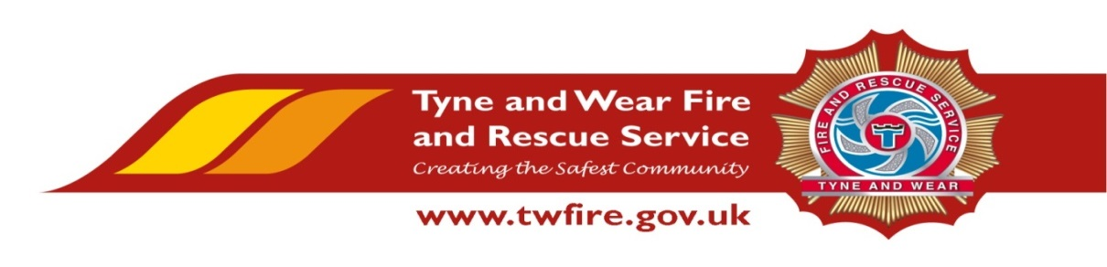

Multi Media Technician – (E-Learning)
Starting salary of £24,799 + Benefits

We have an exciting opportunity for a talented and experienced Multi Media Technician,
(E-Learning).

The Role:
Under the guidance of the Learning and Organisational Development Manager, to undertake the support and delivery of duties within the function which contribute to the provision of an excellent service, whilst ensuring the effective use of resources. To support department managers in the delivery of exceptional services to our community and key stakeholders.
The Service values and respects the diversity of its employees, and aims to recruit a workforce that represents the communities we serve. We welcome applications irrespective of people’s race, disability, gender, sexual orientation, religion or belief, age, gender identity, marriage and civil partnership, pregnancy and maternity.
Required Skills/Experience:
- Proven experience in developing e-learning training packages.
- Experience of Multimedia design and web development.
- Experience of using software such as Photoshop, Flash, After Effects, Adobe Captivate Articulate Storyline and HTML.
- Knowledge of web development principles and copyright law.

What we can offer you
Tyne and Wear Fire and Rescue Service Headquarters are based in a purpose build office in Washington, with ample free parking and easy access from the A1 and A19. On site facilities include catering facilities and an onsite gym. The role also benefits from an attractive package, including up to 22 days holiday and public holidays, Local Government Pension Scheme and access to a range of social and volunteering opportunities.

Closing Date: 20 June 2019 at 17:00

Interview and Assessment: 1 July 2019
