Information for Candidates

Dear Candidate

Thank you for your interest in the post of Caretaker/Cleaning Supervisor at Ovingham Middle School. Ovingham Middle School is one of the nine schools in the Tyne Community Learning Trust (TCLT). There are good collaborations in place across the MAT, developing different aspects of school development work, sharing best practice and considering options for centralised sharing of resources to reduce costs and workload.
The Tyne Community Learning Trust is composed of six first schools, two middle schools and a high school serving a semi- rural, geographically linked area. The MAT board determine the strategic direction of the Trust and the local governing body is responsible for monitoring, supporting and challenging the work of the school.

Our mission for every child is to provide opportunities which raise aspirations, nurture talent, develop resilience and celebrate achievements.
Together our vision is to be beacons of excellence at the heart of the communities we serve. We will deliver exceptional educational experiences for children through inspirational teaching, high standards and ambitious goals. We expect excellence in everything we do within our schools.
Our vision and values focus on the academic and educational experiences that will prepare our learners to be successful in a modern world. All schools have a collective responsibility for all of our children and act as one to this common purpose.
Core Values
The Trust has the following core values at the heart of everything we do.
- Collaboration
- Innovation
- Resilience
- Respect

Our aims are to:
- Provide a seamless educational experience and pastoral care from nursery to 6th form that enables all learners to achieve their full potential
- Deliver an aspirational curriculum with the child at the centre together with a wealth of extracurricular opportunities to inspire all of our learners
- Ensure a continuity of support for all learners enabling them to overcome any barriers to learning
- Work with parents, carers and communities within the Trust to raise aspirations as well as outcomes for all learners and improve social mobility regardless of their ability or background
- Support each school to maintain and celebrate its individual identity
- Create an exciting learning experience for all members of our learning communities
- Invest in the highest quality of professional development to empower a committed and highly skilled team of specialist staff

About our school

Ovingham Middle School’s aims reflect our beliefs and values, and represent our vision and what we want to achieve as a school community. Our aims are translated into priorities to move the school forward and meet the challenges of an ever -changing world.
We aim to:
PROVIDE all our pupils with a broad and balanced curriculum.
HELP each child to learn how to learn.
STIMULATE an enquiring and critical mind in each pupil.
PRESENT the children with a wide range of learning styles in a variety of settings and contexts, providing opportunity for each individual to recognise and develop their strengths and overcome their weaknesses.
ENCOURAGE children to accept the challenges of education in this rapidly changing world with enthusiasm and determination.
WORK closely with the First and High Schools in preparing children for the adult world.
CARE for the individual and recognise his/her worth.
ENCOURAGE every member of the School community to recognise and respect the needs and opinions of others.
RAISE the awareness of pupils about personal, social and moral issues.
DEVELOP children’s understanding of the world around them, their place in it and their responsibilities towards it.
BE as inclusive as we possibly can

The Appointment Process
Completing your application form  Please use the application form provided with this pack and ensure that you provide evidence about how you meet the criteria in the person specification that are assessed at the application stage in the ‘Supporting Statement’ section.  If you are invited to interview you will be required to complete a ‘Criminal Records Declaration’ form to declare whether you have any relevant criminal convictions. We will carry out an enhanced DBS check for the successful candidate.  Please submit your completed application form by email to emma.hansom@ovinghammiddle.co.uk | 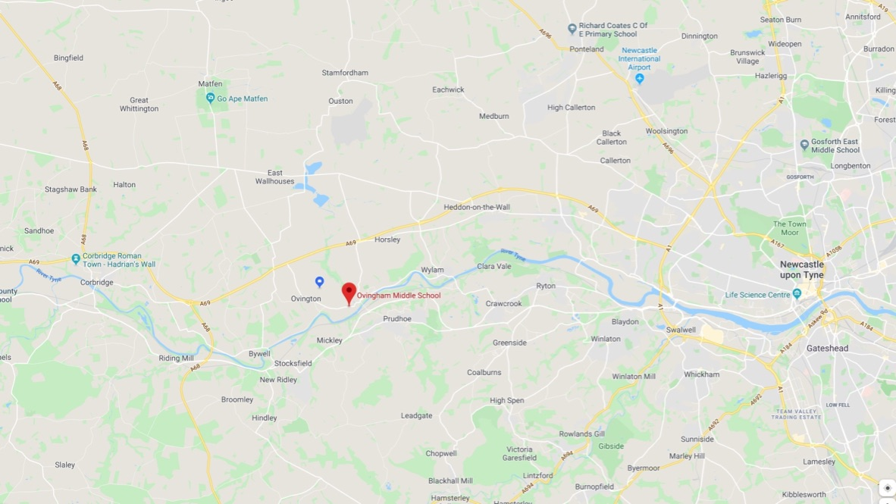
Visits | Please contact Emma Hansom if you would like to arrange a visit to school – 01661 833215
Deadline for applications | Midday Monday 6th July 2020
interviews/ assessment | Interviews will take place the week commencing 6th July 2020

