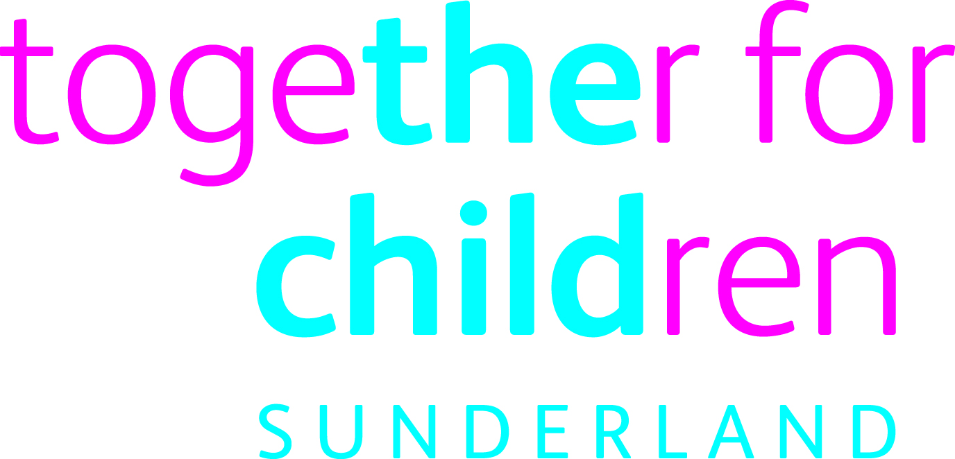

Benefits include:
- Pension - We provide Local Government Pension Scheme whereby the Company pays towards a pension payable on retirement;
- Sick pay - Should you become ill, and with proper documentation, we will pay up to six months’ sick pay on full salary;
- Re-location expenses - In some cases we may offer relocation assistance of up to £3000 for those moving to Sunderland to work with us;
- Annual leave - Together for Children offers 25 days paid annual leave plus bank holidays. This increases to 30 days after 5 years’ service. The Company recognises that employees may wish to take more than their contractual entitlement of annual leave. The Company therefore offers employees the opportunity to request to purchase additional annual leave via a salary sacrifice scheme.
- Flexi Scheme: We are a very flexible employer offering employees the opportunity to strike the right balance between home and the workplace. Where business needs dictate a flexi time policy is in operation which means that employees can bank time accrued during business hours. Employees can take up to 2 days flexible leave per accounting period (pro rata for part time employees).
- Salary sacrifice schemes –
- Cycle to Work Scheme
- Childcare Vouchers Scheme
Employee Benefits
- My Club Nissan Scheme, 20% off a brand new Nissan, and up to 30% off the Infiniti range.
- Annual Employee recognition awards
- Maternity/adoption leave – you will be entitled to up to 52 weeks’ leave of absence, with pay for a specified period dependent upon length of service and personal choice
- Maternity support/adoption leave – you may take up to 5 days’ paid leave as a partner/carer at the time of the birth or adoption.
- Paternity leave – up to two consecutive weeks leave after the birth of the child

Employee Support
In addition to the Company’s benefits package, we also offer support to employees in the form of:
- Free, confidential and independent face to face counselling service through the Occupational Health Service.
- Reasonable adjustments and/or redeployment where practical for employees requiring support after illness or due to disability.
- Good health guide, provided to all employees to help achieve healthier and safer lifestyles both at work and at home.
- A domestic violence policy to ensure support and advice is available.
- Employee Induction scheme.

Employee Involvement
You will have access to our range of employment involvement activities designed to allow you to shape how the Company develops. Your opinions are very important to us and are highly valued.
They include:
- Surveys – this is how we get your feedback (in a structured and confidential way) about a range of issues including what working at the Company is like for you.
- Staff briefing sessions – the Leader and the Chief Executive like to get out and meet as many employees as they can so they hold these sessions several times per year.
- Meet the Directors

Career Development

Learning and Development
Our aim is to embed the concept of learning and development within our day to day work environment. We are committed to developing our employees so they have all the necessary skills and knowledge to be able to do their job effectively. We also want our people to have the chance to develop within their chosen career and so we actively support personal development and are committed to supporting all our employees.
We will do all we can to help you achieve your professional goals.

Performance Appraisal
These take place each year as well as regular one-to-one sessions with your line manager. These meetings are not only to discuss your performance but also your individual development needs both for your current job and those required for your further career progression.

