**Headteacher, Norham St Ceolwulf’s Church of England, Voluntary Controlled,**

**First School**

Nurtured, Outward looking, Respectful, Happy, Achieving, Motivated

**Type of school:** First

**School category:** C of E Voluntary Controlled

**Age range:** 4-8

**Number on roll:** 32

**School address:** West Street, Norham,

Berwick upon Tweed,

TD15 2JZ

**Telephone number:** (01289) 382370

**E-mail:** admin@norham.northumberland.sch.uk

**Chair of governors:** Mr Dougie Watkin

**OFSTED inspection:** May 2010 – Outstanding

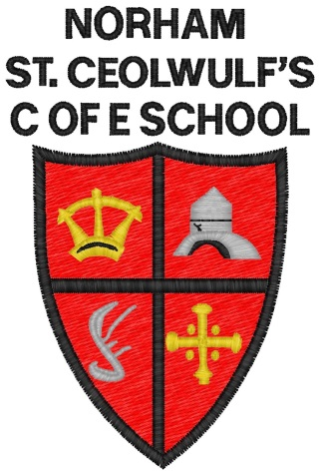



Norham St.Ceolwulf’s First School is a small rural school in an idyllic setting where every child has the opportunity to flourish. The location enables the school to draw children from both sides of the border. It is a happy and caring school with every child’s happiness, safety and well-being our key priority. We offer a stimulating and nurturing environment in which children can develop as a whole person. We currently have 2 teaching staff, and 4 non-teaching support staff, with average class sizes of 14 children. There will be a teaching commitment required as part of this post.

Visitors to school comment on the engagement and enjoyment of our pupils and their attitudes to each other. We believe that the respectful relationships that exist between pupils, staff, parents, governors and the local community are a strength of the school, contributing hugely to family well-being.

We value working in partnership with parents to ensure that each child has the opportunities and conditions to achieve their very best and we have a strong Parent Association who work hard to support the school in their fundraising.

The school also aims to ensure continuity in the children's education by having a positive working relationship with the other schools in the Berwick Partnership.

