

**Applicant Pack**

**Contents**

Welcome from the Chief Executive

Welcome from Chair of Trustees

Who are Prosper Learning Trust?

Governance and Central Team Structures

About Our Schools

Candidate Information

Living in the North East

**Welcome from the Chief Executive Officer**

Dear Applicant

Prosper Learning Trust (PLT) formed in January 2018 and now consists of four academies: two special academies and two alternative provision academies. The Trust caters for children of all ages and abilities who are unable to attend mainstream schools. Although based in the North East, the Trust, through one of its schools works on a national scale, working with children from all parts of the country.

The next exciting step in the growth of Prosper Learning Trust is the soon to be opening special free school in Blyth; Gilbert Ward Academy. By the time Gilbert Ward opens the Trust will operate across three Local Authority areas, educate in the region of 700 pupils and employ around 400 staff.

Everyone within Prosper Learning Trust works very hard to ensure that we are providing the highest quality education for all our pupils. The Trustees have a very clear strategic direction of how as a Trust we can grow and develop while balancing all decisions against risk. This strategic direction is captured in a three-year strategic plan which aligns with our vision and which illustrates how we operate according to our values of aspiration, integrity, kindness and resilience.

We are looking for an outstanding candidate who can inspire and lead as we continue to develop a pupil centred and bespoke offer for some of the most vulnerable children in our communities.

Yours faithfully

Chris Richardson1

*Chris Richardson*

*Chief Executive Officer of Prosper Learning Trust*

**Welcome from Chair of Trustees**

Dear Applicant

Thank you for your interest in joining Prosper Learning Trust. Prosper is a small but growing multi-academy trust, with schools in Newcastle, Sunderland and Northumberland. We work with and support vulnerable learners, aged 3-19, across a number of diverse schools and settings. The Trust is led by a Board of Trustees, who set the strategic direction of the Trust and hold senior leaders to account. Our Board is made up of a strong and committed group of people from a wide range of backgrounds. Each school also has a local advisory committee, which oversees developments at a more local level.

Working within our Trust, you will be rewarded with amazing staff, who go the extra mile to meet the diverse needs of our pupils. You will be supported by a passionate and experienced pro-active Board of Trustees. But most of all, you will find our pupils have so much potential. They deserve the best.

Our Trust wide values identify how we want to work with our pupils, staff and wider community. These values are:

Aspiration

Integrity

Kindness

Resilience

The Trustees are looking for someone who works in an open, honest and constructive manner, who inspires staff and pupils alike.

We are committed to supporting all colleagues in their professional development and really believe that Prosper Learning Trust can offer exciting career development opportunities. If you connect with our values and want to make a positive impact, we would welcome your application.

Yours faithfully

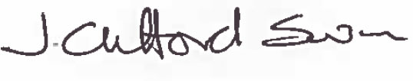

Joanne Clifford Swan

Chair of Trustees

**Who are Prosper Learning Trust?**

**Our Trust Vision**

Prosper Learning Trust, established in January 2018, is a growing multi academy trust serving children with special education needs and children requiring alternative provision across the North East.

The Trust was formed to help vulnerable young people succeed against the odds. Many children and young people face challenges in their lives that many adults will never experience and Prosper is here to support them in doing so. Wherever possible we will help these young people to thrive in a mainstream educational setting, but where that cannot happen we will provide a safe space for them in one of our schools, until they are ready to return or move on.

We believe that learning is the key to their chances of success. We will provide high quality teaching and a coherent and enriching curriculum. Thereby ensuring an equality of opportunity with their peers in mainstream settings.

Our schools offer children and young people with a diverse range of additional needs, the opportunity to learn in a supportive environment, where differences are celebrated, and every pupil is valued and encouraged to achieve their own unique potential.

Our specialist and highly skilled staff will work closely with families, schools and other agencies to create the best possible educational experiences and opportunities for the young people in our care. We will nurture their talent, keep them safe and develop them as informed and active citizens.

Prosper Learning Trust works across the North East of England and is a champion and advocate for vulnerable young people in our region.

**Our Trust Values are:**

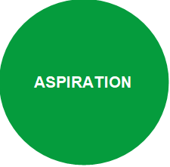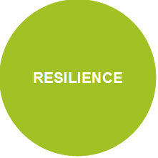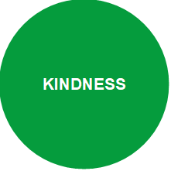

**Prosper Learning Trust is driven by ASPIRATION. Predominantly on behalf of the young people we work with and those who love and support them. But also for ourselves; our staff, our community and those who work with us and support our aims and values.**

**Prosper Learning Trust is an organisation that will act with INTEGRITY at all times. We will do what is best for our young people in every circumstance. We will be fair, open and honest on our dealings with others and will challenge each other every day to live out these values in the workplace. In how we conduct our business and in how we treat each other. We will respect opinion, embrace diversity, work safely and be unrelenting advocates for the wellbeing and character of the young people we care for.**

**Prosper Learning Trust puts KINDNESS at the heart of everything we do. We understand, we empathise and where necessary, we challenge. We work with young people in a way that helps them to appreciate that looking after one another and mutual support are the way to help everybody succeed and thrive. As an employer, we will seek to ensure that staff are valued by treating them with the respect and dignity they deserve.**

**At Prosper Learning Trust, we never give up on children. And we seek to build RESILIENCE in them so they will not give up on themselves. Likewise, as an organisation, we will build resilience in our policies, systems and structures to provide stability and longevity in the face of a dynamic and uncertain environment. Thereby enabling that we can remain a strong and consistent force for good in the lives of the young people and families we work with.**

**Leadership and Governance**

The Board of Prosper Learning Trust has two core functions, which are to set the strategic direction of the organisation and to ensure a robust system of governance.

As a multi-academy trust, the Board of Prosper Learning Trust is responsible for all the academies within the Trust. They do this by delegating functions to the various Trust Committees (Standards, Finance, Risk & Audit, Pay & Appraisal) and the Local Advisory Committees of each academy through a scheme of delegation. Our scheme of delegation clarifies the responsibilities and accountability at every level of the organisation. It clarifies the levels of authorisation placed upon the numerous tiers of the Trust Structure, including CEO and Local Advisory Committees. The Board believe that the best results will be achieved through clear lines of accountability.

**Governance Structure Diagram**

Gilbert Ward Academy

**Prosper Learning Trust Central Team Structure Diagram**

Headteacher

Thomas Bewick School

Executive Leadership

Chief Executive Officer

Finance & Operations Director

Operations Manager

Executive Headteacher

NBS & MAA

Headteacher

Harry Watts Academy

Head of School

Newcastle Bridges School

Head of School

Mary Astell Academy

Finance Manager

Finance Officers

Finance Admin

Headteacher

Gilbert Ward Academy

HR Officer

HR Manager

HR Admin

HR Adviser

Trust Governance Professional

Marketing & Communications Consultant

Premises Management Officer

Communications & Trust Support

CEIAG

Exams Officer

Data Manager

Academies Business Lead Support

**About our Schools**



Newcastle Bridges School is a multi-site school for pupils who have medical needs or are not able to access mainstream school because of mental and/or physical health. A number of provisions are based within hospital settings. The school meets a huge variety of complex needs and strives to ensure that its pupils, no matter what difficulties they face, are not disadvantaged in any way with regard to their education and future opportunities. The school provides a holistic, child centred education that encourages pupils to aim high. Every pupil is equal, valued and unique and we aim to provide an environment where all pupils feel safe and can flourish.

The school has various departments, each of which caters for a particular group of pupils and their needs.

*Alnwood* is a mental health clinical setting for 12-18 year olds with mental health needs or an additional learning disability.

*Ferndene* is a purpose built inpatient centre that provides assessment and treatment for 12-18 year olds with complex mental health, behavioural and emotional needs including pupils with a learning disability.

The *Complex Neurodevelopmental Disorder Service* (CNDS) is a specialist second opinion service for nursery or primary school aged children who may have autism and other complex communication/mental health/neuro-developmental problems.

*The Great North Children’s Hospital* (GNCH) caters for pupils whose education is interrupted by regular stays, or a long-term stay in hospital. Pupils are taught by a team of teachers in the different specialist paediatric wards or in the hospital classroom.

*The Kenton site* is a Newcastle Local Authority commissioned provision offering education to pupils 11-16 years old who are unable to access mainstream school due to medical and mental health needs.

*Medical Pathway Provision* provides education for pupils who are unable to attend their normal place of education due to illness. This service is based within our Kenton site. Pupils are taught from Reception to Year 11 and teaching can take place in a variety of settings within the community as appropriate to their medical needs.

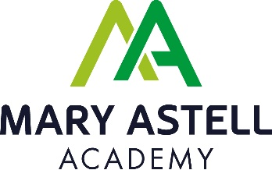

Mary Astell Academy is an AP academy for pupils who have been permanently excluded from mainstream school. The school is based upon values that include giving young people a fresh start and our ultimate aim is to always provide an opportunity to return to mainstream education.  In instances where this is not possible, we continually endeavour to provide a curriculum that provides equality of opportunity. Pupils are able access a stimulating and caring learning environment supported by talented and committed staff who put learning and progression at the forefront of everything they do.

The school is located in West Denton in the West of Newcastle upon Tyne. This is a residential area and the school is located close to a primary school, a secondary school, Thomas Bewick School and a shopping centre. The area is well connected locally by road.

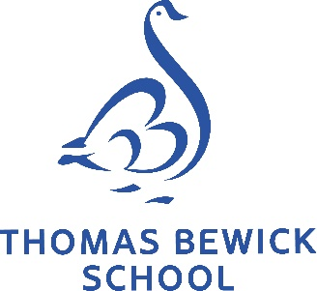

Thomas Bewick School is an all age specialist provision for up to 308 pupils in Newcastle upon Tyne for children and young people with autism (3-19 years), which operates over three different sites. The school offers a broad and balanced curriculum with personalised pathways and high quality pastoral care, to meet their individual needs and learning styles. Pupils are supported with autism specific strategies and approaches by highly trained staff to ensure barriers to learning are addressed and all are able to take advantage of learning opportunities.

The school is located in the West of Newcastle upon Tyne. The school is based on three sites – Early Years at Broadwood Primary School, Site 1 on Linhope Road in West Denton and Site 2 sharing a site with Studio West in West Denton. These are all residential areas and the school is located close to primary schools, a secondary school, Mary Astell Academy and a shopping centre. The area is well connected locally by road.

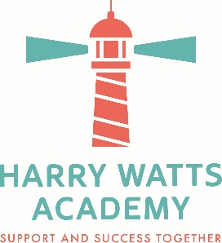

Harry Watts Academy is a specialist school for up to 156 children with autism aged 5-16 based in the city of Sunderland. The school opened in September 2020, with the aim to become a recognised centre of excellence both locally and nationally. As of September 2022, the school is based over two sites at Redhouse and at Harraton. A broad and balanced curriculum with personalised pathways and specialised teaching inspires pupils to learning success, supported with high quality pastoral care. The school’s main priority will be to address the autism-specific barriers to learning so that our pupils are able to take advantage of learning opportunities.

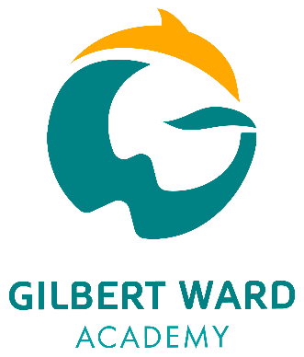

Gilbert Ward Academy will be opening from September 2023 as a purpose built, brand new, state of the art school, catering primarily for children with Social, Emotional and Mental Health needs but also providing for children with autism who have moderate learning needs. The school will provide education for up to 80 children aged 11-16, because of the increased demand within the Northumberland special school system.

The academy will be located on Princess Louise Road in Blyth in a residential area, close to a local primary school and the leisure centre.

Further Information about the schools is available on our website

[www.prosperlearningtrust.co.uk](http://www.prosperlearningtrust.co.uk)

**Candidate Information**

Prosper Learning Trust is committed to safeguarding and promoting the welfare of children and expects all staff and volunteers to share this commitment.

1. Contact Details

Phone: 0191 605 3899

E-mail: [HRadmin@prosperlearningtrust.co.uk](mailto:HRadmin@prosperlearningtrust.co.uk)

Website: www.prosperlearningtrust.co.uk

2. Staff

MAT Support: Chief Executive Officer

Finance & Operations Director

Trust Operations Manager & Central Operations Team

HR Manager & HR Team

Finance Manager & Finance Team

**Living in the North East**

The North East is an exciting and vibrant place to live and work:

* In recent years there has been a great deal of investment and regeneration, not just by local improvements such as better play areas, but real investment by some big-name companies in tech, financial services and manufacturing. Many town and city centres are being modernised and new houses being built. Quaysides are being revamped into leisure hot spots with some very desirable apartments.
* Many sectors of the digital industry are moving to, or have moved to, the North East. And companies such as Nissan have created tens of thousands of jobs in the area. Scientific research, chemical processing, printable electronics, distribution, and of course tourism, are all major employers in the North East.
* From the Northumberland Coast to the North Pennines, Kielder Forest and Park, to Durham Heritage Coast, and Hadrian’s Wall, to Whitley Bay, there are some beautiful places to spend your leisure time. Across the North-East there are golden sandy beaches, award winning parks and gardens and serene countryside within a 15 minute drive of any city centre.
* The North East of England has housing that caters to all budgets and has some of the cheapest property to be found anywhere in the UK. The average house price in June 2019 was £131,000 but prices vary across the area.
* People from the North East are incredibly friendly and helpful. In fact, complete strangers will even talk to you, something that you may find strange and a little unsettling if you come from London. But the locals are rightfully incredibly proud of their heritage and culture and will welcome you with open arms if you make the effort to integrate into the local community.
* The area is well served with transport links, with easy access to London via the motorway and rail services and there are several airports within the region with flights within the UK and beyond.

