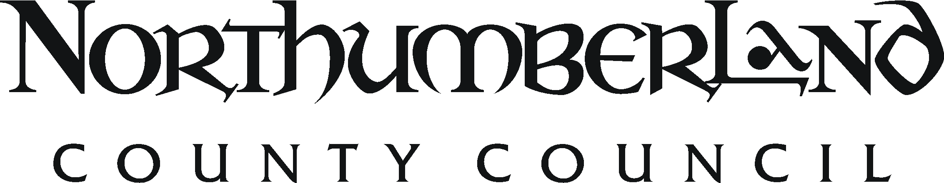 JOB DESCRIPTION

Post Title: Policy Officer (Energy) |  |  | Service: Economic and Inclusion Policy Team  Economy & Regeneration Service  Place Directorate |  | Office Use
Grade: Band 8 |  |  | Workplace: County Hall, Morpeth and other locations in accordance with the Agile Working Policy |  | JE ref: 3408
Responsible to: Senior Policy Officer (Inclusion) |  |  | Date: July 2015  Updated 16.05.18 | Manager Lever:
Job Purpose: To be responsible for developing and implementing the strategic policy and statutory requirements associated with delivering the objectives of the Economic Strategy and the Council’s Corporate Plan
Resources | Staff | Supervise research and support staff
Finance |  | Contribute to the efficient and effective running of the team, including the financial management of specific projects
Physical |  | Design, maintain and operate key corporate policy and research systems
Clients |  | Ensure compliance with relevant legislation, council policies and procedures.
Duties and key result areas:
- To develop both the Council’s corporate and the partnership’s policy framework
- To develop, implement and operate effective and efficient policy processes and ways of working that meet these requirements
- To manage the preparation and delivery of thematic action plans as required as part of the implementation framework for the Economic Strategy and the Council’s Corporate Plan
- To lead on particular strands of thematic activity that cut across disciplines, services, and/or organisations – specifically responding to climate change and renewable energy initiatives.
- To develop and maintain effective and constructive relationships with relevant contacts within partner organisations, including through Local Enterprise Partnership and Combined Authority, in order to promote effective collaboration within climate change and renewable energy.
- To lead the development of effective and constructive relationships with the voluntary and community sector, in accordance with the Local Compact, to maximise the sector’s contribution to improving the well-being of communities within Northumberland
- To provide professional advice to and develop working relationships with elected members, Corporate Directors and Heads of Service on strategic policy matters, including the preparation of Service Plans
- To contribute to the preparation of and take a lead on substantial elements of the Economy and Regeneration Service’s work programme.
- To supervise allocated staff by coordinating and delegating work as appropriate, providing clear guidance, and motivating staff to achieve service objectives and quality standards
- To conduct staff appraisals for allocated staff and thereby contribute to the skills planning and workforce development processes within the service; and assist in the recruitment, selection, induction, discipline, training and development of staff within the Economy and Regeneration Service as appropriate
- To assist in the appointment and management of the work of consultants and in the supervision and mentoring of any apprentices or trainees
- To actively promote and represents the interests of Northumberland and the County Council in relation to service activities and policies at a local, regional and national level as appropriate, particularly through participation in pilot programmes, showcasing good practice, and contributing to exchange networks
- To contribute to the maintenance of effective management and communication systems within the Service, in conjunction with senior colleagues.
- To interpret, explain and enforce statutory and County Council regulations, ensuring appropriate procedures are followed, that parties have a proper understanding of their position and attempting to reach legitimate, mutually agreeable solutions, through negotiation
- To be accountable for expenditure against allocated budgets, ensure effective spend against established targets and compliance with financial regulations
- To fully participate, as a member of the Directorate’s professional team, in the corporate planning and management of the Service

The duties and responsibilities highlighted in this job description are indicative and may vary over time. Post holders are expected to undertake other duties and responsibilities relevant to the nature, level and extent of the post and the grade has been established on this basis.
Work Arrangements
Physical requirements:  Transport requirements:  Working patterns:  Working conditions: |  | Sedentary office work with occasional need to stand, walk and lift.  Will involve travel to meeting venues, area offices or training venues throughout the County and further a field on occasion.  Normal office hours but flexi-hours may apply if colleagues provide cover. Some attendance at evening meetings.  Mainly indoors

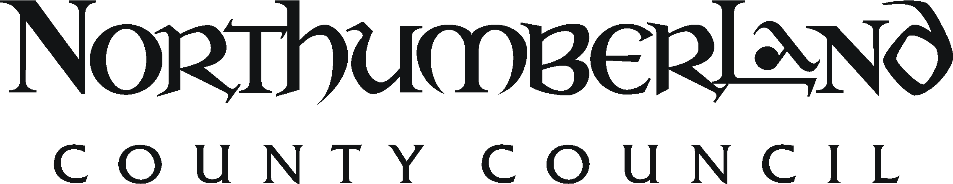 PERSON SPECIFICATION

Post Title: Policy Officer (Energy) | Director/Service/Sector: Economic and Inclusion Policy Team  Economy & Regeneration Service  Place Directorate | Ref:3408
Essential | Desirable | Assess by
Qualifications and Knowledge
Degree, higher degree, professional qualifications and/or NVQ Level 5 or equivalent standard in a subject related to Climate Change or Renewable Energy; plus recent and relevant post qualification training, additional qualifications and experience in a relevant context.  Evidence of having undertaken strategic policy development in relation to cross-cutting issues and challenges  In-depth knowledge of professional theory, practice and procedures.  Knowledge of current inter/national laws, regulations, policies, procedures, trends, and developments.  Commercially aware and understands the relationship between costs, quality, customer care and corporate performance assessment.  Evidence of continuing professional development. | Evidence of recent and relevant management training.  Relevant management degree or post-graduate diploma e.g. MBA, DMS.  Understands the diverse functions of a large complex public sector organisation and the relevant professional issues.
Experience
Recent and relevant post qualification experience in a relevant context.  A breadth of work experience in selecting and applying the full range of professional methods, tools and techniques in a wide range of work situations.  An evidenced track record as a successful consultant/advisor.  Experience in engaging effectively with others and building productive partnerships.  Relevant experience in designing and drafting policies, procedures and other technical documents.  Experience in managing projects to successfully achieve set objectives. | Experience in a particular relevant specialist area.  Supervising staff and their productivity.
Skills and competencies
Able to disseminate acquired knowledge.  Ability to develop policy based on sound reasoning and logic, draw appropriate conclusions, and present these to an audience.  Advanced IT knowledge and skills and able to effectively use ICT to achieve work objectives, understanding of a range of ICT software  Experience in project/task management.  Ability to motivate and develop staff.  Ability to work independently and take the initiative  Prepares written, verbal and other media to best professional standards.  Effectively expresses views using appropriate means depending upon the audience.  Numerate and skilled at analysing/reasoning with complex business related statistics.  Persistence in applying a methodical approach to problem solving.  Negotiation skills and able to persuade others to an alternative point of view.  Operates as an effective advocate for the Directorate both within and externally.  Maintains a professional demeanour in stressful and difficult situations. | Experience in project management & monitoring and evidence of the application of these techniques, as appropriate.  Budgeting and financial management skills.  Experience of mentoring and supervising staff.  Advanced skills in Microsoft Office
Physical, mental, emotional and environmental demands
Normally works from a seated position with some need to walk, bend or carry items.
Need to maintain general awareness with lengthy periods of enhanced concentration.
Some contact with public/clients in dispute with the County Council.
Some exposure to working outdoors.
Motivation
A strong corporate orientation and a commitment to tackling issues in a non-departmental manner.
Dependable, reliable and keeps good time.
Self reliant, able to exercise discretion and possessing the ability to manage time effectively.
Models and encourages high standards of honesty, integrity, openness, and respect for others.
Helps managers create a positive work culture in which diverse, individual contributions and perspectives are valued.
Proactive and achievement orientated
Works with little direct supervision.
Other
Able to meet the transport requirements of the post

Key to assessment methods; (a) application form, (i) interview, (r) references, (t) ability tests (q) personality questionnaire (g) assessed group work, (p) presentation, (o) others e.g. case studies/visits

