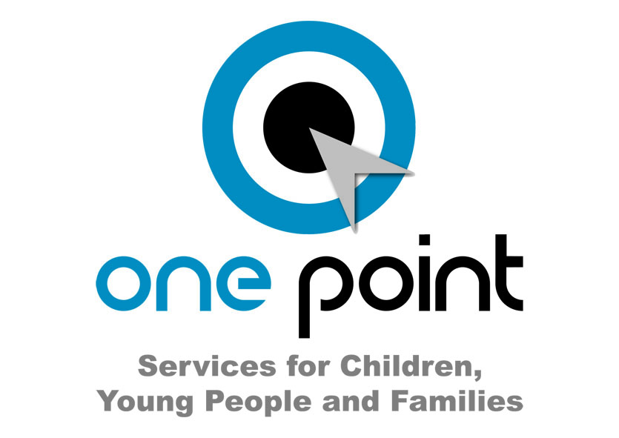



1. **POST TITLE: YEI Progression Worker**
2. **POST NUMBER:**
3. **GRADE: Grade 6**

Job Evaluation Ref No: N8942

1. **LOCATION: Any of the One Point Service Localities in County**

**Durham**

1. **RELEVANT TO THIS POST:**

**This post is 100% funded until July 2018 through ESF/YEI through the DurhamWorks project**

**Flexible Working:**  Subject to service needs the Council’s flexible working policy is applicable to this post. The post holder may be required to work outside of normal hours.

**Contract:** Subject to approval, this post is funded through ESF and the Youth Employment Initiative (YEI) as part of the 2014-2020 European Structural and Investment Funds Growth Programme in England. The YEI/ESF funding will end in July 2018.

**Disclosure & Barring Service:** Subject to DBS Enhanced Disclosure

1. **ORGANISATIONAL RELATIONSHIPS:** The post holder will be accountable to the identified One Point Service Manager and the YEI Transition Officer.
2. **DESCRIPTION OF ROLE:**

The Youth Employment Initiative (YEI) is an EU funded programme to help unemployed 16-24 year olds improve their skills and move into employment, training or education. YEI Personal Advisers will work intensively with young people in the Not in Education, Employment or Training (NEET) group. The YEI Progression Worker will work alongside YEI Personal Advisers, with young people who have been identified as requiring additional support to enable them to progress and remain in learning and employment.

1. **DUTIES AND RESPONSIBILITIES SPECIFIC TO THIS POST:**

**KEY FUNCTIONS**

**Support the Participation and Progression agenda**

* Work with young people who require additional, but less intensive support – assessed at Level 2 on the Durham Staircase - to progress into learning and work by offering 1:1 support and group work activities.
* Case manage own clients using Management Information Database (IYSS) and case management systems
* Support young people in learning to manage effective transitions from short term projects.
* Support job search activities, CV sessions and job applications.
* Follow up destinations, including home visits to young people who are not contactable in other ways.
* Work with other agencies in the provision of support to young people.
* To work within the Single Assessment/Stronger Families Frameworks including being Lead Professional to provide practical support to young people, in line with the agreed care plan, and liaising with other relevant partners as appropriate.
* Provide practical support to young people to tackle barriers to progression.
* Maintain appropriate records and documentation in line with YEI/OPS agreed standards and ensure progress and improved outcomes are effectively and appropriately evidenced.
* To identify and map areas of good practice within YEI initiative including case studies.

**Work with Employers and Learning Providers:**

* Seek and identify vacancies for young people and work with employers to ensure that appropriate young people are nominated for the vacancies.
* Ensure vacancies secured locally are recorded accurately and entered onto the YEI and CCIS client management systems to enable sharing across the county.

**Key Outcomes**

* Ensuring effective safeguarding and child protection arrangements in line with DCC policy and guidelines
* Engage young people in effective dialogue in the review and improvement of service delivery.

**Delivering Integrated Support:**

* Contribute fully to the YEI and One Point Service integrated teams including the Single Assessment process and Stronger Families Framework.
* Development and delivery of integrated working including use of the SAF and Think Family approaches.
* To work effectively and creatively with partners from a range of children and adult services in order to meet needs and improve outcomes for young people who are in need of additional support.
* To ensure effective information sharing in relation to effective early identification and assessment of need and delivery of support to young people in need of additional and early help to improve outcomes.

**Professional Development & Conduct:**

* Work in line with organisational policies and procedures, contributing suggestions for improvement as necessary;
* To be aware of and adhere to County Council, One Point Service and YEI policies and guidance;
* To maintain a current, professional knowledge base and competency in the required skills for this role as set out in the Person Specification.
* To identify personal development needs and promote own professional development by attending appropriate courses and study days.
* Participate in in-service training and personal development opportunities as identified through supervision and appraisal.

**COMMON DUTIES AND RESPONSIBILITIES:**

**9.1** **Quality Assurance**

To set, monitor and evaluate standards at individual, team performance and service quality so that the user and the Service’s requirements are met and that the highest standards are maintained.

To establish and monitor appropriate procedures to ensure that quality data are reported and used in decision making processes and to demonstrate through behaviour and actions a firm commitment to data security and confidentiality as appropriate.

**9.2** **Communication**

To establish and manage the team communications systems ensuring that the Service’s procedures, policies, strategies and objectives are effectively communicated to all team members.

**9.3** **Professional Practice**

To ensure that professional practice in the team is carried out to the highest standards and developed in line with the Service’s stated objectives of continual improvement in quality of its service to internal and external customers.

**9.4** **Health and Safety**

Manage health and safety in their area of responsibility in accordance with the relevant section(s) of the Corporate/Service Health and Safety Policy and to ensure that the Health and Safety policy, organisation arrangements and procedures as they relate to areas, activities and personnel under your control are understood, implemented and monitored.

**9.5** **General Management (where applicable)**

To provide vision and leadership to staff within a specialist team, ensuring that effective systems are in place for workload allocation and management, the application of the Authority’s and the Service’s policies and procedures, including those relating to equality, supervision and appraisal and all aspects of their performance, personal development, health and welfare.

**9.6** **Financial Management (where applicable)**

To manage a designated budget (as required) ensuring that the Service achieves value for money in all circumstances through the monitoring and control of expenditure and the early identification of any financial irregularity.

**9.7 Appraisal**

All members of staff will receive appraisals and it is the responsibility of each member of staff to follow guidance on the appraisal process.

**9.8 Equality and Diversity**

As an organisation we are committed to promoting a just society that gives everyone an equal chance to learn, work and live free from discrimination and prejudice.  To ensure our commitment is put into practice we have an equality policy which includes responsibility for all staff to eliminate unfair and unlawful discrimination, advance equality of opportunity for all and foster good relations.

       These policies apply to all employees of Durham County Council.

**9.9 Confidentiality**

All members of staff are required to undertake that they will not divulge to anyone personal and/or confidential information to which they may have access during the course of their work.

All members of staff must be aware that they have explicit responsibility for the confidentiality and security of information received and imported in the course of work and using Council information assets. The Council has a Personal Information Security Policy in place.

* 1. **Induction**

The Council has in place an induction programme designed to help new employees to become effective in their roles and to find their way in the organisation.

**The Children & Young People’s Promise:**

The following are Staff Promises which set out what behaviours and skills young people want to see One Point Service staff in the hubs demonstrating in their day-to-day contact. These have been agreed and form part of the job descriptions for all staff:-

|  |  |
| --- | --- |
| 1. | We will treat you with respect and listen and value your opinions |
| 2. | We will ask you where you want to have your meeting |
| 3. | If we have to cancel a meeting with you, we will aim to give you at least three hours notice if at all possible. We will either telephone or text you as soon as we know we need to cancel |
| 4. | We will always ask how you want to be contacted and contact you directly if we need to speak to you. There may be occasions when we need to speak to your parent, carer or another adult, but we will always speak to you first about this. |
| 5. | Workers will put in writing what they have agreed to do and give you a copy |
| 6. | We will do what we have agreed to do or let you know if there is a reason why we can’t. We will put young people’s priorities at the top of the list. |
| 7. | We will carry out young people’s events (agenda days) every 3 months to evaluate the service. |
| 8. | We agree young people should be involved in interviewing and selecting staff. |
| 9. | We will let you know how you can compliment the service or make a complaint. We will always listen and act upon every complaint. We will let you know we have your complaint and what we are doing with it within 5 working days. We will make sure you know how you can complain. |
| 10. | A young person will never be rejected or turned away from a hub |
| 11. | We will “hold the baton” eg. we won’t say we can’t help or make you leave until you are happy with the help you have been given |

**The Promise sits alongside the existing skills, knowledge and experience as requirements for your role and for the integrated environment in which you work. Your understanding and ability to meet these requirements will be regularly assessed alongside your existing role requirements as set out in your job description/role profile.**

The post holder will undertake such other duties which may be allocated, commensurate with

the grade of the post.

**Variation in the Role**

Given the dynamic nature of the role and structure of Children and Adult Services at the present time, it must be accepted that, as the Service’s work develops and changes, there will be a need for adjustments to the role and responsibilities of the post. The duties specified above are, therefore, not to be regarded as either exclusive or exhaustive. They may change from time to time commensurate with the grading level of the post and following consultation with the officer which may, if he/she so wishes, involve a union representative.

**Person Specification: YEI Progression Worker**

|  |  |  |  |
| --- | --- | --- | --- |
|  | **Essential** | **Desirable** | **Method of Assessment** |
| **Qualification** | * Level 3 qualification in Information Advice & Guidance. | * Higher qualification in a relevant field | Application form  Selection Process  Pre-employment checks |
| **Experience** | * Experience of working with young people who are NEET. * Experience of working in an integrated team. * Experience of assessing need using Single Assessment processes. * Working in partnership with delivery agencies; * Implementing and monitoring quality assurance systems; * Good practice in relation to Health and Safety procedures. * Experience of delivering planned interventions using evidence based practice that lead to improved outcomes for young people. | * Experience as a lead professional * Managing a case load * Experience of planning and delivering group work activities to targeted groups of young people * Using IYSS to record interventions | Application form  Selection Process  Pre-employment checks |
| **Skills / Knowledge** | * The ability to deliver high quality one to one support. * To communicate effectively * To be able to use ICT effectively. * Knowledge and understanding of key policies and issues relating to the transitions and progression of young people * To be able to demonstrate at all times the requirement to focus on the needs of the young person * Writing and presenting reports. | * Knowledge of the local area and services that are available | Application form  Selection Process  Pre-employment checks |
| **Personal Qualities** | * The ability to work flexibly to meet the needs of the service. * The ability to work under direction and using own initiative when appropriate * Enthusiastic and positive approach to client-led service delivery * Open, friendly and supportive manner * Commitment of Equal Opportunities * Commitment to high quality service delivery * Capable of independent travel to meet the requirements of the post * Good Team Player * Holds high aspirations for young people. |  | Application form  Selection Process  Pre-employment checks |
| **Special Requirements** | * Access to a car or means of mobility support (if driving must have current valid driving licence and appropriate insurance). |  |  |