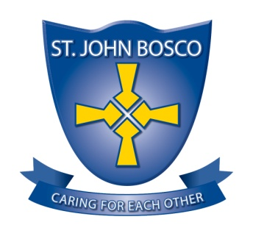

ST. JOHN BOSCO RC
PRIMARY SCHOOL

SCHOOL CONTEXT

St John Bosco is a Roman Catholic primary school situated in Town End Farm, Sunderland. It serves the parish of Sacred Heart and St. John Bosco. We currently have 215 pupils on roll; Nursery – Year 6. St. John Bosco is situated in the highest percentile of social deprivation indicator (IDACI) and the number of pupils eligible for free school meals and Pupil Premium is above the national average. St. John Bosco is a fully inclusive school with pupils entering across a full spectrum of needs and academic abilities. The proportion of pupils identified as special educational needs and those supported at school action plus or have an Educational Health Care Plan (EHCP) are above average. Our school motto of ‘Caring for Each Other’ is at the heart of everything we do in school.

St. John Bosco is an Outstanding school with hard working, enthusiastic and committed staff. Teachers and support staff who work well together are committed and focused on the care and education of our pupils. We are very proud of our school with its happy and caring atmosphere and its tradition of high expectations, academic achievement and community involvement. Teachers have high expectations of all pupils. Children start Nursery with skills which are below those expected for their age, but make good progress as they move throughout the school. A strength of the school is the high quality relationships between pupils, teachers and other adults which results in positive attitudes to learning and high standards of attainment and progress.

Our school provides a caring, supportive environment which encourages pupils to confidently accept roles and responsibilities as Play leaders and school councillors or monitors. A wide range of enrichment activities are provided. These promote inclusion opportunities for participation by all pupils.

A strength of the school is robust, rigorous school self evaluation which informs highly effective development planning. The school is well supported by a Governing Body committed to excellence. Governors are engaged in all aspects of school improvement and hold the school to account in positive ways that help to shape the direction of the school. Our parents, carers, local and wider communities also engage very well with the school.

