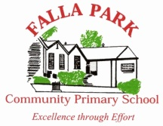

Falla Park Community Primary School

Candidate Information Booklet

**Deputy Head Teacher**

**Appointment Information**

**March 2017**





|  |  |
| --- | --- |
| **CONTENTS** | **PAGE NUMBER** |
| **Our Vision and Values** | **3** |
| **Person Specification** | **4** |
| **Job Profile** | **6** |
| **Information about the Process** | **10** |
| **Advertisement Information** | **11** |

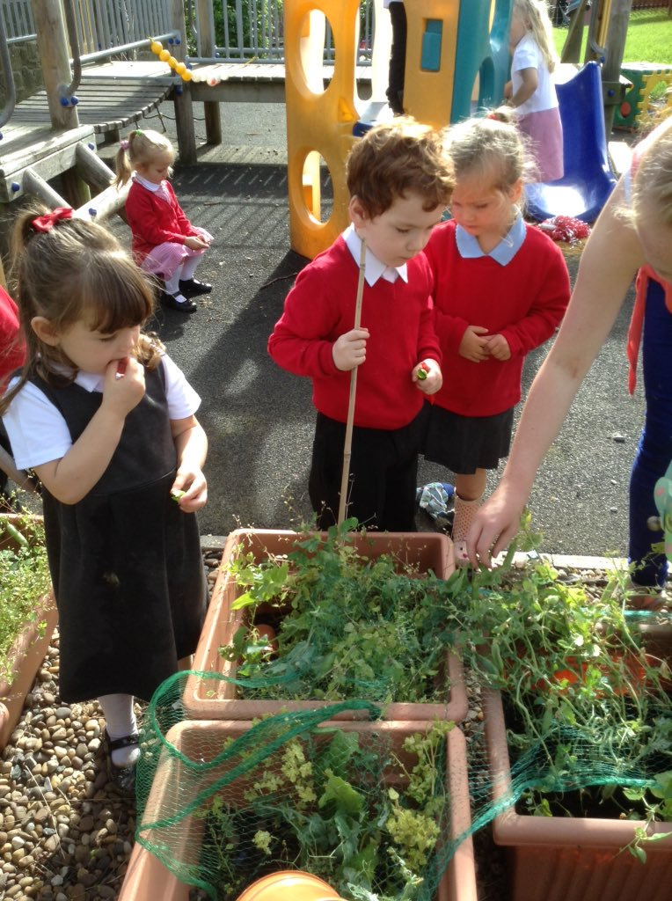

**OUR MISSION STATEMENT**

We are a positive, professional team dedicated to providing high quality education in a happy, safe, inclusive environment; where all are valued, cared for and challenged to attain high standards and develop the skills to achieve well.

**OUR VISION AND VALUES**

Our vision is that Falla Park Community Primary School is:

* An exciting, interesting and fun place for all to learn and succeed
* An inclusive school with a caring, safe environment where all members are valued and encouraged
* A school that is creative in all aspects of its provision and enriches learning by providing exciting and inspiring opportunities for all to achieve and excel
* A school that is at the heart of the community, providing extended services matched to the needs of the community
* A school that has a vibrant, welcoming environment and where all achievement is celebrated
* A school that has the highest expectations of all members of its community and is dedicated to maintaining and building on the highest possible standards



**Responsibility** - we take responsibility for our own actions, thoughts and words

**Compassion** – we show care and concern for others and show understanding of others feelings

**Respect** – we always show respect by treating others the way we would like to be treated

**COMMUNITY** PRPERSON **SPECIFICATION – DEPUTY HEAD TEACHER – PERMANENT– PERS**

**ON SPECIFICATI0N**

|  |  |  |
| --- | --- | --- |
|  | **Essential** | **Desirable** |
| **Qualifications and Experience** | * QTS (primary age range) * Degree level qualification * Experience of working in at least two key stages (Early Years/Key Stage 1/Key Stage 2 * Experience of leadership and management in a primary school e.g core subject, key stage or non-subject based area * Experience of delegating, supporting and monitoring the work of others * Recent, relevant training * Experience and knowledge of the ‘self-evaluation’ process, target setting and school improvement planning | * Evidence of further professional development e.g NPQH, Leading from the Middle * Primary teaching experience in Key Stage 2 * Experience of leading staff training and professional development * Effective collaboration with external agencies * Designated safeguarding lead |
| **Skills, Knowledge and Aptitdue** | * Excellent classroom practice with high expectations of both children and self. Able to act as a role model in these areas for other staff * A good understanding of effective strategies for gaining and maintaining high standards of behaviour at whole school level * Clear vision of primary education and expected pupil outcomes * Ability to prioritise areas for action * Experience of interpreting and using assessment data to raise achievement * A good understanding of assessment for learning and the ability to implement and model these strategies | * Leadership of a non-subject based initiative * Experience of Ofsted |
| **Personal qualities, skills and characteristics** | * Ability to communicate effectively, orally and in writing to a range of audiences e.g staff, children, parents, governors * Ability to initiate and manage change * Have high expectations for behaviour and performance * Excellent organisational skills and the ability to work under pressure, prioritise appropriately and meet deadlines * Motivated and ability to motivate others * Ability to work collaboratively * Ability to work within a team in a leadership role * Ambitious for our school * Enthusiasm and humour | * Eager to develop professionally |
| **Other** | * Fulfil the requirements of an enhanced DBS * Excellent record of attendance and punctuality * Open and honest * The ability to work with the wider school community and partner organisations * Good ICT skills |  |

**FALLA PARK COMMUNITY PRIMARY SCHOOL**

**JOB PROFILE**

**DEPUTY HEAD TEACHER**

**Job Title:** Deputy Head Teacher

**Responsible to:** Head Teacher

The job profile identifies the responsibilities attached to your post. It is subject to the limits on working time set out in the Teachers’ Pay and Conditions Document. This job profile is subject to amendment from time to time within the terms of your conditions of employment, as the needs of the school may require, but only to an extent consistent with those conditions of employment, and only after consultation with yourself.

**Fulfil the general responsibilities of Deputy Head Teacher.** This will include:

* Deputising for the Head Teacher in all aspects of the leadership and management and good discipline of the school
* Undertaking training for Designated Person role for Looked after Children and Child Protection and deputise for the Head Teacher in her absence.
* Supporting the vision, ethos and policies of the school and promoting high levels of achievement across the school
* Sharing with the Head Teacher in the day to day management and organisation of the school
* Assisting the Head Teacher in the production, implementation, monitoring and review of policies adopted by the School Governing Body
* Assisting the Head Teacher in the creation and implementation of the School Improvement Plan, and take responsibility for appropriately delegated aspects of it
* Sharing in an overview of the curriculum across the primary range to support and complement the skills and expertise of the Head Teacher
* Supporting the Head Teacher in the monitoring of the quality of teaching and learning including the analysis of performance data
* Assisting the Head Teacher with the discipline and pastoral care of all children and the supervision and welfare of all teaching and associate staff
* Developing an understanding of financial management and administrative procedures
* Taking an active role in the Appraisal process as a Reviewer
* Promoting parental links and learning opportunities for parents/carers in school
* Taking responsibility for the effective induction, training and assessment of NQT’s and Trainee Teachers
* Taking responsibility for development of the school curriculum and devise plans which identify clear targets and success criteria for its development and/or maintenance
* Disseminating information to staff and provide INSET to promote staff development and improve teaching and learning
* Maintain up to date knowledge of local and national initiatives by attending relevant courses and undertaking personal research
* Supporting, motivating and advising staff in the development of their classroom practise

**MAIN DUTIES AND RESPONSIBILITIES AS A TEACHER**

**Areas of Responsibility and Key Tasks – Planning, Teaching and Class Management**

**Teach allocated children by planning their teaching to achieve progression of learning through:-**

* Identifying clear teaching objectives and specifying how they will be taught and assessed
* Setting tasks which challenge children and ensure high levels of interest and motivation
* Setting appropriate and demanding expectations
* Setting clear targets, building on prior attainment
* Identifying SEN, More Able, Pupil Premium, LAC and EAL children
* Providing clear structures for lessons maintaining pace, motivation and challenge
* Making effective use of assessment and ensure coverage of national curriculum
* Ensuring effective teaching and best use of available time
* Maintaining good behaviour standards in accordance with the school’s procedures and policies
* Encouraging good practice with regard to punctuality and attendance
* Developing and maintaining effective relationships with children and their families in order to maximise learning potential

**Using a variety of teaching methods to:-**

* Match approach to content, structure information, present a set of key ideas and use appropriate vocabulary
* Use effective questioning, listen carefully to children, give attention to errors and misconceptions
* Select appropriate learning resources and develop self learning and study skills through library, ICT and other sources
* Ensure children acquire and consolidate knowledge, skills and understanding appropriate to the subject taught
* Continuously evaluate own teaching critically to improve effectiveness
* Ensure the effective and efficient deployment of classroom support to enhance learning
* Take account of children’s needs by providing structured learning opportunities which develop the areas of learning identified in national and local policies and particularly the foundations for literacy and numeracy
* Encourage children to think and talk about their learning, develop self-control and independence, concentrate and persevere, and listen attentively
* Use a variety of teaching strategies which involve planned adult intervention, first-hand experience and play and talk as a vehicle for learning

**Monitoring, Assessment, Recording, Reporting**

* Have a good knowledge of assessment procedures
* Assess how well learning objectives have been achieved and use them to improve specific aspects of teaching
* Continuously assess children’s work and set targets for progress
* Assess and record children’s progress systematically and keep records to check work is understood and completed, monitor strengths and weaknesses, inform planning and recognise the level at which the child is achieving
* Follow school procedures for assessing children
* Prepare and present informative reports to parents

**The Role of Pastoral Class Teacher**

The pastoral element of class teaching is a key role of monitoring children’s progress and supporting all members of the class in making progress commensurate with their ability. The main responsibilities are to assist in raising the level of performance of all children by:

* Being aware of the strengths and needs of each child
* Monitoring and providing appropriate advice and guidance on individual children’s progress in respect to attendance, homework, behaviour
* Promoting high standards of behaviour, appearance and attitudes to work
* Communicating effectively with staff and parents to achieve the targets set for each child
* Promptly completing administrative tasks relating to the class

**Other Professional Requirements**

* Have a working knowledge of teachers’ professional duties and legal liabilities
* Operate at all times within the stated policies and practices of the school
* Establish effective working relationships with other staff and set a good example through their personal and professional conduct
* Contribute to the corporate life of the school through effective participation in meetings and management systems necessary to co-ordinate the management of the school
* Take responsibility for their own professional development and duties in relation to school policies and practices
* Liaise effectively with parents, governors and the wider school community
* Take on any additional responsibilities which might from time to time be determined

This job profile may be amended at any time following discussion between the Head Teacher and member of staff, and will be reviewed annually.

Signed: ____________________________________________________

Signed (Head Teacher): _______________________________________

Date: ______________________________________________________

**INFORMATION ABOUT THE APPOINTMENT PROCESS**

|  |  |  |
| --- | --- | --- |
| **Date and Time** | **Aspect of Procedure** | **Location** |
| Monday 13 March | Advertisement in press | Local |
| Thursday 16 March @ 2pm  Monday 20 March @ 2pm | Informal visits prior to application | School |
| Monday 27 March | Closing date for applications | Applications at school |
| Friday 31 March | Shortlisting meeting will take place | School |
| Wednesday 3 May | Formal interviews to be held starting 9.00am | School |



|  |
| --- |
|  |
| **APPLICATION DETAILS**  Falla Park Community Primary School is a welcoming, supportive and inclusive school with a strong ethos where every child is valued. We are determined to improve the life chances of our children to fulfil our mission statement ‘Be the Best you can Be!’  Due to the promotion of our Deputy to Headship, the Governors wish to appoint a Deputy Head Teacher who is a dedicated and ambitious leader, who is an outstanding teacher and a strategic leader with a resilient character and a strong personal drive.  If you are passionate about education and making a real difference to children’s lives then we would like to hear from you.  To find out more about our school visit our website [www.fallapark.gateshead.sch.uk](http://www.fallapark.gateshead.sch.uk). Visits to the school are essential. Contact Beverley Edgar on 0191 4334011 to make an appointment on either Thursday 16 March @ 2pm or Monday 20 March @ 2pm.  Gateshead Council is committed to safeguarding and promoting the welfare of children, young people and vulnerable adults and expects all staff and volunteers to share this commitment. Successful applicants will require an Enhanced Certificate from the Disclosure and Barring Service. |

**Closing date: Monday 27 March 2017**

**Shortlisting: Friday 31 March 2017**

**Interviews: Wednesday 3 May 2017**