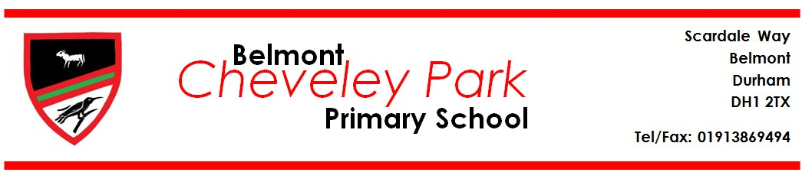

**Lunchtime Supervisor**

**Person Specification**

**CRITERIA**

**ESSENTIAL**

**DESIRABLE**

**INDICATOR**

**Comply with**

**DfES/LA**

**requirements**

•

DBS Check

•

School Policies and

P

rocedures for

Safeguarding

children

•

Receipt of

satisfactory

employment

reference

•

Successful DBS

**Interpersonal Skills**

•

Able to relate well to

children

•

Able to relate well to

adults

•

Be able to work as

part of a team

•

Be able to work to

school and LA

Codes of Conduct

•

References

•

Application Form

•

Interview

**Experience /**

**Training**

•

Previous experience

of

supporting /

working with

children

•

Previous

experience as a

Lunchtime

Supervisor

•

First Aid

qualification

•

Child Protection

/ Safeguarding

training

•

References

•

Application Form

•

Interview

**Additional Qualities**

•

Willingness /

initiative to

engage

children in

specific

activities, eg

playground

activities and

games etc

•

References

•

Application Form

•

Interview



**cheveleypark@durhamlearning.net**

**www.belmontcheveleypark.durham.sch.uk**

**Headteacher: Mrs A Goodwin**

