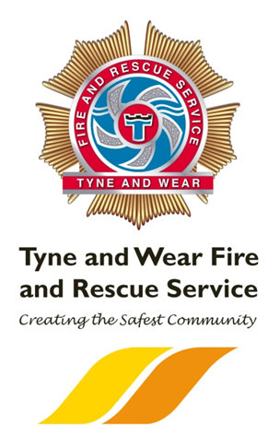

***COMMUNITY VOLUNTEERS REQUIRED WITH THE OPPORTUNITY TO BECOME A SPECIALIST VOLUNTEER***

***Community Volunteer***

Volunteers will generate referrals for Home Safety Checks and provide fire safety information within targeted community groups. To assist in the facilitation of internal and external events such as community fire station open days, sporting events, conferences and charity events.

***Volunteers for the Deaf Community (Specialist)***

Volunteers improve fire safety amongst deaf and hard of hearing people, ensuring people know about Emergency SMS and sensory impairment alarms, supporting vulnerable people for Home Safety Checks. Volunteers work with staff to offer BSL support to ensure we can provide Home Safety Checks to people who are deaf and hard of hearing.

**SafetyWorks Volunteers (Specialist)**

Volunteers support staff in delivering safety messages to visitors in our interactive safety centre. SafetyWorks provides an innovative, enjoyable learning experience enabling visitors to participate in realistic situations illustrating everyday hazards and how to prevent them.

***Young Fire Fighters Association (YFA) Volunteer***

As an YFA volunteer you will support the scheme in providing young people with an insight into working within a uniformed services as well as encouraging them to develop both personally and socially while promoting self-discipline, team work and citizenship.

***Business Liaison Volunteer (Specialist)***

As a volunteer you will represent the service engaging with members of the business community at community based events. Whilst, assisting in the delivery of community safety awareness within targeted community groups.

***WHY VOLUNTEER?***

Volunteering with Tyne and Wear Fire and Rescue Service is rewarding as it offers the opportunity to meet new people, undertake new challenges and experiences; and provides the satisfaction that comes from making a real contribution to the safety of communities in Tyne and Wear.

***Volunteers must be over 18 years old to apply***

To apply for this role visit [www.twfire.gov.uk/jobs](http://www.twfire.gov.uk/jobs) and complete an online expression of interest form.

Completed applications to be sent via [hr.helpdesk@twfire.gov.uk](mailto:hr.helpdesk@twfire.gov.uk) or by post to HR Department, Tyne and Wear Fire and Rescue Service Headquarters, Nissan Way, Sunderland, Tyne and Wear, SR5 3QY

V

O

L

U

N

T

E

E

R

***Now Recruiting New Volunteers***