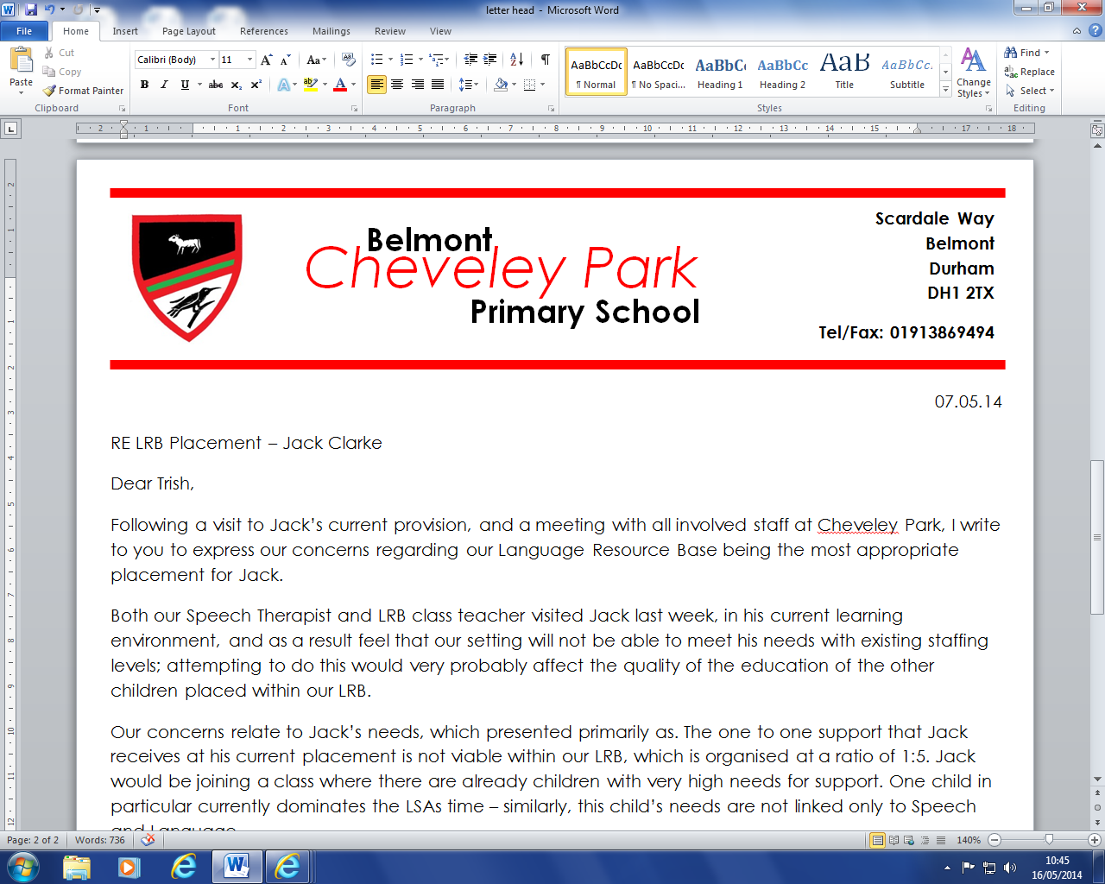

**Lunchtime Supervisor Job Description**

**Responsible to:** The Headteacher and the Governing Body of the school

**Main Purpose Of The Job:**

To be responsible for the care and supervision of the children before, during and after meals, until afternoon lessons begin, in accordance with the school’s policies and procedures.

* Adhere to all COVID-19 procedures (in place at any given time) to ensure the highest levels of safety and hygiene.
* Supervise the washing of hands of pupils.
* Supervise entry/exit into/from the dining hall by the pupils.
* Assist pupils during the meal service.
* Ensure pupils maintain high standards of behaviour, reporting any cases of misbehaviour, as appropriate.
* Clear up all spillages during mealtime promptly.
* Assist in wiping up tables and chairs and set up the dining hall prior to service with drinks, cutlery and condiments.
* Supervision of children in designated areas ensuring good conduct in behaviour in accordance with the schools behaviour policy.
* Initiate games and activities where appropriate, whilst maintaining broad supervision.
* Supervise children indoors during inclement weather.
* Engage pupils in safe, enjoyable, and creative activities.
* Maintain accurate and relevant incident records.
* To attend any training courses relevant to the post, ensuring continuing, personal and professional development.
* Role requires working within a team.
* Ability to present oneself as a role model to pupils in speech, dress, behaviour and attitude.
* Provide pastoral care and support to sick and injured children taking appropriate action as necessary ensuring school staff are fully informed of incidents and accidents.
* Undertake any other duties that are commensurate with the post.

**General**

Comply with health and safety policy and systems, report any incidents/accidents/hazards and take pro-active approach to health and safety matters in order to protect both yourself and others.  
  
Demonstrate and promote commitment to safeguarding procedures and principles and equal opportunities and to the elimination of behaviour and practices that could be discriminatory.  
  
Any other duties deemed appropriate towards the provision of a high quality service.  
  
Have excellent timekeeping

**cheveleypark@durhamlearning.net www.belmontcheveleypark.durham.sch.uk Headteacher: Mr. M. Dent**

Scardale Way   
Belmont   
Durham   
DH1 2TX

Tel/Fax: 0191 3869494