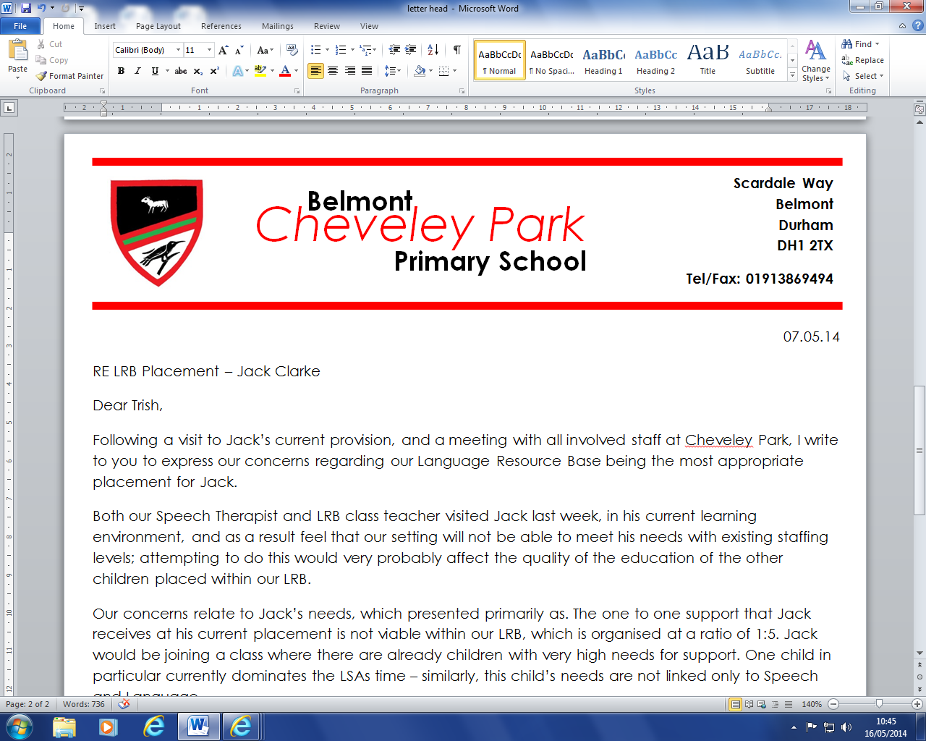

**Lunchtime Supervisory Assistant Vacancy**

Would you like to work with a group of wonderful children, in order to help them to have a happy and settled lunchtime experience? If so, we are looking for an additional lunchtime supervisory assistant to join our team. The role is for 1 hour and 15 mins each day.

If you are interested in the position, please download an application pack from our school website [www.belmontcheveleypark.durham.sch.uk/vacancies](http://www.belmontcheveleypark.durham.sch.uk/vacancies), or call in to pick one up in person. Should you require any further information about the role, please do not hesitate to contact Janet Johnstone, our Office Manager.

**Role Specifics**  
Days: Monday – Friday   
Time: 1 hour 15 mins over lunchtime (6¼ hours per week)  
£18,065 pro rata

This position is paid whole time with retainer adjustments applied to periods of school closure.  You will not be required to work during the school closure periods however your salary in these periods will be adjusted accordingly in line with the retainer regulations as specified in the National Joint Council (NJC) Green Book agreement.

The School is committed to safeguarding and promoting the welfare of children and young people and expects all staff and volunteers to share this commitment. Safer recruitment practice and pre-employment checks will be undertaken before any appointment is confirmed. This post is subject to an enhanced Disclosure and Barring Service (DBS) check (previously CRB), Pre-employment Health Check and supportive references.

Where our roles are customer facing and you are required to speak to members of the public, the ability to converse at ease with customers and provide advice in accurate spoken English is essential for the post. As a disability confident employer, we are committed to employing disabled people and people with health conditions making reasonable adjustments to support disabled applicants when required

We look forward to hearing from you.

Mrs A Goodwin   
Headteacher



**cheveleypark@durhamlearning.net www.belmontcheveleypark.durham.sch.uk Headteacher: Mrs A Goodwin**

Scardale Way   
Belmont   
Durham   
DH1 2TX

Tel/Fax: 0191 3869494