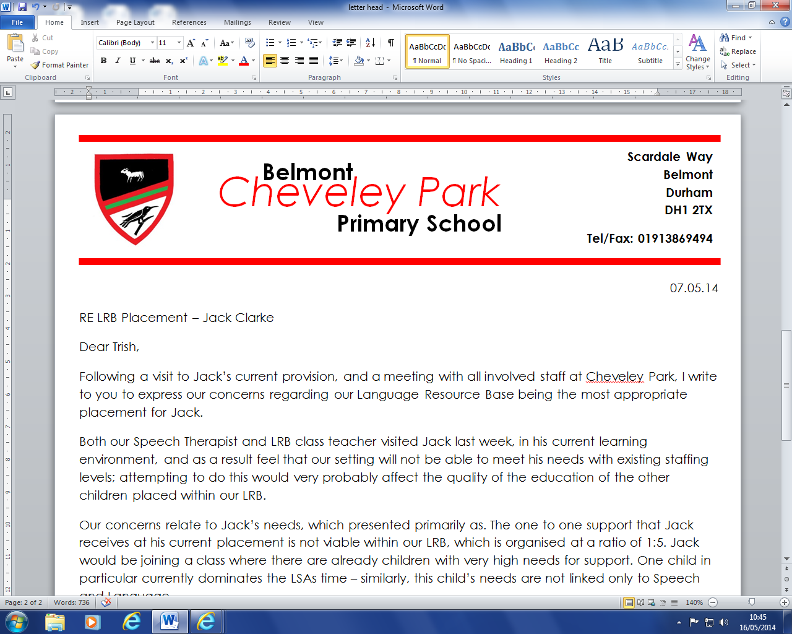

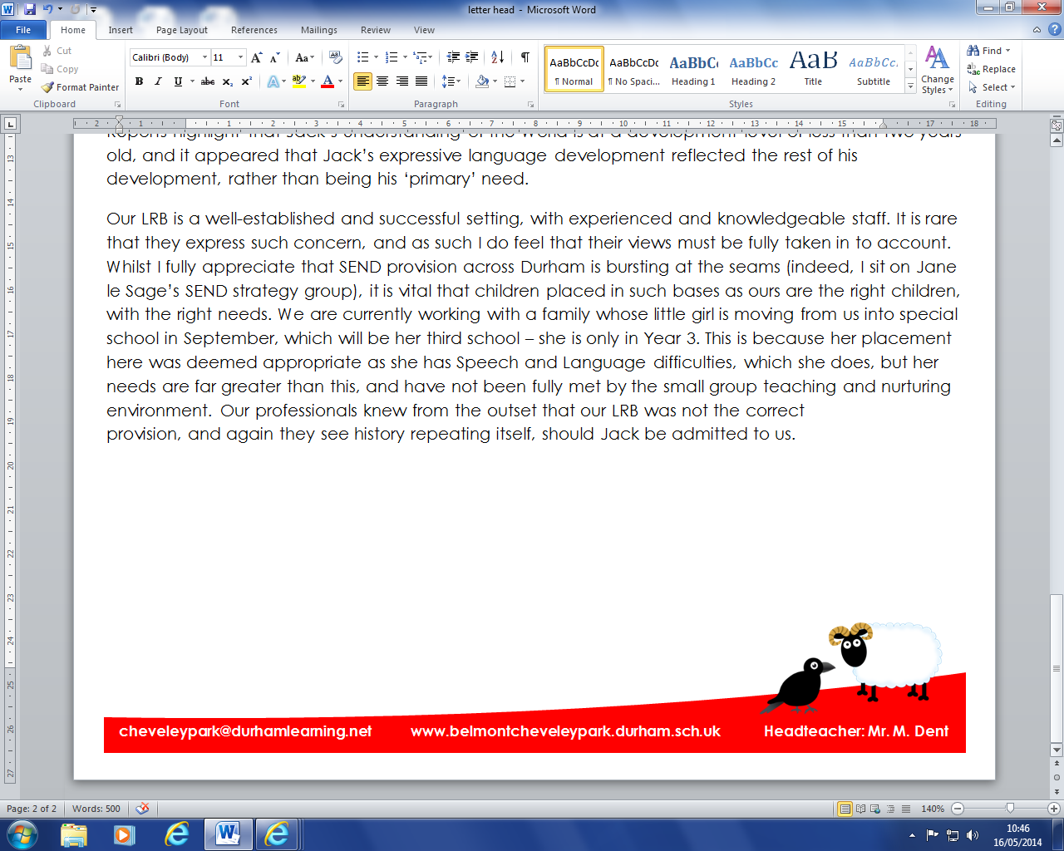

Dear Applicant,

Thank you for your interest in working with us as a cleaner.

We are looking for a great cleaner with high standards to help us to care for our school. We need you to take pride in our building – and in your work so that we can rely on you to do your best to help keep our environment sparkling!

You will need to be trustworthy, flexible, friendly and kind – as our children will often be on site after school and like to chat! You will be working in a small team, so must be reliable and committed.

Interviews will be held week commencing 27th April 2015.  
  
This post is not open to job share.  
  
Please note that the Childcare Disqualifications Regulations 2009 apply to this position and therefore you are required to complete the “disqualification by association” declaration form (attached). Should you be successful in your application for this post, your appointment can not be progressed without this declaration. You will also be required to complete an enhanced DBC check.

You can download packs from the ‘vacancies’ section of our school website, or by calling in to school to pick up a pack in person. Please note, only shortlisted candidates will be contacted.

|  |  |
| --- | --- |
| Closing date | **Thursday 23rd April – 12pm** |
| Interview date | **W/C Monday 27th April** |
| Contact for application packs | **www.belmontcheveleypark.durham.sch.uk/vacancies** |

If you have any questions, please do not hesitate to contact Mr Dent, Headteacher.



**cheveleypark@durhamlearning.net www.belmontcheveleypark.durham.sch.uk Headteacher: Mr. M. Dent**

Scardale Way   
Belmont   
Durham   
DH1 2TX

Tel/Fax: 0191 3869494