Durham Trinity School & Sports College
Additional information for the teaching vacancies
An update on the new school build programme
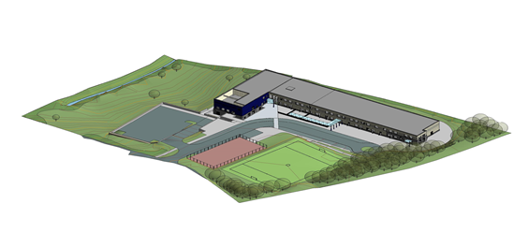
Would you like to teach in this purpose built environment? If so, read on.
The new school building is scheduled to open after half term in November 2014.
The new school building is located at Flambard Premises, Aykley Heads, Durham.
Our new school building will accommodate:
- Nursery, KS1 & KS2 classes, all ages of specialist ASD provision, all ages of sensory provision on the ground floor. Each class has direct access to their outdoor learning space.
- Secondary pupils and Post 16 pupils on the first floor. Specialist teaching rooms are located on this floor.
There are 2 dining areas on the ground floor. One will be used by primary pupils and the other by secondary pupils. The multi purpose hall will be timetabled for PE lessons throughout school.
The design of the building has embraced the gradient of the site and there is a small lower ground floor area. The small swimming pool is located on this level along with a variety of rooms for professionals, visiting and school based staff.
Externally there will be a mugar and sports field. The sports field will be operational from April 2016 after the current school building has been demolished and the seed sown. There is also a grassed area for pupil use below the building and car park.
A staffing structure review has taken place a number of new posts (teaching, non-teaching and premises support staff) have been created.
We are a popular school. Currently there are 189 pupils on roll. To date we have 203 places allocated to pupils in September 2014. The new school building will have capacity for 220 pupils.
The school prospectus can be accessed on the school website www.durhamtrinity.durham.sch.uk

The teaching posts currently being advertised are new posts.
The enclosed staffing structure paper illustrates the new posts and the diversity of the work force.
Assistant Headteacher post. Lead for pupil attainment, achievement & progress.
This is a new full time
post. The successful candidate will join the Senior Leadership Team.
The post will carry a small teaching commitment which can be primary/secondary/Post 16 based.
Secondary English teacher. This is a new full time post.
We are looking to appoint an English teacher who can deliver relevant Key Stage 4 externally accredited English courses and co-ordinate the delivery of English at Key Stage 3. At Key Stage 3 this will include advising and supporting non- English specialist teachers delivering English.
There will be a secondary tutor group commitment attached to this post.
Music teacher. This is a new full time post.
The music teacher will deliver music throughout the whole school. We are looking for someone who can inspire our pupils and develop their creative skills.
The successful candidate will play at least 1 musical instrument and have the drive to promote creative arts throughout the school including performances.
There will be a secondary tutor group commitment attached to this post.
Nursery teacher. This is a new full time post
In the new school building we will have a discrete 8 (fte) place nursery class, taking pupils from the age of 2. Pupils will have a range of special educational needs including ASD, severe learning difficulties and profound and multiple learning difficulties.
We are looking for someone who will positively engage with families of very young children who have significant special educational needs and develop a nursery environment that ensures each child has the best start in their school life.
As this is a new provision it is a wonderful opportunity for a nursery teacher to develop an exceptional provision from the beginning.
The successful candidate will join the staff in September 2014 and during that first half term will work within the existing EYFS provision.

