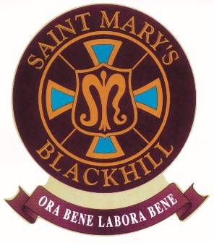
ST. MARY’S R.C. PRIMARY SCHOOL
Pemberton Road, Blackhill, Consett, Co Durham, DH8 8JD
Tel: (01207) 502657

Fax: (01207) 503237
E-mail: blackhillstmary@durhamlearning.net
Website: www.blackhill-st-marys-rc.durham.sch.uk

Headteacher: Mr D Miller

Further Information

Required from As soon as possible.

Grade 3: (points 12-16) £16123- £17419
Permanent, Full Time Post – 37 hours per week (split shift)

The governors of this friendly and successful Primary School wish to appoint a Caretaker/Handyman.

Governors are keen to appoint a trustworthy and reliable individual who can act as a good role model to pupils. The successful candidate should be friendly, show initiative and positively deal with the unexpected challenges and changes to routine that are an inevitable part of school life.

As well as overseeing security and maintaining the cleanliness of the school, the successful candidate will be someone who is willing and able to turn their hand to a variety of repairs and small improvements that will help maintain and enhance the condition of the premises.

Application forms are available to download from this webpage and the school website; completed forms should be returned to the school by the closing date: 12 noon, 27th September 2018.

Interviews will be held 4th October 2018

Durham County Council is an Equal Opportunities Employer. We want to develop a more diverse workforce and we positively welcome applications from all sections of the community. Applicants with disabilities will be invited for interview if the essential job criteria are met.

Please note that the Childcare Disqualifications Regulations 2009 apply to this position and therefore you are required to complete the “disqualification by association” declaration form. Should you be successful in your application for this post, your appointment cannot be progressed without this declaration.

Please note that this position is whole time, which means that you will be in attendance at work all year round (52 weeks a year) and will have an annual leave entitlement (26 days if you have less than 5 years’ continuous local government service, 31 days if you have in excess of 5 years’ continuous local government service; pro rata for part time), which must be taken during school closure periods. During periods of school closure outside of your annual leave entitlement, you are required to be in attendance at work.

This post is not open to job share.

St Mary’s RC Primary School
Pemberton Road
Blackhill
Consett
County Durham
DH8 8JD

Tel: 01207 502657
Email: blackhillstmary@durhamlearning.net

