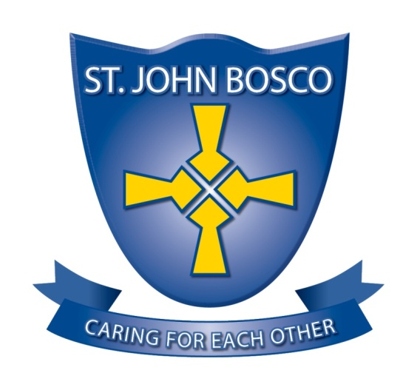

ST. JOHN BOSCO RC PRIMARY SCHOOL

DEPUTY HEADTEACHER JOB DESCRIPTION

The school has been designated by the Secretary of State as a school with a religious character. Its Instrument of Government states that it is part of the Catholic Church and is to be conducted as a Catholic school in accordance with Canon Law, the teachings of the Roman Catholic Church and the Trust Deed of the Diocese of Hexham and Newcastle. At all times the school is to serve as a witness to the Catholic Faith in Our Lord Jesus Christ. The post therefore requires a practising Catholic who can show by example and from experience that he or she will ensure that the school is distinctively Catholic in all its aspects.

This appointment is with the governors of the school under the terms of the Catholic Education Service contract signed with the governors as employers. It is subject to the current conditions of service for Deputy Headteachers contained in the School Teachers’ Pay and Conditions document and other current education and employment legislation. In carrying out his/her duties the Deputy Headteacher shall consult with the Headteacher and, when appropriate, with the governing body, the Diocese, the local authority, the staff of the school, the parents of its pupils, the parish(es) served by the school and other local Catholic schools, particularly where collaboration or federation is being developed.

This job description is based on the key areas identified in the National Standards of Excellence for Headteachers published by the Department for Education (2015). It recognises the role of the Deputy Headteacher in sharing responsibility for the leadership of the school. Where specific responsibilities have been agreed for the Deputy Headteacher for individual key areas, it is recommended that that these be added to the list of main tasks and actions. Other specific tasks e.g. designated safeguarding officer should be added as required.

The governing body and the Diocese acknowledge the importance of the role of the Catholic Deputy Headteacher and will actively offer long term support, encouragement, affirmation and realistic challenge to the successful candidate. The governing body and the Diocese are committed to safeguarding and promoting the welfare of children and young people and vulnerable adults and the Headteacher must ensure that the highest priority is given to following the guidance and regulations to safeguard them. The successful candidate will be required to undergo an Enhanced check for Regulated Activity from the Disclosure and Barring Service.

The core purpose of the Deputy Headteacher is to assist the Headteacher to set and implement the strategic direction of the school and to provide professional leadership and management to drive achievement of high standards in all areas of the school’s work, particularly in ensuring the provision of sustainable outstanding education through the preservation and development of its Catholic character. The school’s objectives relate to the provision of Catholic education and the school is part of the Catholic Church and, as such, is to be conducted as a Catholic school in accordance with Canon Law, the teachings of the Catholic Church and the Trust Deed of the Diocese of Hexham and Newcastle. Therefore, the post of Deputy Headteacher must be filled by a practising Catholic who can show, by example and from experience, that he or she will ensure that the school is distinctively Catholic in all aspects. The term school covers both voluntary aided schools and academies
THE FOUR DOMAINS

The National Standards of Excellence for Deputy Headteachers are set out in four domains.
There are four ‘Excellence as Standard’ domains:

- Qualities and knowledge
- Pupils and staff
- Systems and process
- The self-improving school system

Within each domain there are six key characteristics expected of the nation’s Deputy Headteachers.

DOMAIN ONE
Excellent Deputy Headteachers in Catholic schools: qualities and knowledge Deputy Headteachers:

- Deputise for the Headteacher in his/her absence and work with the Headteacher to hold and articulate clear values and moral purpose, which take account of the educational mission of the Church focused on providing a world-class education for the pupils they serve.
- Demonstrate optimistic personal behaviour which stems from Christ’s vision for humanity. Promote positive relationships and attitudes towards their pupils, staff and parents.
- Inspired by Christ, lead by example – with integrity, creativity, resilience, and clarity – drawing on their own professional knowledge, understanding, expertise and skills.
- Pursue continuous professional development.
- Work within a clear set of principles influenced by the Gospel message and Church teaching, centred on the school’s vision.
- Work with the Headteacher to communicate compellingly the school’s vision and drive the strategic leadership, empowering all pupils and staff to excel.

DOMAIN TWO
Excellent Deputy Headteachers in Catholic schools: pupils and staff
Deputy Headteachers will work with the Headteacher to:

- Demand ambitious standards for all pupils.
- Secure excellent teaching.
- Establish an educational culture of ‘open classrooms’ as a basis for sharing best practice within the school.
- Create an ethos within which all staff are motivated and supported to develop their own skills and subject knowledge, and to support each other.
- Identify emerging talents, coaching current and aspiring leaders in a climate where excellence is the standard, leading to clear succession planning.
- Hold staff to account for their professional conduct and practice, emphasising the distinctive nature of Catholic Education.

DOMAIN THREE
Excellent Deputy Headteachers in Catholic Schools: systems and process
Deputy Headteachers will work with the Headteacher to:

- Ensure that the school’s systems, organisation and processes are well considered, efficient and fit for purpose, upholding the principles of transparency, integrity and probity reflecting the school’s Gospel values.
- Provide a safe, calm and well-ordered environment for all pupils and staff, focused on safeguarding pupils and developing their exemplary behaviour in school.
- Establish rigorous, fair and transparent systems and measures for managing the performance of staff, addressing any under-performance, supporting staff to improve and valuing excellent practice.
- Develop effective governance.
- Ensure effective and efficient use of budget and resources.
- Develop leadership throughout the school.

DOMAIN FOUR
Excellent Deputy Headteachers in Catholic schools; the self-improving system
Deputy Headteachers will work with the Headteacher to:

- Create outward-facing schools which work with other schools and organisations – in a climate of mutual challenge – to champion best practice and secure excellent achievements for all pupils
- Develop effective relationships with fellow professionals and colleagues in other public services to improve academic and social outcomes for all pupils.
- Ensure that the school is constantly seeking to be self-improving.
- Provide high quality professional development opportunities for all staff.
- Model innovative approaches to school improvement and leadership.
- Inspire and influence others – within and beyond schools – to believe in the fundamental importance of Catholic education in young people’s lives and to promote the value of education.

