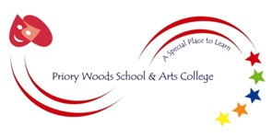

PRIORY WOODS SCHOOL & ARTS COLLEGE

“ A Special Place to Learn “

School Information:

Priory Woods & Arts College is an all age special school situated in Netherfields. We are co-located with Outwood Ormesby Academy on a modern purpose built site. We provide a quality, inclusive education for our pupils who have a range of needs including severe learning difficulties, profound and multiple learning difficulties and complex needs.

We have a large team of teachers, teaching assistants, care assistants lunchtime assistants and office support staff. Our work is also supported by Speech and language Therapist a Physiotherapists and a School Nurse.

The mission statement of Priory Woods is that:-

‘By working together, our pupils will enjoy a creative, innovative, exciting and challenging curriculum within a safe environment which will enrich and enhance every child’s learning’

Schedule:

Closing Date for Applications: 28th April 2017
Interviews: Monday 8th May 2017

