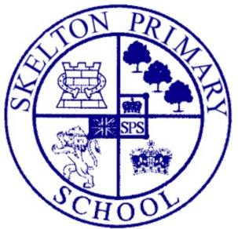

PRIMARY CLASSROOM TEACHER for September 2017
Main scale (temporary for one year)
M1-U3 £22,467-£38,250

The Governing Body, children and staff of Skelton Primary School are looking for a creative and enthusiastic classroom teacher to join our supportive and dynamic school family in Lower School. This is an exciting post for a candidate interested in working with pupils age 3-6 years.

We are looking for someone special who aims for excellence at all times. They must have a passion to make a difference to the lives of our children, be a good communicator with a real ability to inspire and motivate. They must be enthusiastic and hardworking and enjoy working as part of a team. A sense of humour is essential!

Please click here to be taken to our website to find out more information. Informal visits by prospective candidates are warmly welcomed and encouraged and can be arranged by contacting Sarah Walker: headteacher@skeltonprimaryschool.co.uk. Application forms and further details are available from and returnable to the school office.

Closing date noon on April 28th.

Interviews will take place during week beginning May 2nd.

We are committed to safeguarding and promoting the welfare of children and young people and expects all staff and volunteers to share this commitment. This post is subject to an enhanced DBS check together with other relevant employment checks. Please note that we do not accept CVs.

