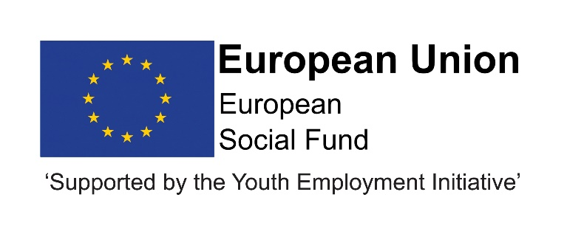

Job Description
Post title | Marketing Support Officer
JE Reference No | N10380
Grade | 5
Service | Children and Young People’s Services
Service Area | Education & Skills; Progression and Learning
Reporting to | Marketing Officer
Location | Your normal place of work will be County Hall. However, you may be required to work at any council workplace within County Durham.
DBS | This post is not subject to an enhanced disclosure.
Flexitime | This post is eligible for flexitime.
Politically restricted | This post is not designated as a politically restricted post in accordance with the requirements of Section 1(5) of the Local Government and Housing Act 1989 and by regulations made from time to time by the Secretary of State.
Relevant to this Post | This post is part funded until December 2023 through the ESF 1.2 DurhamDirections project through the 2014-2020 European Structural and Investment Funds Growth Programme in England. This post will spend 70% of time on DurhamDirections.  This post is part funded until 31 December 2023 through the ESF/YEI DurhamWorks 3 project; this post will spend 30% of time on DurhamWorks 3. This post is part funded through ESF and the Youth Employment Initiative, under the 2014-2020 European Structural and Investment Funds Growth Programme - 1.3 Sustainable Integration of Young People into the Labour Market.  The contract is permanent.

Description of role

The post holder will assist with all aspects of marketing and communications related to the projects.

Duties and responsibilities

Listed below are the responsibilities this role will be primarily responsible for:

- Assisting in the delivery of integrated marketing campaigns which promote the range of activities available from the projects to young people and employers.

- Supporting the use of all digital platforms including the website, Facebook and Instagram as the key tools for recruitment and promotion of the projects.

- Assisting with the support of Delivery Partners and Subcontractors to market their delivery, including the creation of case studies, good news stories and promotional materials.

- Assisting in the production of the project’s internal and external publications and other communications.

- Representing and promoting the projects at events and other campaign activities.

- Monitoring the outcomes from communications, marketing activity and other relevant information and support the development and production of evaluation reports and analysis.

- Ensuring close working relationships with, and assisting, staff on both projects.

- Commitment to continuous professional development.

- Understanding and keeping up to date with all protocols and strategies within the communications and marketing team offering ideas to improve these where appropriate.

The above is not exhaustive and the post holder will be expected to undertake any duties which may reasonably fall within the level of responsibility and the competence of the post as directed by your manager.

Organisational responsibilities

- Values and behaviours
To demonstrate and be a role model for the council’s values and behaviours to promote and encourage positive behaviours, enhancing the quality and integrity of the services we provide.

- Smarter working, transformation and design principles
To seek new and innovative ideas to work smarter, irrespective of job role, and to be creative, innovative and empowered. Understand the operational impact of transformational change and service design principles to support new ways of working and to meet customer needs.

- Communication
To communicate effectively with our customers, managers, peers and partners and to work collaboratively to provide the best possible public service. Communication between teams, services and partner organisations is imperative in providing the best possible service to our public.

- Health, Safety and Wellbeing
To take responsibility for health, safety and wellbeing in accordance with the council’s Health and Safety policy and procedures.

- Equality and diversity
To promote a society that gives everyone an equal chance to learn, work and live, free from discrimination and prejudice and ensure our commitment is put into practice. All employees are responsible for eliminating unfair and unlawful discrimination in everything that they do.

- Confidentiality
To work in a way that does not divulge personal and/or confidential information and follow the council’s policies and procedures in relation to data protection and security of information.

- Climate Change
To contribute to our corporate responsibility in relation to climate change by considering and limiting the carbon impact of activities during the course of your work, wherever possible.

- Performance management
To promote a culture whereby performance management is ingrained and the highest of standards and performance are achieved by all. Contribute to the council’s Performance and Development Review processes to ensure continuous learning and improvement and to increase organisational performance.

- Quality assurance (for applicable posts)
To set, monitor and evaluate standards at individual, team and service level so that the highest standards of service are delivered and maintained. Use data, where appropriate, to enhance the quality of service provision and support decision making processes.

- Management and leadership (for applicable posts)
To provide vision and leadership to inspire and empower all employees so they can reach their full potential and contribute to the council’s values and behaviours. Managers and leaders must engage in personal development to ensure they are equipped to lead transformational change; always searching for better ways to do things differently to meet organisational changes and service priorities.

- Financial management (for applicable posts)
To manage a designated budget, ensuring that the service achieves value for money in all circumstances through the monitoring of expenditure and the early identification of any financial irregularity.

The above is not exhaustive and the post holder will be expected to undertake any duties which may reasonably fall within the level of responsibility and the competence of the post as directed by your manager.

Person Specification

 | Essential | Desirable | Method of Assessment
Qualification | - NVQ Level 3 or equivalent | - Educated to degree level of equivalent | - Application form  - Pre-employment checks  - Interview
Experience | - Experience of working in a marketing and/or communications function  - Experience of assisting in the delivery of communications and/or marketing campaigns and evaluation. | - Experience of creating digital content for social media and web. | - Application form  - Interview  - References
Skills / Knowledge | - Strong computer skills including web and social media  - Understanding marketing and communications evaluation tools and techniques  - Excellent ability to communicate clearly and effectively verbally and in writing to a wide range of audiences through a range of media  - Good inter-personal skills. |  | - Application form  - Interview  - References
Personal Qualities | - Energetic, enthusiastic, confident and self-motivated  - Ability to work to tight deadlines  - Ability to use initiative and plan work effectively  - Customer focused  - Ability to contribute towards effective team working  - Innovative approach to problem solving and multi-tasking to a mix of deadlines  - Ability to work unsupervised  - Committed to the principles of equality and diversity  - Access to a car or means of mobility support (if driving then must have a current valid driving licence and appropriate insurance). |  | - Application form  - Interview  - References

