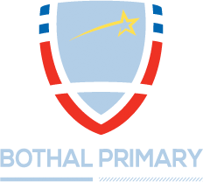

Required September 2018

Deputy Head of School
L8-L12

Bothal Primary School require a Deputy Head of School to join us in our exciting journey from good to outstanding. This is a fantastic opportunity for a dynamic and motivated professional to join our thriving leadership team.

‘The highly skilled governing body, school leaders and the wider school community provide a formidable team, constantly striving to ensure that a continued cycle of improvement is the norm….Pupils’ attitudes to learning are excellent … the school’s work to promote pupils’ personal development and welfare is outstanding.’ Ofsted, April 2018.

If you have high expectations and an unwavering desire to provide the best possible teaching, outcomes and experiences for all pupils then we would love to hear from you.

We are committed to safeguarding the welfare of children and young people and expect the same commitment from our employees. All new staff will be subject to an enhanced DBS clearance, identity checks, qualification checks, and employment checks, including the investigation of any gaps between jobs and two satisfactory references.

Visits are warmly welcomed and can be arranged by contacting Louise Hall, Head of School at louise.hall@alptrust.co.uk or telephone us on 01670 812360.

Completed applications to be returned to jayne.hawkins@alptrust.co.uk

Closing Date: 9am Monday 21st May 2018.
Interviews: Wednesday 23rd May 2018.

