Durham County Council

Apprenticeship Information Pack

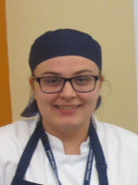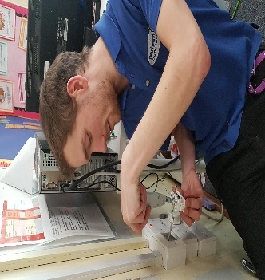
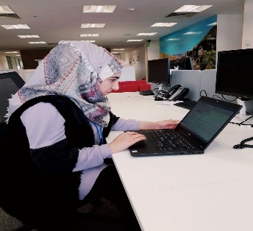

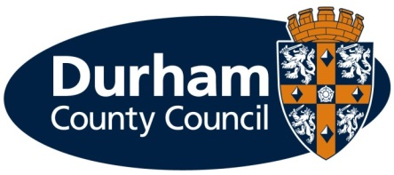
What is an apprenticeship?

Apprenticeships are an excellent option for all ages. An apprenticeship is a genuine job where you will receive formal training to gain a recognised qualification alongside gaining technical knowledge, practical experience and wider skills you need for employment and a future career.

What types of apprenticeships are available?

We currently have a Business Administration vacancy for our new Business Services team whom provide support to teams across the Council.

Durham County Council provides the majority of local council services in the county. The council offers a huge range of job opportunities and a wide range of apprenticeships are also available including catering, accounting, construction and business administration to name a few. We have the career to meet your aspirations. Further information on the council’s services can be found on our website at www.durham.gov.uk

We are pleased to be offering the following apprenticeship for a March 2020 start:

Service Area | Apprenticeship | Length of Apprenticeship | Location | Training | Training Provider
Adult Learning and Skills Service | 1 x Apprentice (Business Administration) | 2 years | Crook Civic Centre | Business Administration Level 2 or 3 | Durham County Council Adult Learning and Skills Service

What are the different levels of apprenticeship on offer?

Our internal training provider will enrol you onto the most suitable level of course depending upon your existing qualifications and experience, either;

- Intermediate level (Level 2) – equivalent to five GCSE passes
- Advanced level (Level 3) – equivalent to two A level passes

How much will I earn?

This will depend on the type of apprenticeship you are doing.

If you are working towards a Level 2, 3 or 4 qualification during the term of your apprenticeship (excluding craft apprenticeships) you will be paid:

- £3.90 per hour for the first year of your apprenticeship
- If you are aged 19 years or over and have completed the first year of your apprenticeship you will then be paid:
  - 19 to 20 year old £6.15 per hour
  - 21 to 24 year old £7.70 per hour
  - 25+ years £8.21 per hour
(Rates effective from 1 April 2019 and will be increased in April 2020)

You will be paid on the last working day of each month, with the money paid directly into your bank account.

Your apprenticeship training will be fully funded by the council.

What should I expect from an apprenticeship at the council?

- A workplace induction to help you understand your role and the council
- A structured work programme working alongside experienced employees
- Ability to study towards a recognised qualification
- Regular review meetings with your manager
- A workplace mentor
- Opportunities to undertake work based and off the job training
- Access to a range of training opportunities
- Support to help you apply for jobs
- To be part of an Apprenticeship Network where you will receive updates of what is happening across the council including any training or job opportunities available, build a network of support, be able to discuss support/information required and put forward ideas for improvements.
- Working in an environment that promotes an inclusive and diverse workforce.

What are the additional benefits of working for the council?

- Holiday entitlement
- Pension
- A range of flexible working options, some depending on job role
- Maternity, paternity, dependency and adoption leave
- Sickness pay

How do I apply?

If you are not already registered you will need to register with North East Recruitment Portal and apply online at https://www.northeastjobs.org.uk/default.aspx?page=orghome&orgid=73 Click on the apprenticeship job category to see the opportunities available.

If you require any reasonable adjustments at the application or selection stage, please contact Peter Brockman, Senior Resources and Development Officer (Organisational Workforce Development Team) on Tel: 03000 268 547 or via email (peter.brockman@durham.gov.uk)

Key dates

Applications | Online applications close on 2 March 2020
Shortlisting | Takes place the week following the closing date
Interviews | Take place a week after shortlisting is completed

If you are shortlisted you will receive notification of the date and time of your interview via an e-mail from North East Recruitment Portal.

Additional Support

As a disability confident employer, we welcome applications from people with disabilities and as an inclusive employer we recognise the importance and benefits of having an inclusive and diverse workforce. To ensure we can offer the best possible support for applicants, we will pro-actively make reasonable adjustments within the recruitment and selection process for disabled people.

The range of reasonable adjustments that can be accommodated throughout the selection process include (but is not exhaustive):

- Alternative formats for job applications
- More detailed/pictorial instructions for interview
- Support from an appropriate person at the interview
- Additional time to complete applications (and or tests) where appropriate.
- Adjustments to interview venue/accommodation
- Adjustments to method of testing
- Adjustments to interview questions e.g. receiving questions in advance

Please contact Peter Brockman, Senior Resources and Development Officer, Organisational Workforce Development Team on Tel: 03000 268 547 or via email (peter.brockman@durham.gov.uk) to discuss any reasonable adjustments in more detail. This will ensure you get the appropriate support during the recruitment and selection process.

In addition to reasonable adjustments, the council also provide a ‘guaranteed interview scheme’ which allows people with disabilities to be shortlisted where they demonstrate they can meet the essential criteria of the role.

What happens if I am unsuccessful?

If you have been unsuccessful with your application to a role at Durham County Council, we would like to support you as much as possible with reviewing your options. Therefore;

- If you are unemployed and between 18-24 live in County Durham and would like support with education or training, please e-mail: durhamworks@durham.gov.uk or telephone: 0300 026 2930 for further information, support, advice and guidance.

- If you are 19 years of age and older you can also access support, information, advice and guidance or access accredited qualifications on a formal or flexible basis through our Adult Learning and Skills Service (ALSS). From more information or to speak to one of our engagement team, please contact us by emailing alss@durham.gov.uk or telephone: 03000 266 115.

There are no restrictions, in terms of accessing this services, and we would treat each enquiry on an individual basis.

We look forward to hearing from you.

Overview of the service area:
Business Services & Transformation

The Business Services team was created in 2019 to provide an efficient and effective business and administration support service across the whole of Durham County Council.

With over 700 employees, we have colleagues based in teams across the whole of County Durham including from offices at Seaham, over to Crook, up to Consett and down to Barnard Castle.

As a new team, we are continuing to shape and change to support the Councils’ needs, our apprentices are an important part of this and our desire to improve the services we provide to our customers and the public of County Durham.

We currently have Business Administration apprentice vacancy located at;

Adult Learning and Skills Service - The team works with entering data from enrolments forms for all of the adult learning courses that the Council Provides, including Apprenticeships, Traineeships, Supported Internships and Direct and Subcontracted courses. A high level of accuracy and attention to detail is required as entry of funding has a direct impact on funding (Full training and mentoring is given by the whole team). Also dealing with incoming public enquiries relating to course information.

Our Transformation Programme

Our Vision for the future is simple but very ambitious. Our Vision is based upon achieving four distinct objectives;

● redesigned our services to better meet customers’ needs at reduced cost to the Council.
● helped communities become more self-reliant and resilient
● moved our partnership working from good to great
● become renowned for our skilled and flexible workforce and our employee engagement.
In order to achieve this we have launched our “Inspire” Transformation programmes and projects to drive significant change and innovation through the Council, to help us provide the very best outcomes with the resources available. The programme is based on three interlinking themes:

Inspiring Change is about looking at how we work as a single organisation for the benefit of the people of County Durham. To do this we will adopt a ‘One Council’ approach, looking at how to get the best out of digital technology, work smarter on the front line and de-clutter our business processes.
Inspiring People: To transform our services, we must change the way that we work. This means not only changing our systems, services and processes but also our behaviours, values and attitudes. This change in mind-set is needed throughout our council to make the transformation happen in practice.
Inspiring Places are flexible working spaces that are paper-lite and clutter free.
- Priority zones: areas where teams are based while having the flexibility to use equipment, desks etc across other sites.
- Shared desks: these will have easy laptop plug-in monitors, a keyboard and mouse.
- Touchdown areas/hot desk areas: standing and seating areas for short stays.
- Break out spaces: unbookable areas where you can have informal meetings, take confidential phone calls, find a quiet space for writing or reading reports.
- Meeting rooms: various sized rooms for discussions that require a discrete space. All meeting rooms will be bookable.
- Centralised facilities: facilities such as photocopier/printers (MFDs)

