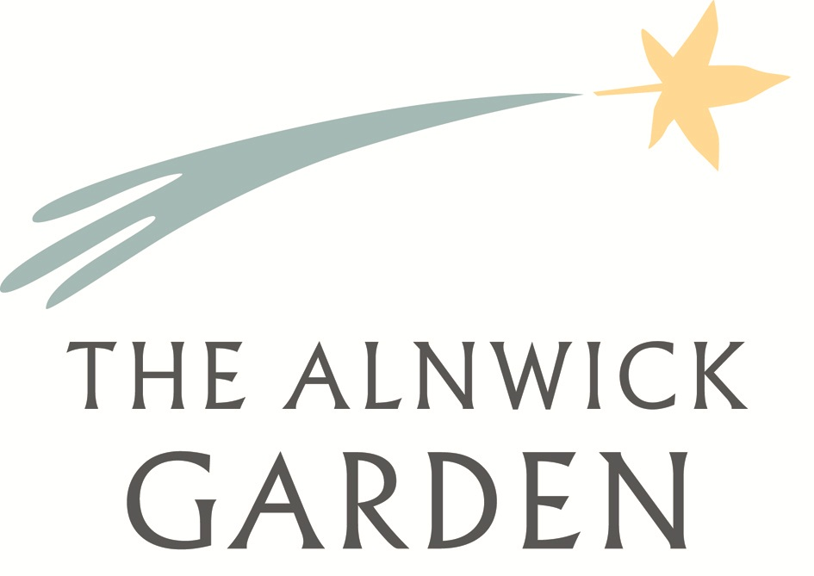
Application for Employment

Vision – Cultivate communities and raise aspirations in a place of beauty.

Mission – Fearlessly inspiring and connecting people in an inclusive garden environment that creates learning opportunities and enriches lives.

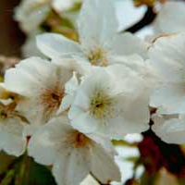

Before you start please note additional sheets (other than those enclosed in this application) or CVs should not be submitted along with this application. Any additional sheets or CVs will be destroyed. If your application is successful you will be invited to attend an interview, following which a conditional offer may be made subject to necessary reference, eligibility and security checks.

This application may be photocopied, therefore please ensure that all sections are completed as legibly as possible and in black ink. This application is made up of ten sections over eight pages. Failure to complete the application form in full may affect your application.

If you require adjustments to be made to this application, or our application process under provisions of The Equality Act 2010 please contact a member of the People Services team.

Pages one, two and three of this application will be removed before your application is assessed by recruiting managers.

The Alnwick Garden
Gardener’s Cottage
Greenwell Road
Alnwick
Northumberland
NE66 1HB
T: 01665 511350
E: stephen.telford@alnwickgarden.com
W: www.alnwickgarden.com

Section One – Personal Details

Surname |  | Title
Forename(s)
Address
Telephone number |  | Mobile number
Email address
Are you eligible to work in the UK? |  | Yes/No
Do you hold a UK driving licence? |  | Yes/No

Section Two – Declaration

I confirm that all of the information given is, to the best of my knowledge, true and accurate, and I understand that to make a false declaration could jeopardise my application or, if found to be false once employment has commenced, could lead to my dismissal.

Signature |  | Date

Return completed applications to:

Head of People Services and Development, The Alnwick Garden, Gardener’s Cottage, Greenwell Road, Alnwick, Northumberland, NE66 1HB
Or
stephen.telford@alnwickgarden.com
Please note
The Alnwick Garden will hold your application securely; however, we can make no guarantee of privacy with email communication. We advise you don’t email information which, if intercepted, would cause you distress.

Section Three – References

Please supply at least two people who will provide a reference. One reference must be your most recent employer. Academic referees are also acceptable.
Referees may be contacted prior to interview unless you have asked us not to. Where you do not give us this permission, references will be requested after we make you a conditional offer.
Name |  | Name
Company |  | Company
Address |  | Address
Telephone number |  | Telephone number
Email address |  | Email address
Relationship to you |  | Relationship to you
May we contact them prior to an interview? |  | May we contact them prior to an interview?

Section Four – Convictions
Do you have any unspent criminal convictions or offenses?
Do you hold a valid DBS certificate?
If yes, please provide details

** THIS PAGE HAS BEEN LEFT INTENTIONALLY BLANK**

Section Five – Data

How we will use your data

Your personal data will be stored securely by The Alnwick Garden. The Alnwick Garden and its processors* will use this information to assess your suitability for employment. You don’t have to provide what we ask for but it might affect your application if you don’t. If your application is successful, your data will be held for the duration of your employment plus seven years. If you are unsuccessful following assessment for the position you have applied for, we will retain your details in our talent pool for a period of six months.

You have the right to request a copy of the information that we hold about you. If you would like a copy of some or all of your personal information, please write to us at the address on the cover of this document or email privacy@alnwickgarden.com. We want to make sure that your personal information is accurate and up to date, you may ask us to correct information you think is inaccurate. If you’d like us to restrict or stop processing your personal data at any time, please write to us at the address on the cover of this document or email privacy@alnwickgarden.com.
*A full list of data processors and further information about the use of your data can be found online at www.alnwickgarden.com/privacy or from The Alnwick Garden.

Section Six – Employment History
Employer | Dates (from & to) | Positions held & description of duties | Reason for leaving
If you require further space, please continue in section ten - additional sheet

Section Seven – Education
School/college/university attended | Dates (from & to) | Qualification gained or course attended
If you require further space, please continue in section ten - additional sheet

Section Eight – Additional Information
Please give details of any experience, skill or achievements you feel may be relevant in your application for employment
If you require further space, please continue in section ten – additional sheet

Section Nine – Availability For Interview
Please provide details of any dates that you will not be available for interview.

Section Ten – Additional Sheet

You may use this sheet to continue your response from any of the previous sections. Please indicate each section clearly.

