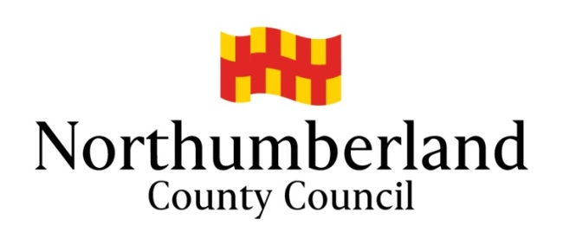

Care Worker – Further information

Our Service offers:-

- Salaried posts with generous, competitive rates of pay with enhancements and Bank Holiday working, including paid travel time between clients
- Expenses and mileage (paid in accordance with the organisation’s agreed rates)
- Paid training on induction
- Uniform / all protective equipment needed
- Company mobile phone
- Free DBS check
- Company Pension scheme
- Staff Benefits scheme
- Out of Hours support
- Annual Holiday entitlement
- Excellent on-going training and support

If this post appeals to you and you feel you have caring qualities and wanted a job that makes a difference within a team known for it’s outstanding service, ring for more information on 01434 612 910 or apply as directed on North East Jobs website.

Contact – Shirley Proctor, Service Manager 01434 612 910

