Northumberland County Council
JOB DESCRIPTION

Post Title: Concessionary Travel Assistant |  | Director/Service/Sector: Corporate Resources - Financial & Customer Services |  | Office Use
Band: 3 |  | Workplace: |  | JE ref: 2667  HRMS ref:
Responsible to: Benefits and Customer Information Centre Manager |  | Date: | Manager Lever:
Job Purpose: To support professional managers in the delivery of effective and efficient administration of concessionary bus passes

Resources | Staff | Not applicable
Finance |  | Co-ordinate responsibility for administration and issue of approx. 80,000 concessionary bus passes with a travel reimbursement value of 5,000,000 annually
Physical |  | Shared responsibility for operation and maintenance of IT systems including ACT concessionary pass software and records including authorising the issuing bus passes
Clients |  | The concessionary bus passes that this post deals with impact directly on the well-being of members of the general public, specifically approx. 80,000eldery or disabled bus pass holders, bus company’s bus drivers, and internal council customers.
Duties and key result areas:

- To administer the Council’s responsibilities for the issue and administration of concessionary bus passes for older and disabled people
- To be responsible for the day-to-day liaison with customers services teams and members of the general public, in the fulfilment of bus pass applications and inquiries.
- To update the ACT bus pass data base for example with address changes, removal and creation of personal records of bus pass holders
- To deal with routine and non-standard queries but refer contentious or difficult issues to the Transport support team leader with recommended courses of action
- To ensure correct data base records are maintained and that any queries are dealt with
- To ensure all complaints and queries relating to bus pass issues are properly followed up
- To take responsibility for the correct maintenance and recording of personal and other data on bus passes and holders, including the upkeep of databases, spreadsheets and documentation
- To assist in producing reports of bus pass holders and of bus pass use, using appropriate software
- To ensure applications for new and replacement bus passes and changes to bus pass holder records are processed and associated tasks are performed within the agreed timescales
- To undertake monitoring and chasing up of outstanding issues regarding bus passes.
- To actively adopt effective and constructive relationships with contractors and bus operators including at senior management levels, regarding bus passes on a daily basis
- To act as principal point of contact for the councils clients such as the general public, contactors and bus operators concerning bus passes.
- To assist in making decisions concerning procedures relating to the issue, monitoring and administration of bus passes
- To provide support and guidance to the general public and bus pass holders regarding bus pass applications and use of bus passes
- To liaise closely with staff in other Directorates regarding bus passes.

The duties and responsibilities highlighted in this Job Description are indicative and may vary over time. Post holders are expected to undertake other duties and responsibilities relevant to the nature, level and extent of the post and the grade has been established on this basis.
Work Arrangements
Transport requirements:  Working patterns:  Working conditions: |  | Occasional travel to meetings/road shows / other offices  May be required to work outside normal office hours during peak times  Extensive use of comport software and data bases
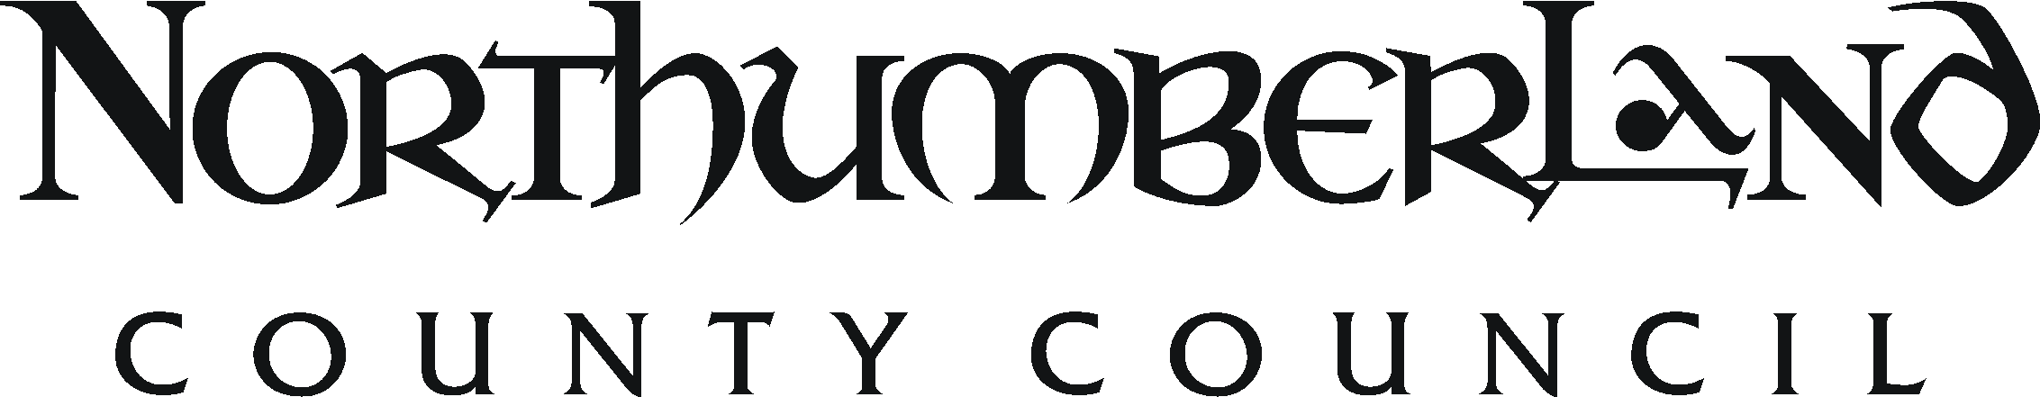 PERSON SPECIFICATION

Post Title: Concessionary Travel Assistant | Director/Service/Sector: | Ref: 2667
Essential | Desirable |  | Assess  by
Knowledge and Qualifications
- GCSE Maths and English or equivalent  - Familiarity with databases and spreadsheets  - Competence with e-mail, Excel and Word  - Understanding of practical issues relating to an Integrated Transport Unit or similar  - Understanding of passenger transport and concessionary travel  - Understanding of cost/quality/customer care relationship  - Willingness to undertake continuing professional and personal development  - Knowledge of concessionary Travel  - Understanding of the diverse functions of the County Council and other organisations | - NVQ level 3 or equivalent  - Understanding of passenger transport
Experience
- Use of IT systems and databases egg Microsoft Office, Word, Excel etc. for office tasks  - Working in a similar environment  - Maintain and updating accurate data base records  - Active desire to provide a high quality service to customers and contractors  - Basic administration background. | - Working in an Integrated Transport Unit
Skills and competencies
- Ability to work as part of a team  - Ability to communicate effectively by telephone, e-mail and face to face  - Ability to pay close attention to detail whilst undertaking repetitive detailed tasks  - Able to express own views effectively in a variety of work situations  - Ability to develop use of IT in the work environment  - Ability to work methodically and systematically  - Ability to use own initiative and work with minimum supervision and also as part of a team.  - Ability to manage own work  - Ability to make effective decisions  - Negotiating and influencing skills | - Ability to produce reports from a variety of sources
Physical, mental and emotional demands
- Ability to stay calm as day-to-day evolving priorities demand flexibility over tasks and workloads
- Ability to maintain a firm but courteous stance under pressure when dealing with disputes
- Confident and articulate in order to effectively express to colleagues and other concerns about accuracy of data base and other records
- Ability to schedule own work load to tight time-scales and deadlines.
- Ability to relate to people at all levels.
- Able to concentrate for long periods on complex work eg scrutinising data base records and application forms
- Ability to maintain a negotiating stance effectively against opposing claims

Motivation
- Dependable, reliable, a good timekeeper and effective guide/mentor to subordinate staff.  - Demonstrates and encourages high standards of honesty, integrity, openness and respect for others.  - Helps managers to create and encourages a positive work culture, in which diverse, individual contributions and perspectives are valued.  - Proactive and achievement orientated  - Able to work with minimum supervision.  - Willing to undertake further training as and when necessary | - Appreciation of how to tackle issues from a corporate perspective
Key to assessment methods; (a) application form, (i) interview, (r) references, (t) ability tests (q) personality questionnaire (g) assessed group work, (p) presentation, (o) others e.g. case studies/visits

