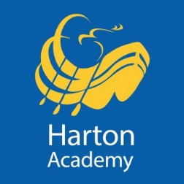
Harton Academy

Receptionist

£17,298 per annum, 37 hours a week, Term Time working plus 1 week

To commence in late October, 2022

We are looking for an enthusiastic and customer focussed individual to be our first point of contact for the many visitors and communications we receive. Your experience will enable you to provide an excellent reception and switchboard service for the Academy, together with comprehensive administrative support for the Academy under the direction of the Office Manager.

We are committed to safeguarding and promoting the welfare of children, young people and vulnerable adults. We expect all our staff and volunteers to share our commitment. Successful applicants are required to obtain an Enhanced Certificate of Disclosure from the Disclosure and Barring Service.

Application packs are available from Harton Academy’s website (below) and should be returned to Harton Academy by midday on Thursday 7th July, 2022.

https://harton-tc.co.uk/year-7-11/information/vacancies/receptionist/

