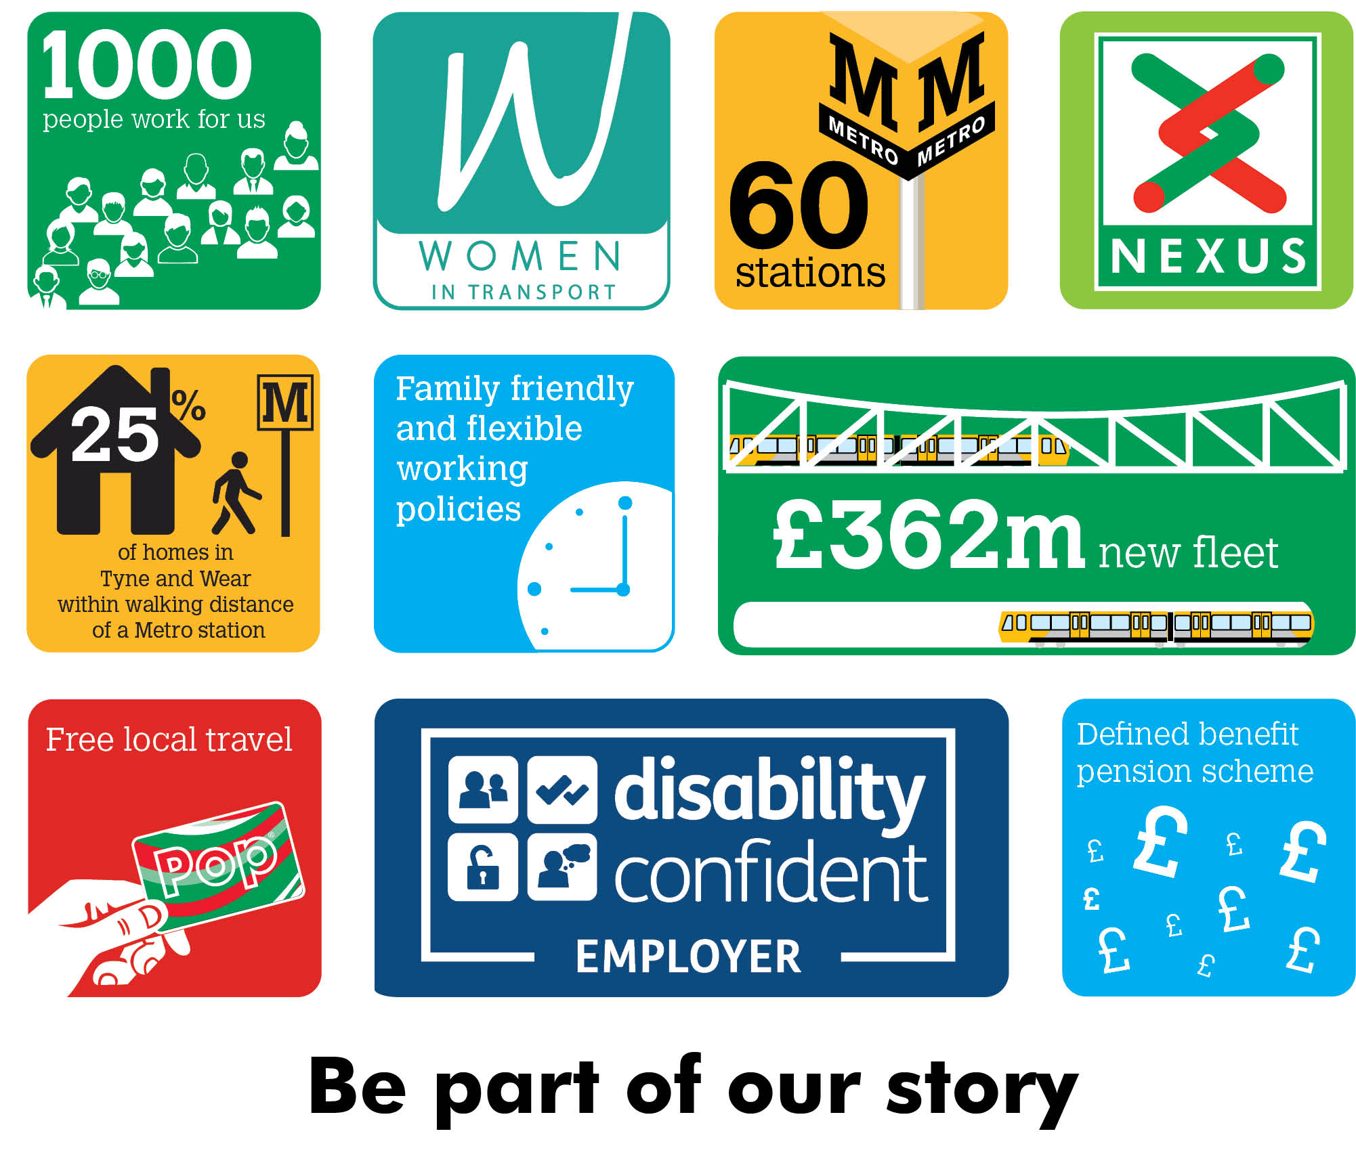

Corporate Planning Trainee
Fixed Term (up to 2 Years depending on progression)
Would you like the opportunity to make a real difference to public transport across the Tyne and Wear area?

The role will be based in the Business Development section of Corporate Planning, and you will be involved in the development of Strategies, Policies and Business Cases to support the full activities of Nexus.

The role involves a tailored programme of learning and development with an opportunity to progress to a permanent Business Development Officer, progression will be dependent on achievement of learning and development outcomes. This position would be suitable for a recent graduate.

For an informal conversation about the role, please contact Matthew Godwin, Business Development Manager. Matthew.godwin@nexus.org.uk – 07816 452750.
Salary £26,456 pa
Plus defined benefit pension scheme, free local travel and access to other benefits.
Closing date 30th May 2022
Find out more at nexus.org.uk or northeastjobs.org.uk

