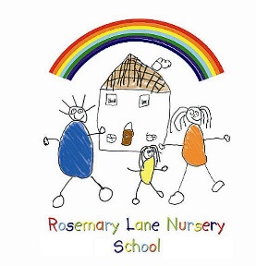

ROSEMARY LANE NURSERY SCHOOL

Assistant Head Teacher

Job Description

Salary scale : Leadership Pay Spine L1- L5

You are required to carry out the professional duties of a nursery teacher with Key Person responsibilities and in addition assist the HeadTeacher in the leadership and management of the total provision of the nursery school. The school delivers education for 2 / 3 and 4 year olds and the leadership role includes working with all ages.

Leading the team

- Lead the full staff team in the planning, delivery and evaluation of a high quality Early Years curriculum in accordance with the Early Years Foundation Stage Framework.
- Promote high standards of individual children’s achievement and ensure the development of a high quality enabling learning environment.
- Promote an ethos and learning climate which enables children to become strong, independent, confident learners.
- Lead the staff team in understanding, identifying and documenting children’s learning.
- Deliver high quality teaching which is appropriate to individual needs and learning styles.
- Support the team with assessment procedures to evaluate children’s learning.
- Provide support for new members of staff through induction programmes.
- Be responsible for the effective deployment of staff and resources within the nursery, supporting with identifying and ordering appropriate resources.
- Encourage the development of a diverse culture that offers equality for all.
- Produce, implement, monitor and review staff procedures and routines to ensure high standards of delivery for children.
- Support the team in their work with children with special educational needs through taking a lead role in: identification, planning, delivery and recording children’s learning.
- Support the team with the delivery of high standards of “Outreach” services for children with SEN in other settings.
- Promote positive links with parents and families, encouraging engagement in all areas of nursery life.

Leadership and management

- Share the responsibility for the education and welfare of all children within the school.
- To actively promote safeguarding policies and procedures both on the nursery site and on out of school visits.
- Work with the HeadTeacher to articulate and promote the ethos, vision and values of the school.
- Maintain the day to day running of the nursery in the absence of the HeadTeacher.
- Maintain and develop the role of the nursery within the community.
- Maintain and develop the partnerships with parents and extended families.
- Take a SENCO role within the nursery.

- Assist the HeadTeacher in:
- Identification of relevant school improvement issues.
- The production and implementation of the School Development Plan.
- School Self Evaluation systems.
- Identification and delivery of staff training and development needs.
- Delivery of a high quality appropriate Early Years curriculum.

- Take a leadership role under the direction of the HeadTeacher in the development of the aims and objectives of the school through: identification of policies and procedures, managing staff and resources and monitoring and evaluating progress.

- Undertake any professional duties reasonably delegated to you by the HeadTeacher.

