External advert

Independent Persons (Volunteer Work)

We are looking for 2 volunteer Independent Persons to assist the County Durham and Darlington Fire Authority in maintaining high standards of conduct. Each Independent Person will assist with the handling of any complaints against elected members carrying out their duties. The term of office will be two years from the date of appointment, with the option to extend for a further two years.

The Authority is responsible for the scrutiny of County Durham and Darlington Fire and Rescue Service (CDDFRS) and for the handling of complaints against its elected members. It is required to take into account the views of an Independent Person before making a decision on any complaint it has decided to investigate. The Independent Person may be consulted by the Monitoring Officer when they are considering complaints made against councillors. Fire Authority Members who are subject to complaints are also entitled to consult the Independent Person for their views.

We are looking for candidates who:
- have a keen interest in standards in public life.
- wish to serve the local community and uphold democracy.
- are able to demonstrate high standards of personal integrity.
- are objective, independent and impartial.
- have direct experience of implementing and upholding standards and/or dealing with complaints and customer care issues.
The position is voluntary and unpaid but forms an important part of upholding standards in public life. If you need to travel to carry out the role, travelling and subsistence allowances will be paid in respect of attendance at meetings. Training for the role will be provided.

If you are or have been a member, co-opted member or an officer of CDDFRS or Durham or Darlington Councils within the last 5 years, or are a relative or close friend of any member or officer of Durham county council, Darlington Borough Council or a town or parish council within County Durham or Darlington, you are not eligible to apply.

Application forms are available on the Authority’s website: www.ddfire.gov.uk or from the County Council’s website www.durham.gov.uk. Paper copies are available from Helen Lynch, Clerk to the Fire Authority, Legal and Democratic Services, County Hall, Durham DH1 5UL. Telephone 03000 269732 or email: helen.lynch@durham.gov.uk
Closing date: 09:00hrs on the 31st May 2023

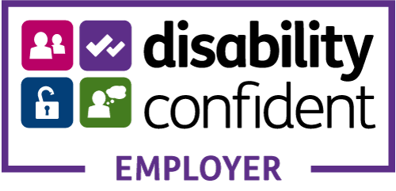 |  | 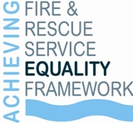
County Durham and Darlington Fire and Rescue Service aims to be an Equal Opportunities Employer and welcomes applications from under-represented groups.
Application details are available in large type, Braille, audio tape and via email. Disabled applicants who meet the essential criteria are guaranteed an interview.

