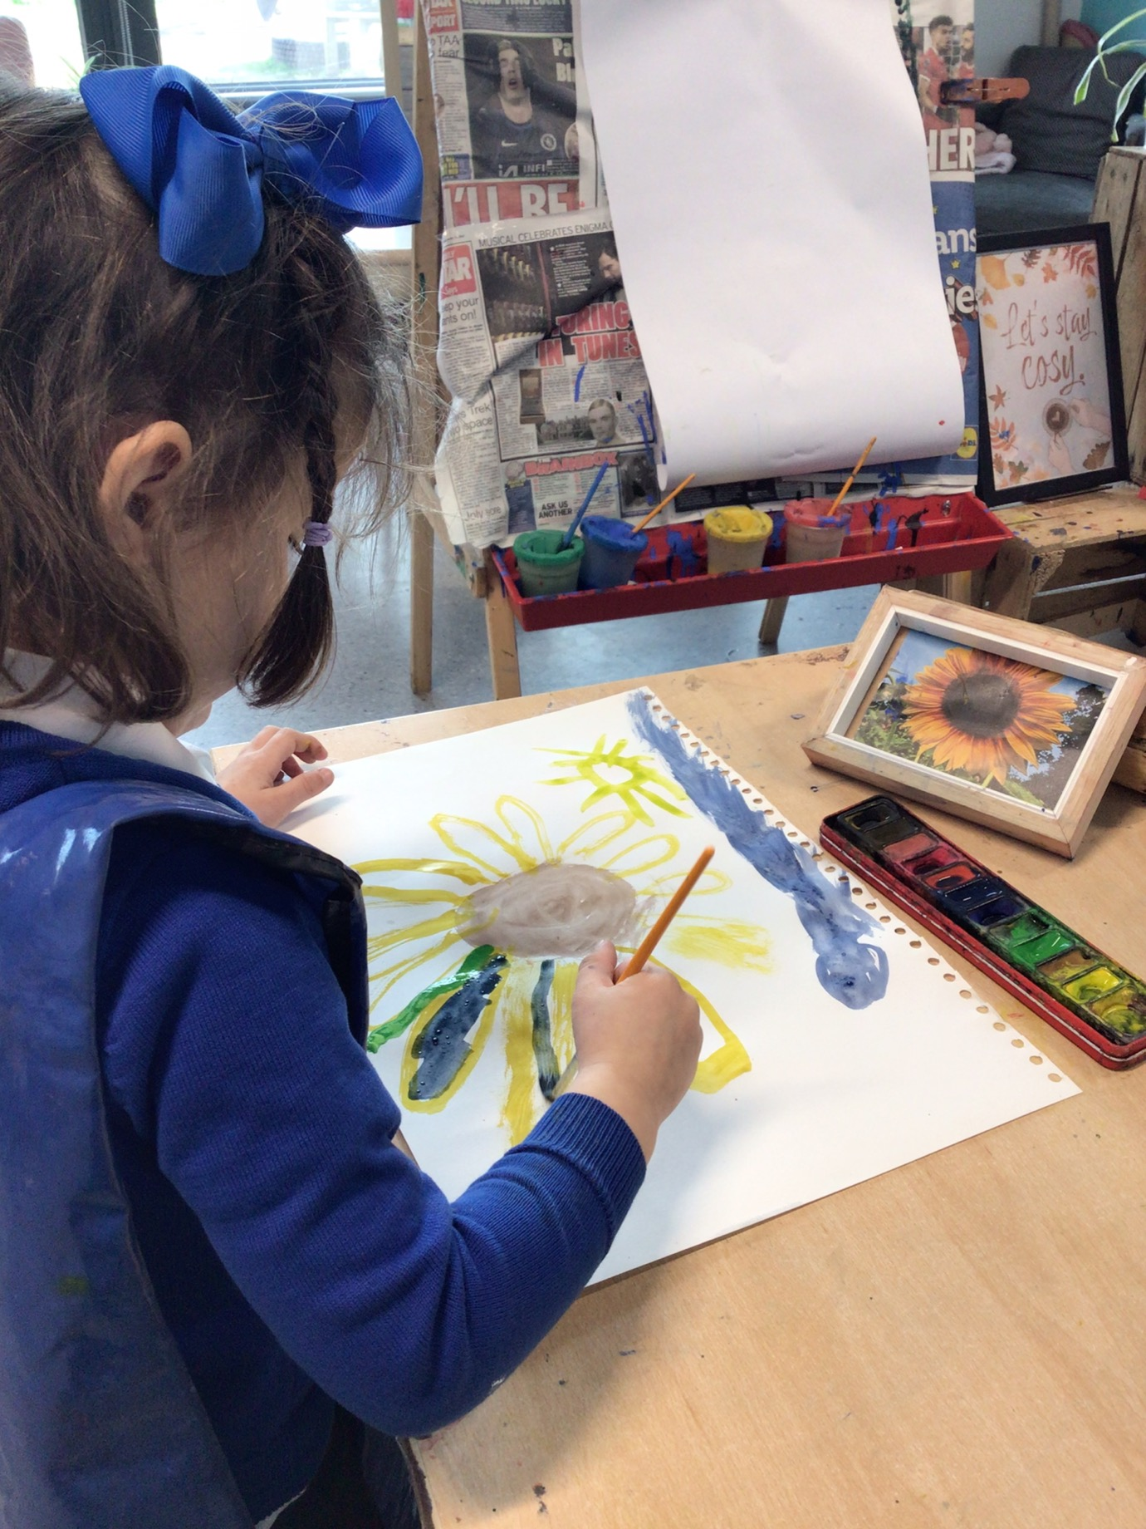
APPLICANT PACK
Special Educational Needs Teaching Assistant
2 x Permanent
1 x 1:1 Fixed Term – August 2027
South Bank Community Primary School

Letter to Applicants

Dear Applicant
We are delighted that you have shown an interest in applying for our vacancies for a Special Educational Needs Teaching Assistant.
Within this pack you will find:
- Details of how to apply for the position
- Job Description and Person Specification for the role
- Further information about our school, including our development offer and benefits and wellbeing package.
At South Bank Primary School, we believe that our staff are our most valuable resource, and we are committed to supporting your development in your role, and supporting your wellbeing through our comprehensive wellbeing offer.
You will be joining a staff team of highly skilled and passionate professionals working within our Special Educational Needs support base to promote the education and development of our most vulnerable learners.
Applications must be returned to the school office either in hard copy or by email to office@southbankprimary.co.uk by the closing date.
Closing date: Wed 15th May 2024 @ 9am
Previous applicants need not apply.
You will be notified by the end of the day on Friday 17th May 2024 if you have been invited to interview.
Interviews will take place on Tuesday 21st May 2024.
We wish you every success with your application.
Best Wishes
Tammy Cooper
Head Teacher

Job Advertisement & Job Description
Required:  Salary:  Hours:  Contract Type: | September 2024 – earlier if possible  Grade D SCP 8-11 (Actual salary £18,913 - £22,157) Pay award pending from April 2024  8.30am to 3.30pm, 32.5 hours per week term time plus PD days  X2 Permanent  X1 1-1 Fixed Term till August 2027

Advert Date:  Visits: (Please contact the school office to book in a visit on 01642 453451)  Closing Date:  Shortlisting Date:  Interview Date: | Friday 19th April 2024  Monday 22nd April 2024 at 7.30am and 3.30pm  Thursday 25th April 2024 at 7.30am and 3.30pm  Tuesday 30th April 2024 at 7.30am and 3.30pm  Wed 15th May 2024 @ 9am  Friday 17th May 2024  Tuesday 21st May 2024

Are you committed to making a real difference to the lives of the children at South Bank Primary School?
Are you ready for a new challenge? If so, we need you!
South Bank Primary School is a medium sized Foundation School, in the South Bank area of Middlesbrough.
We believe that our staff are our most valuable resource and are seeking to appoint highly skilled motivated and caring practitioners to work collaboratively within our Support base team to support our wonderful children to achieve and fulfil their potential.
Our ideal candidates will make learning fun, always put children first and will be committed to making a real difference to the lives of the children in our school.
The successful candidates will join our special needs support base, working with younger children with complex additional needs including communication/interaction needs and autistic spectrum disorder. We particularly welcome applications from people who have experience supporting children with these needs. Our support base team are committed to supporting our most vulnerable learners, giving the children the best possible start to their school career.

Main purpose
To provide learning and care support for pupils with special educational needs (SEN). This will involve working with the teacher to plan and deliver activities and supporting pupils with routines, transitions and behavior management.
Duties and responsibilities
Supporting pupils
- Build positive relationships with pupils, promoting high self-esteem and independence
- Adapt communication style to respond to pupils according to their individual needs
- Support pupils with their social, emotional and mental health needs, escalating concerns where appropriate
- Promote high standards of behavior, responding to incidents in line with the school’s behavior policy and guidelines on physical intervention
- Assist with the development and delivery of individual education and support plans

Teaching and learning
- Contribute to the planning of differentiated learning activities for individual or small groups of pupils with special educational needs (SEN), delivering activities inside or outside the classroom
- Support the teaching of a broad and balanced curriculum aimed at pupils achieving their full potential in all areas of learning
- Use ICT skills to advance pupils’ learning
- Through observations, provide regular feedback to teachers on pupil progress, attainment and barriers to learning
- Support class teachers with maintaining good order and discipline among pupils, managing behaviour effectively to ensure a good and safe learning environment
- Monitor, record and report on progress and attainment
- Supervise a class if the teacher is temporarily unavailable
- Contribute to the overall ethos, aims and work of the school
Working with staff, parents/carers/families and relevant professionals
- Share knowledge and understanding of pupils to other school staff and education, health and social care professionals, so that informed decision making can take place on intervention and provision
- Communicate effectively with parents and carers under the direction of teachers
- Contribute to meetings with parents and carers by providing feedback on pupil progress, attainment and barriers to learning, as directed by teachers
- Collaborate and work with colleagues and other relevant professionals within and beyond the school
- Develop effective professional relationships with colleagues
Professional development
- Help keep their own knowledge and understanding relevant and up-to-date by reflecting on their own practice, liaising with school leaders, and identifying relevant professional development to improve personal effectiveness
- Take opportunities to build the appropriate skills, qualifications, and/or experience needed for the role, with support from the school
- Take part in the school’s appraisal procedures
- Undertake any relevant CPD as required
- Engage with the school’s Supervision process – termly

Other areas of responsibility
Safeguarding
- Work in line with statutory safeguarding guidance (e.g. Keeping Children Safe in Education, Prevent) and our safeguarding and child protection policies
- Promote the safeguarding of all pupils in the school
- Complete CPOM logs

Please note, this is illustrative of the general nature and level of responsibility of the role. It is not a comprehensive list of all tasks that the postholder will carry out. The postholder may be required to do other duties appropriate to the level of the role, as directed by the headteacher or phase leaders.
What we can offer:
  - Enthusiastic, friendly and well-behaved children
  - Hard-working, dedicated colleagues
  - The opportunity to work as part of an ambitious and forward-thinking teaching team
  - Support for your future through quality professional development opportunities.
  - Supportive governors.
Applications are invited from prospective candidates who are able to demonstrate that they meet the essential criteria set out in the person specification.
Applications from existing members of staff are welcome.
Our school is committed to the safeguarding and welfare of all pupils and expects all staff and volunteers to share this commitment. Safer recruitment practice and pre-employment checks will be undertaken before any appointment is confirmed. The post is subject to satisfactory completion of pre-employment checks including an Enhanced DBS Disclosure check.

Person Specification
criteria | qualities
Qualifications  and training | - GCSE or equivalent level, including at least a Grade 4 (previously Grade C) in English and Maths  - Level 3 Supporting teaching and learning or equivalent
Experience | - Extensive experience working in a school environment  - Extensive experience working with children with special educational needs (SEN) particularly children with communication and interaction needs including autistic spectrum disorder.  - Experience planning and delivering personalised learning activities  - Experience using a variety of SEN interventions – including therapeutic interventions
Skills and knowledge | - Good literacy and numeracy skills  - Good organisational skills  - Ability to build effective working relationships with pupils and adults  - Skills and expertise in understanding the needs SEN pupils who often have a complex profile  - Knowledge and understanding of how to create individualized learning programmes based on pupils needs  - Subject and curriculum knowledge relevant to the role, and ability to apply this effectively in supporting teachers and pupils  - Excellent verbal communication skills  - Ability to work as part of a team and to be flexible in their approach to daily routines  - Active listening skills  - The ability to remain calm in stressful situations  - Knowledge of guidance and requirements around safeguarding children  - Good ICT skills, particularly using ICT to support learning  - Team Teach/de-escalation techniques experience would be welcomed
Personal qualities | - Enjoyment of working with children who have a range of complex SEN needs  - Sensitivity and understanding, to help build good relationships with pupils  - A commitment to getting the best outcomes for all pupils and promoting the ethos and values of the school  - Commitment to maintaining confidentiality at all times  - Commitment to safeguarding pupil’s wellbeing and equality  - Resilient, positive, forward looking and enthusiastic about making a difference  - Capacity to inspire, motivate and challenge children and young people

Employee Benefits and Wellbeing

South Bank Primary School recognises the importance of staff wellbeing and a managed workload that enables staff to achieve a good work/life balance. This is reflected in the way be train, develop and support our people.
As a responsible and caring employer, we appreciate and value each of our staff. Holistic health and wellbeing are vital to enable our staff to maintain the optimum work-life balance. Our staff welfare package includes a range of measures to support your emotional and physical well-being, and includes:
- A day’s wellbeing leave of absence with pay every academic year, in additional to your normal paid holidays.
- A school issue iPad and laptop if required for the role.
- Access to emotional and medical support through our HR partners, including counselling, physiotherapy, Occupational Health, nursing and out of hours GP support.
- On site wellbeing team to support your emotional health.
- Discounted membership to Everyone Active Leisure centres in Redcar and Middlesbrough.
- Free on-site parking at our school premises
- A fantastic new school building, with relaxing staff facilities and free tea and coffee.
- Delicious 2 course school lunch available daily for only £3.50 per meal.
- Delicious free buffet lunch on the last day of each term, supplied by Homemade by Gingers.

Pay related benefits
- Competitive pay
- Defined benefit occupational pension
- Performance related pay progression for teachers, and annual cost of living uplifts in line with national pay awards for all staff.

