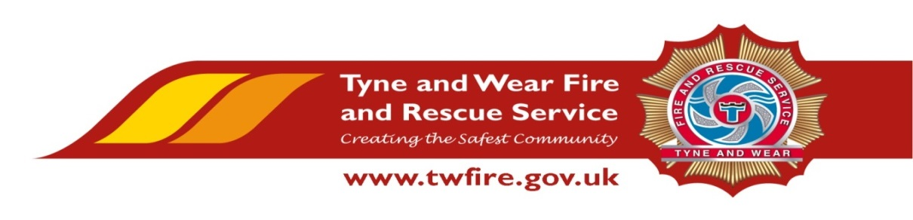

FIRE GROUND ASSISTANT
£17,681 - £18,672 + Benefits

We have an exciting opportunity for a talented and experienced Fire Ground Assistant. To be responsible for the operation and routine maintenance of vehicles, equipment, premises and grounds within Barmston Training Centre (BTC).

This role will involve operating training equipment, assisting in exercise preparation, undertaking safety duties, minor building and facilities repairs as required and deliver exceptional services to our community and key stakeholders.
The Service values and respects the diversity of its employees, and aims to recruit a workforce that represents the communities we serve. We welcome applications irrespective of people’s race, disability, gender, sexual orientation, religion or belief, age, gender identity, marriage and civil partnership, pregnancy and maternity.

Required Skills/Experience:
- Proven experience in manual work, including working at heights and heavy lifting
- Experience of undertaking clerical and administrative duties
- Ability to wear Breathing Apparatus and Personal Protective Equipment (PPE)
- Current full driving licence

What we can offer you
Tyne and Wear Fire and Rescue Service, Barmston Mere Training Centre is based in a purpose build office in Washington, with ample free parking and easy access from the A1 and A19. On site facilities include catering facilities and an onsite gym. The role also benefits from an attractive package, including up to 22 days holiday and public holidays, Local Government Pension Scheme and access to a range of social and volunteering opportunities.

Closing Date: Monday 15 October 2018 at 09:00

Interviews and Assessments: Week Commencing 22 October 2018
