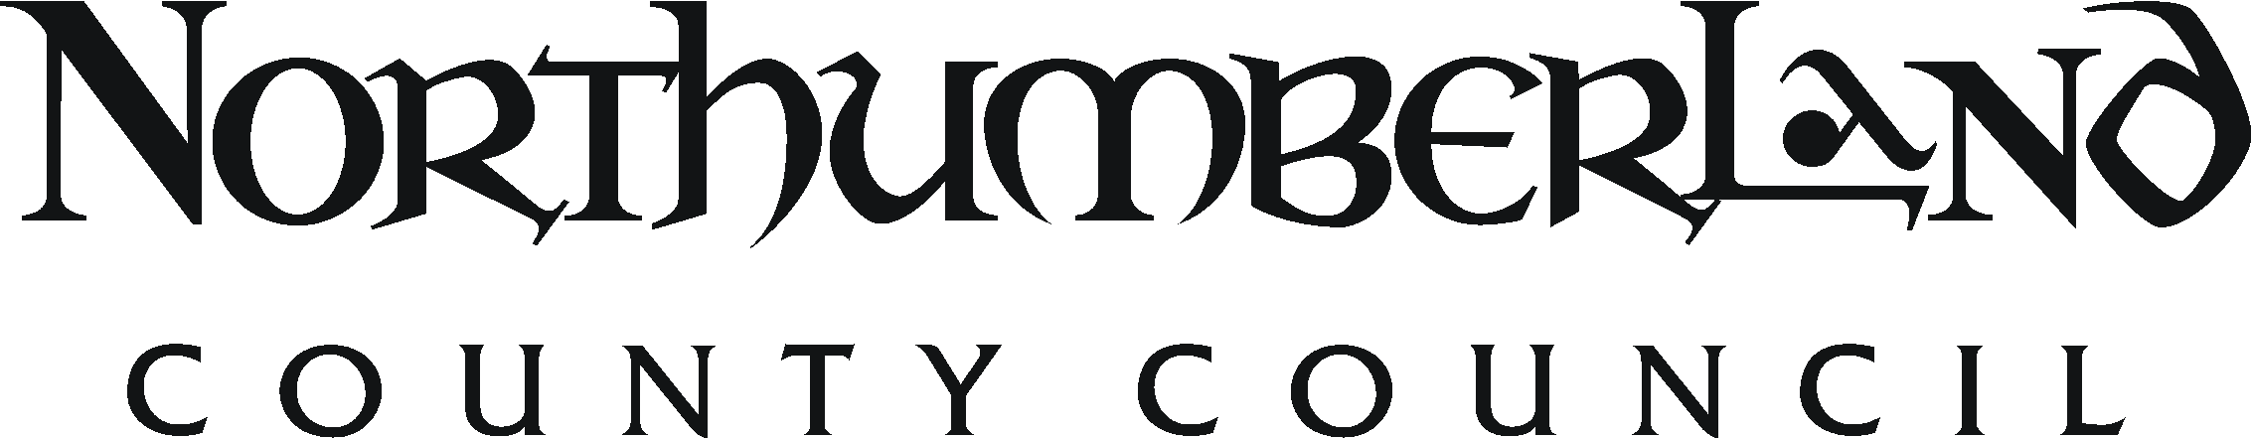 JOB DESCRIPTION

Post Title: Building Conservation Officer (Temporary) |  | Group - Service: Planning, Planning, Housing and Resilience |  |  | Office Use
Grade: Grade band 7 |  | Workplace: County Hall |  |  | JE ref: 136  HRMS ref:
Responsible to: Conservation Team Manager |  | Date: August 2017 | Manager Lever:
Job Purpose: To develop and deliver a full building conservation service to Northumberland County Council.
Resources | Staff | None
Finance
Physical |  | Maintain and operate service information systems, processes and procedures
Clients |  | Assist in the development of policies and procedures whose application has a significant impact upon service users. Assist in dealing with the public to deliver the service, working with internal and external partners to deliver joint projects, delivery of Service Level Agreement services to partners..
Duties and key result areas:
1. To work as part of the multi-disciplinary Historic Environment Team, and with other Conservation Officers within that team, to deliver a full building and historic area conservation service across the geographical area of Northumberland County Council.
2. To provide specialist advice to the Development Management teams in relation to listed building consent, and other applications affecting the historic environment. This will include pre-application advice, commenting on applications, recommending conditions, advising on the discharge of conditions, monitoring work on site and preparation for and attendance at public inquiries and hearings.
3. To provide design and building conservation policy input to the Local Development Framework, including Supplementary Planning Guidance as required and contribute to County wide policy making as appropriate.
4. To advise on appropriate methods of repair, maintenance and alterations of historic fabric including advice on specialist repair techniques and availability of materials and skills both locally and nationally.
5. To liaise with and advise Building Control, Asset Management, Highways and other council departments.
6. To designate and amend boundaries to conservation areas, assess design and new developments in conservation areas, prepare conservation area appraisals and management plans, Article 4 and 4(2) Directions and other supplementary planning documents.
7. To undertake repair and urgent works notices under Section 47 & 48 or Section 54 of the Planning (Listed Buildings & Conservation Areas) Act 1990 and Section 215 notices To undertake serving of building preservation notices.
8. To develop close working relations with Historic England, respond to consultations on statutory designations and undertake spot listing applications.
9. To undertake the preparation of a local list of buildings and heritage assets of special architectural or historic interest.
10. To represent the Council’s building conservation and design interests on a wide range of partnership groups, including conservation area advisory committees and conservation area project steering groups.
11. To advise enforcement officers in investigations of unauthorised works to listed buildings and works in conservation areas.
12. Work with the Historic Environment Record Officer to maintain historic records and historic environment database systems including computer records of listed buildings, local listed buildings and photographic records.
13. To provide education and outreach activities for local members and local communities.
14. To provide advice and guidance on all current legislation and central government advice affecting the protection of the historic environment.
15. To provide design advice on development affecting the built heritage, including; the production of policy guidance and development briefs.
16. To, take action to reduce Buildings At Risk, to initiate and implement enhancement schemes on listed buildings and conservation areas and to provide specialist advice for heritage led regeneration schemes and other environmental improvement initiatives.
17. To liaise with the County’s Historic Environment and Design Champions
18. To provide advice on conservation grant availability and on grant funded projects including the County Council’s building conservation grant budget, Townscape Heritage Initiatives, Conservation Area Partnerships and other funding programmes.
19. Other duties appropriate to the nature, level and grade of the post.

Work Arrangements
Physical requirements: Predominantly sitting or standing on site but occasional requirement to walk to remote or inaccessible sites, to access scaffolding and enter confined spaces. Occasional requirement for lifting files, documents and equipment of moderate weights.
Transport requirements: Involves travel to work at sites and area offices throughout the County and further a-field on occasion
Working patterns: Normal office hours with some evening and week-end meetings. Flexi-hours scheme applies.
Working conditions: Regular exposure to working outdoors in the full range of weather conditions

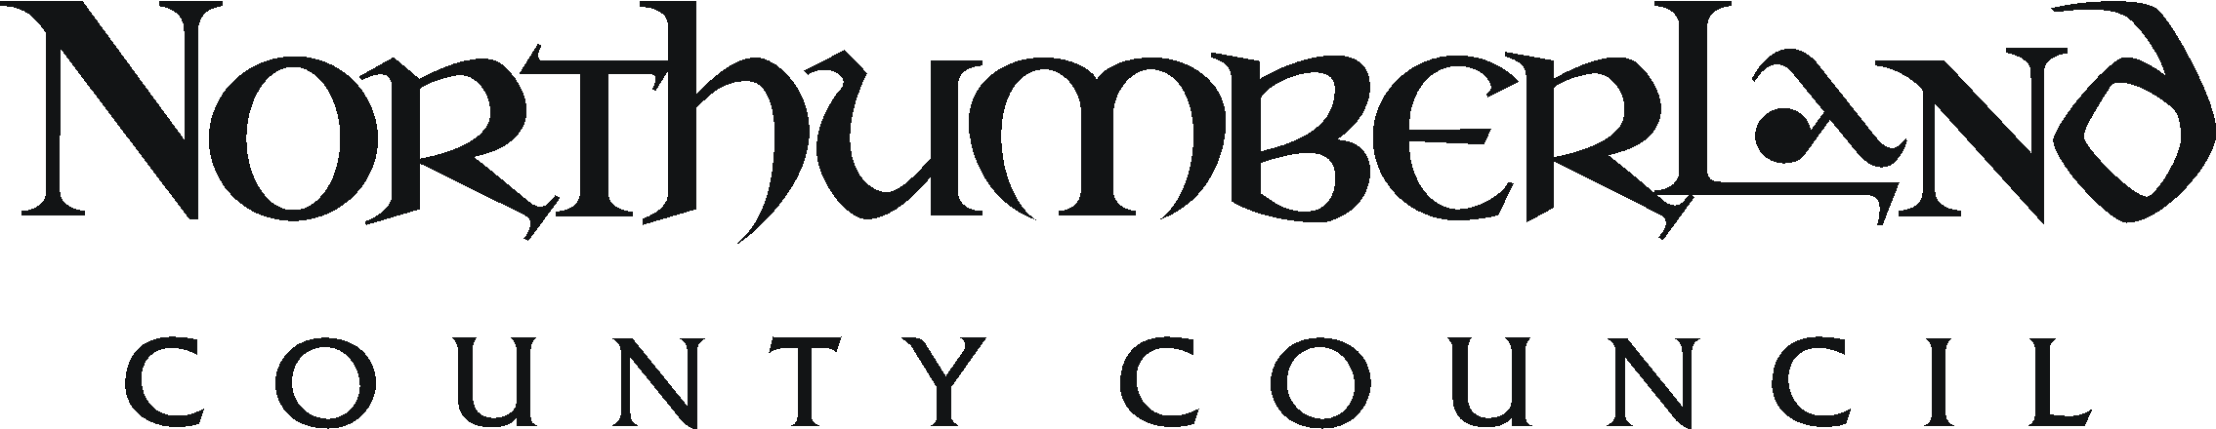 PERSON SPECIFICATION

Post Title: Building Conservation Officer | Group - Service: Local Services Group, Development Services | Ref:
Essential | Desirable |  | Assess  by
Knowledge and Qualifications
Degree or postgraduate qualification in Historic Building Conservation, Planning, Architecture or Surveying.  Eligible for Full membership of the Institute of Historic Building Conservation  Knowledge of historic building design and construction.  Knowledge of techniques for the conservation, management and enhancement of historic buildings and areas.  Knowledge of funding regimes and opportunities for historic building conservation.  Knowledge of conservation legislation and policy.  Knowledge of development management and strategic planning elements of the town and country planning system.  Knowledge of the legislative and policy framework relating to the conservation of the historic environment, technical skills for the repair and maintenance of historic buildings, and architectural history.  Knowledge of appropriate survey and recording techniques | Post graduate qualification in Historic Building Conservation and/or Urban Design
Experience
Recent experience providing specialist conservation advice (preferably with a Local Authority).  Recent experience of providing building conservation advice to property managers and owners.  Recent experience of contributing to the LDF or equivalent plan drafting process.  Recent experience of providing building conservation advice within the strategic planning and development management system. | Experience of complex EIA casework and the process of planning appeals and public inquiries.  Experience of Conservation Area Assessments  Experience of working with communities  Recent experience of managing grant budgets and schemes
Skills and competencies
Ability to assess the significance of historic buildings and areas and advise on appropriate conservation techniques and materials.  Ability to assess the conservation implications of complex development and regeneration proposals  Ability to communicate advice effectively.  Ability to draft reports and pamphlets on matters of historic and architectural detail.  Well developed communication and negotiation skills and ability to work as part of a team.  Competence in use of standard word processing, database and spreadsheet programmes.  Ability to advise on appropriate methods of repair.  Ability to understand and interpret legal documents and advisory circulars. Knowledge of legislative and policy framework relating to conservation of the historic environment. | Effective presentation skills
Physical, mental and emotional demands
Ability to organise and undertake detailed iterative analysis of evolving documents.
Ability to organise and prioritise heavy workload comprising a mixture of casework and longer term project work.
Ability to advocate positive outcomes for the historic environment in situations of competing priorities.
Ability to work outdoors in inclement weather conditions.
Ability to work without close direct supervision.

Other
Able to meet the transport requirements of the post

